新 书 推 荐

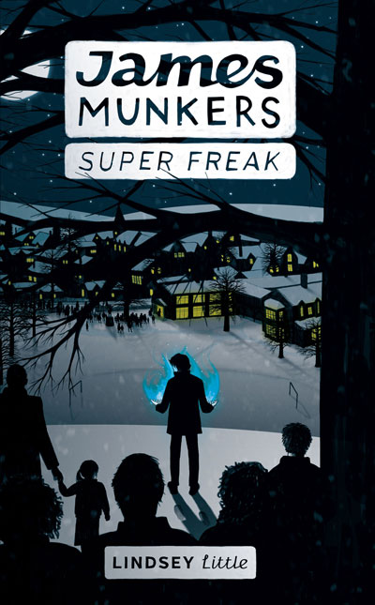
中文书名： 《超级怪人詹姆斯.蒙克斯》
英文书名：James Munkers: Super Freak
作 者：Lindsey Little
出 版 社：Interactive Publications
代理公司：ANA
出版日期：2014年4月
代理地区：中国大陆、台湾
审读资料：电子稿/样书
页 数：258页
类 型：9-12少年文学

内容简介：

James Munkers’ world is changing. New town. New school.

New hallucinations of bright blue animals wreaking havoc.

And when you add a leather-clad maniac who haunts the back garden, the loopy girl at school with her messages of doom, a cryptic prophecy and a bunch of shadowy strangers intent on murder, it looks as though James won’t even make it to Christmas.

The sensible thing to do would be to run. To hide. To generally escape.

But James Munkers can’t hide. He can’t escape.

Because James Munkers is different.

James Munkers has a destiny.

But James Munkers would rather forget all that and go back to playing God of War.

作者简介：


Lindsey Little was born in South Australia and raised in Tasmania, where she still lives.

She obtained her masters degree in Medieval Studies from the University of York, and considered a career in academia before remembering that novels have more scope for creativity and noticeably fewer footnotes than dissertations do.

She likes dogs, daffodils and looking at things from a great height.

James Munkers: Super Freak is her first novel.

谢谢您的阅读！
请将回馈信息发至：李馥辰(Cindy Li)
安德鲁﹒纳伯格联合国际有限公司北京代表处
北京市海淀区中关村大街甲59号中国人民大学文化大厦1705室, 邮编：100872
电 话：010-82509406
传 真：010-82504200
Email：Cindy@nurnberg.com.cn
网址：www.nurnberg.com.cn
微博：http://weibo.com/nurnberg
豆瓣小站：http://site.douban.com/110577/
微信订阅号：安德鲁书讯

