新 书 推 荐

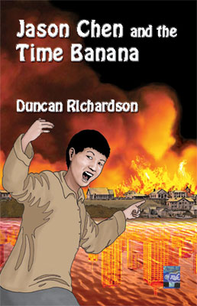
中文书名： 《杰森和时间香蕉的奇遇》
英文书名：Jason Chen and the Time Banana
作 者：Duncan Richardson
出 版 社：Interactive Publications
代理公司：ANA
出版日期：2012年12月
代理地区：中国大陆、台湾
审读资料：电子稿/样书
页 数：192页
类 型：少年文学

内容简介：

Jason Chen learns of a strange and powerful machine lurking in his neighbour’s backyard. Mrs Bryant is supposed to be weird, but she buys fish and chips from his parents’ café so he thinks she can’t be too bad. But Mrs B has a secret. And when she says she can’t succeed in her dangerous mission without him, Jason agrees to join her for a ride in her Time Banana.

They travel back to the 1860s, with the Great Fire of Brisbane looming. Knowing what they do about the Present, do they dare to tinker with the Past? It’s a thrilling adventure neither of them—or you—will forget…

作者简介：


Duncan Richardson writes prose and poetry for children and adults.
His verse play The Grammar of Deception will be broadcast on ABC Radio National in 2008.
He lives in Brisbane where he conducts writing workshops.
Previous children’s books include Wennabees and Yum-worms and Revenge

谢谢您的阅读！
请将回馈信息发至：李馥辰(Cindy Li)
安德鲁﹒纳伯格联合国际有限公司北京代表处
北京市海淀区中关村大街甲59号中国人民大学文化大厦1705室, 邮编：100872
电 话：010-82509406
传 真：010-82504200
Email：Cindy@nurnberg.com.cn
网址：www.nurnberg.com.cn
微博：http://weibo.com/nurnberg
豆瓣小站：http://site.douban.com/110577/
微信订阅号：安德鲁书讯

