Pup Patrol series

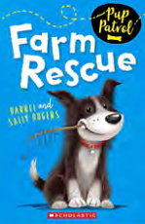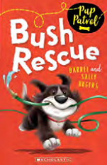

作者简介：

Sally Odgers has written many books for children, including the perennial favourite Bunyips Don’t! Sally and her husband Darrel Odgers wrote the hilarious Jack Russell mysteries and the Pet Vet series.

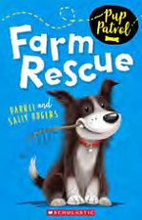
英文书名：Pup Patrol Book 1: Farm Rescue
作 者：Darren & Sally Odgers（文）Janine Dawson（图）
出 版 社：Scholastic Australia
代理公司：Rights People/ANA
出版日期：2015年3月
代理地区：中国大陆、台湾
审读资料：电子稿/样书
页 数：96页
类 型：7-12岁少年文学

内容简介：

* My name is Barnaby Station Stamp of Approval, but you can call me Stamp *
Stamp is having a pawfectly wonderful time travelling around the country with his owner James and his terrier friend, Ace, in the Fourby 4WD. As the Pup Patrol drive around Australia, they not only meet lots of new friends, but they have plenty of time for some wild adventures, too!

First in a series with two further titles signed up.

谢谢您的阅读！
请将回馈信息发至：李馥辰(Cindy Li)
安德鲁﹒纳伯格联合国际有限公司北京代表处
北京市海淀区中关村大街甲59号中国人民大学文化大厦1705室, 邮编：100872
电 话：010-82509406
传 真：010-82504200
Email：Cindy@nurnberg.com.cn
网 站：Http://www.nurnberg.com.cn
新浪微博：http://weibo.com/nurnberg
豆瓣小站：http://site.douban.com/110577/


