新 书 推 荐

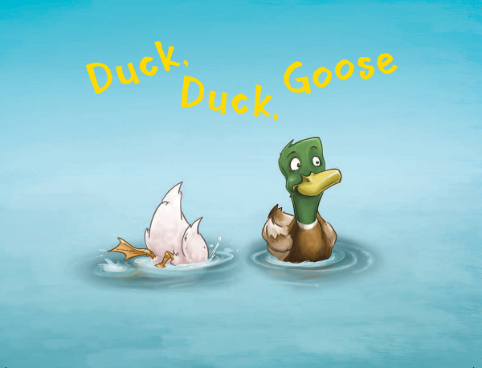
英文书名：DUCK, DUCK, GOOSE
作 者：Michael Blassnig
出 版 社：Hachette Australia
代理公司：ANA
出版日期：2015年9月
代理地区：中国大陆、台湾
审读资料：电子稿/样书
页 数：24页
类 型：儿童绘本

核心卖点：

A delightful, inventive and thoroughly silly story.
The simple rhyming text is perfect for reading with little ones.
Blassnig introduces an array of amazing characters who are hard to resist.

内容简介：

Two ducks meet an incredible cast of characters on the river one day in this hilarious and vibrantly illustrated rhyming picture book.

Duck, Duck, Goose is a visual treat. A crazy, fun-filled journey down the river of the cute and the absurd, it will delight youngsters and have them reading this book over and over. Inspired by the beloved kids’ game, two ducks meet new friends each time the page is turned - a cockatoo ... a gnu in a canoe ... a pirate crew ... and many more!

作者简介：

Michaela Blassnig is a Brisbane-based illustrator who has worked on various film, character design and book projects. The critically acclaimed Hermione and the Enormous Storm was her first picture book with Lothian Children’s Books.

媒体评价：

“It is a lovely story about making friends when you least expect it. The fun and easy-to-read rhyming text makes it hard not to imbue a little bit of party vibe along the way, and the kids enjoy it, too.”
----Newcastle Herald

“a delightful story ... packed full of colourful images”----Practical Parenting

“I loved the couplet poem style writing ... super cute”----TheBestKidsBooks.com

内文图画：

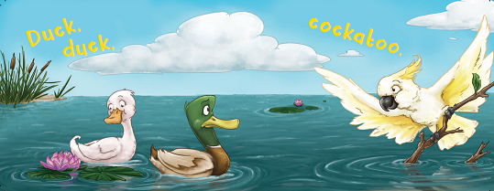
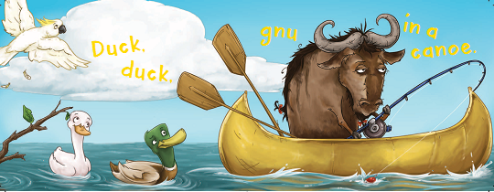

谢谢您的阅读！
请将回馈信息发至：李馥辰(Cindy Li)
安德鲁﹒纳伯格联合国际有限公司北京代表处
北京市海淀区中关村大街甲59号中国人民大学文化大厦1705室, 邮编：100872
电 话：010-82509406
传 真：010-82504200
Email：Cindy@nurnberg.com.cn
网 站：Http://www.nurnberg.com.cn
新浪微博：http://weibo.com/nurnberg
豆瓣小站：http://site.douban.com/110577/


