新 书 推 荐

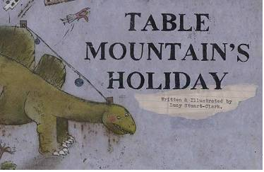
英文书名：TABLE MOUNTAIN’S HOLIDAY
作 者：Lucy Stuart-Clark
出 版 社：Bumble Books
代理公司：S.B.Rights Agency/ANA
出版日期：2013年9月
代理地区：中国大陆、台湾
审读资料：电子稿/样书
页 数：32页
类 型：儿童绘本

内容简介：

A beautifully illustrated picture book about a dinosaur who decides to go on holiday.Tired of being covered by a cold, cloudy blanket, Table Mountain, an almost fossilised dinosaur, stretches his reptilian legs, waves goodbye to Lion’s Head ... and goes on holiday!
The illustrations were achieved using a technique of gouache resist then hand-coloured with chalk pastels.
Work from this book was selected for the 2013 Bologna Children’s Book Fair Illustrator’s Exhibition and which also toured Japan.

作者简介：

Lucy Stuart-Clark is a Cape Town-based artist who holds a Bachelor of Fine Arts (Printmaking) from Rhodes University and a MPhil in Visual Arts (Illustration) from Stellenbosch University, South Africa. Table Mountain’s Holiday is her first children’s book.

内文图画：

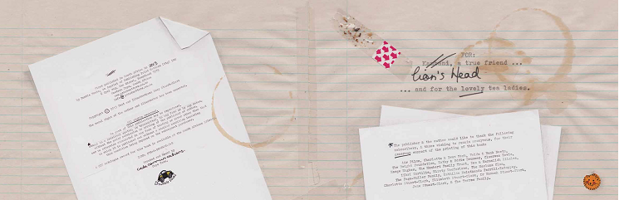
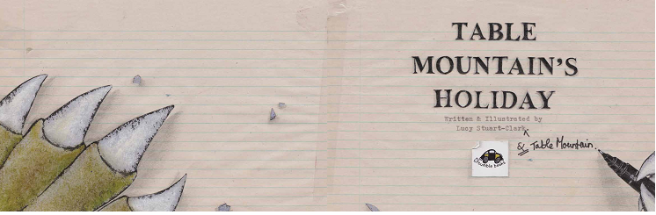
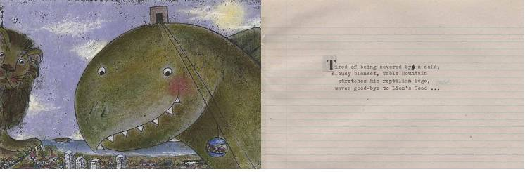
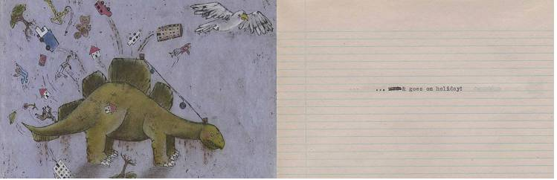

谢谢您的阅读！
请将回馈信息发至：李馥辰(Cindy Li)
安德鲁﹒纳伯格联合国际有限公司北京代表处
北京市海淀区中关村大街甲59号中国人民大学文化大厦1705室, 邮编：100872
电 话：010-82509406
传 真：010-82504200
Email：Cindy@nurnberg.com.cn
网 站：Http://www.nurnberg.com.cn
新浪微博：http://weibo.com/nurnberg
豆瓣小站：http://site.douban.com/110577/


