新 书 推 荐

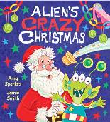
英文书名：Alien's Crazy Christmas
作 者：Amy Sparkes（文）Jamie Smith（图）
出 版 社：Scholastic UK
代理公司：ANA
出版日期：2015年10月
代理地区：中国大陆、台湾
审读资料：电子稿/样书
页 数：32页
类 型：3-6岁儿童绘本

卖点提炼：

An alien attempts to recreate Christmas on his home planet with hilarious results
A festive picture book packed full of humorous illustrations that young audiences will love
A madcap tale packed with funny mix-ups and a little toilet-humour too, perfect for fans of THE DINOSAUR THAT POOPED CHRISTMAS
This laugh-out-loud Christmas romp is the perfect festive treat!

内容简介：

This hilarious picture book is the perfect festive treat!
After visiting earth one Christmas day, an alien decides to recreate the festivities on his home planet. Zobble takes notes and collects everything he will need. However, as the spaceship spins through the sky on his way home his notes get muddled up. Zobble tries to remember what goes with what but - of course - gets everything mixed up. Cue socks and pants stuffed with holly, a donkey in a fairy costume, and a bemused Santa in pursuit of his missing reindeer.

作者简介：

Amy Sparkes is the author of the bestselling DO NOT ENTER THE MONSTER ZOO as well as GRUFF'S GUIDE TO THE SECRET SEA and THE MOUSE WHO SAILED THE SEVEN SEAS. Amy lives in Devon.
@AmySparkes amysparkes.co.uk
Jamie Smith has illustrated over 100 books for children, including the JIGSAW JONES MYSTERIES. Jamie lives in Surrey. jamiesmithillustration.com

内文图画：

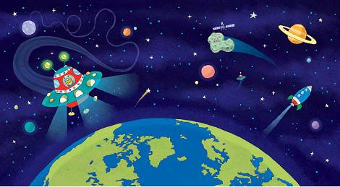

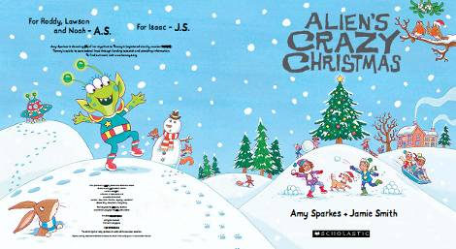

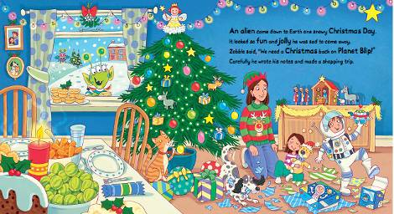

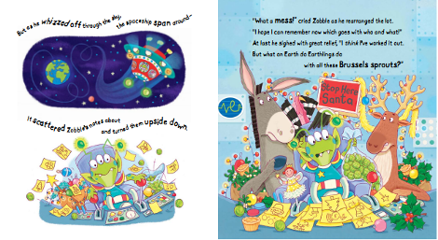

谢谢您的阅读！
请将回馈信息发至：宁非 (Katalin Ning)
安德鲁﹒纳伯格联合国际有限公司北京代表处
北京市海淀区中关村大街甲59号中国人民大学文化大厦1705室, 邮编：100872
电 话：010-82509406
传 真：010-82504200
Email：Katalin@nurnberg.com.cn
网 站：Http://www.nurnberg.com.cn
新浪微博：http://weibo.com/nurnberg
豆瓣小站：http://site.douban.com/110577/
微信订阅号：安德鲁书讯


