新 书 推 荐

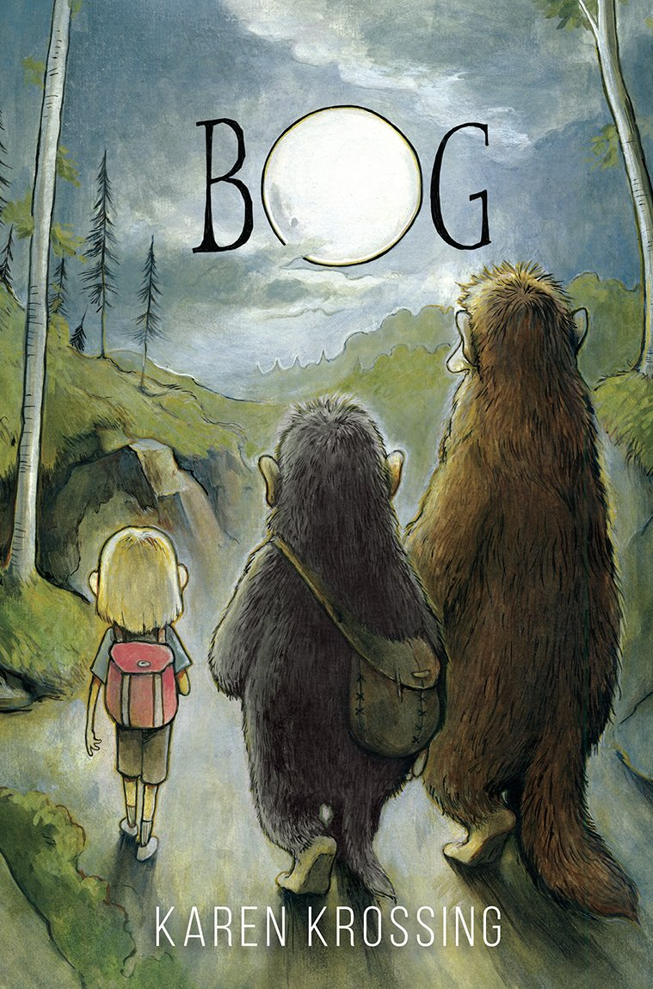
英文书名：Bog
作 者：Karen Krossing
出 版 社：Fitzhenry & Whiteside
代理公司：ANA
出版日期：2014年4月
代理地区：中国大陆、台湾
审读资料：电子稿/样书
页 数：229页
类 型：7-12岁少年文学

内容简介：

Bog smelled the humans from across the lake. The stench floated high on the breeze, infecting the stars themselves, and then settled among the branches of the birch trees. What were humans doing in their hunting grounds?
When his father is mercilessly turned to stone by the Troll Hunter's followers, a cave troll named Bog sets out to find the murderers and avenge his father. But with no leads and little knowledge of the human world, Bog knows his journey won't be easy. Along the way, he meets a huge forest troll named Small and a young human girl named Hannie. Together, they venture deeper into human territory, where they learn of the legendary Nose Stone—a rock rumoured to bring a stone troll back to life. Hope fills Bog's heart, but when he discovers the Troll Hunter is also going after the Nose Stone to destroy it, his quest becomes a race of cunning, trickery, and wits.

作者简介：


Karen Krossing is addicted to stories. She began to create stories when she was eight, and she continued this habit by writing poetry in high school. By then she was hooked on books, so she studied English at university then became a book editor and a copywriter. Today, Karen writes novels and short stories for children and teens. She also encourages new writers through workshops for kids, teens and adults. Karen lives with her family in Toronto, Canada. For more about Karen, visit karenkrossing.com.

媒体评价：

“Bog is an irresistible character—grouchy but sweet, deeply flawed but deeply noble. I didn't want his quest to end. Funny, inventive, and full of heart.”
----Lena Coakley, author of Witchlanders
“If you can read this novel without wishing you were a troll, you're a better human than me.”
----Emily Pohl-Weary, author of Not Your Ordinary Wolf Girl
“Bog is a well-written and intriguing allegory that delves into many of the tougher questions of life. Krossing uses magic, mystery, and humour to draw readers in, and she employs an engaging protagonist and cast of characters to take her readers on a journey of discovery. . . The main characters are all well-drawn, and the secondary characters play their parts well. Images and descriptions are evocative, and, at times, beautiful.Highly Recommended.”
----CM Magazine

谢谢您的阅读！
请将回馈信息发至：李馥辰(Cindy Li)
安德鲁﹒纳伯格联合国际有限公司北京代表处
北京市海淀区中关村大街甲59号中国人民大学文化大厦1705室, 邮编：100872
电 话：010-82509406
传 真：010-82504200
Email：Cindy@nurnberg.com.cn
网 站：Http://www.nurnberg.com.cn
新浪微博：http://weibo.com/nurnberg
豆瓣小站：http://site.douban.com/110577/


