**新 书 推 荐**

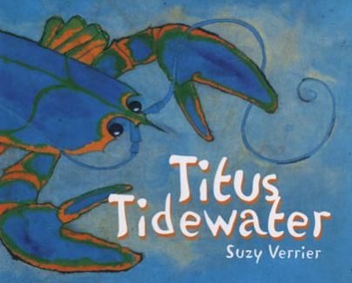

**中文书名：《海岸线大冒险》**

**英文书名：*Titus Tidewater***

**作 者：Suzy Verrier**

**出 版 社：Islandport Press**

**代理公司：Transatlantic Literary Agency Inc./ANA**

**出版日期：2013年**

**代理地区：中国大陆、台湾**

**审读资料：电子稿**

**页 数：38页**

**类 型：儿童绘本**

**内容简介：**

For blue lobster Titus Tidewater, summer means exciting happenings near the shoreline, but also lurking dangers. Titus explores the ocean floor, but soon finds himself caught in a trap. He is taken away from his familiar surroundings and to a strange new world on land, before he is ultimately rescued by two children.

**作者简介：**

 Maine native **Suzy Verrier** is the author and illustrator of Titus Tidewater. Verrier, who studied illustration at the Boston Museum Art School and the Philadelphia Museum College of Arts, lives in Phippsburg, Maine, where she owns and operates North Creek Farm, a country store and nursery featuring an eclectic mix of merchandise and a large selection of roses. In addition to illustrating children’s books, Suzy has written two books on flowers. Titus Tidewater is based on an event in her childhood when she purchased a lobster from Johnny’s Pound in Ogunquit, only to lose it to the rising coastal tide.

**内文图画：**

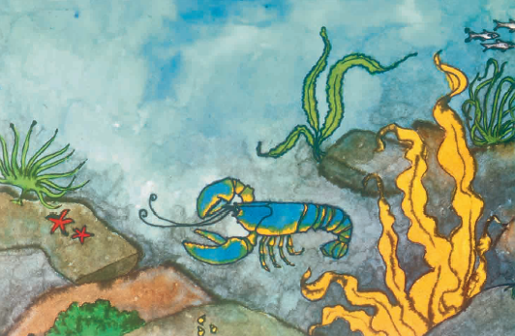

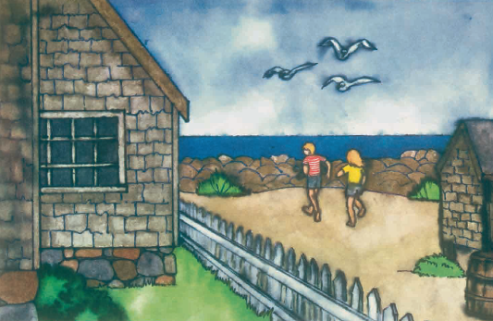

**谢谢您的阅读！**

**请将回馈信息发至：宁非(Katalin Ning)**

**安德鲁﹒纳伯格联合国际有限公司北京代表处**  
北京市海淀区中关村大街甲59号中国人民大学文化大厦1705室, 邮编：100872  
电 话：010-82449901

传 真：010-82504200  
Email：[Katalin@nurnberg.com.cn](mailto:Katalin@nurnberg.com.cn)

网 站：[Http://www.nurnberg.com.cn](http://www.nurnberg.com.cn/" \t "_blank)

新浪微博：http://weibo.com/nurnberg

豆瓣小站：[http://site.douban.com/110577/](http://site.douban.com/110577/" \t "_blank)

