作 者 推 荐

作者简介：

安妮·莱弗·西顿（Anne Rivers Siddons），美国悬疑小说家，作品屡登纽约畅销书榜。著有《樱桃街》《心碎旅店》《邻居》《过季》《魔山》等18部小说。其中《樱桃街》销量突破100万册，《心碎旅店》《邻居》等多部小说被改编成电影、电视剧，最新作《魔山》被各大书榜评为2011年最畅销小说。

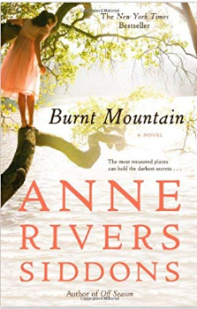
中文书名：《魔山》
英文书名：BURNT MOUNTAIN
作 者：Anne Rivers Siddons
出 版 社：Grand Central Publishing
代理公司：WME/ANA/Jackie Huang
出版日期：2012年7月（再版）
页 数：336页
审读资料：电子稿
类 型：小说
授权已授：2012年4月授权现代出版社，版权已回归

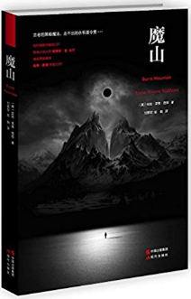
中简本出版记录
作 者：(美)安妮·莱弗·西顿
出版社：现代出版社
译 者：刘勇军、徐娟
出版年：2015年9月
页 数：255页
定 价: 33.00元
装 帧：平装

内容简介：

“当他爬上那座魔山，我就知道，我的丈夫永远都回不来了。”

童年的魔山——火烧岩，在山上矗立着一座永恒夏令营。

在那里，她遇见了第一个爱情。纯真、热烈。

虽已彼此零落在异地，那个人却始终在她的记忆深处。

10年光阴如箭，她嫁给了一个斯文妥帖的爱尔兰男人。一个神学教授。

一场家庭变故，使她不得不带着新郎回到旧居。

物是人非，曾经留恋的往事成灰。

魔山的孤影深深刺在了内心最柔软的地方。

然而她的爱尔兰新郎，那个神学家却对这座魔山和永恒夏令营异常狂热，深深痴迷。

噩梦般的黑暗，慢慢张开

每日与我共枕而眠的他，到底变成了什么……

作者简介：

安妮·莱弗·西顿（Anne Rivers Siddons），美国悬疑小说家，作品屡登纽约畅销书榜。著有《樱桃街》《心碎旅店》《邻居》《过季》《魔山》等18部小说。其中《樱桃街》销量突破100万册，《心碎旅店》《邻居》等多部小说被改编成电影、电视剧，最新作《魔山》被各大书榜评为2011年最畅销小说。

目录：

Epilogue回归
温特沃斯家的女孩们
汉伯山姆之梦
火烧岩
汉密尔顿的没落
潮湿的夏令营
初恋
无尽的等待
“与我共舞在爱尔兰”
传说
古宅
特纳诺格的永生
新邻居
祭祀
争吵
永恒夏令营
魔法
黑暗之夜
恶魔
树篱彼端
尾声

媒体评价：

我一直很喜欢读安妮·西顿的文章，她真的是一个很棒的悬疑作家，简直是一个天才。
——斯蒂芬·金

每个人都应该读读安妮·西顿。
——芝加哥论坛报

安妮·西顿是最秀的南部作家之一。
——洛杉矶时报

安妮·西顿总是能发现不曾被感知到的人性，她的作品总是能带给我们最深沉的悸动。
——丹佛邮报

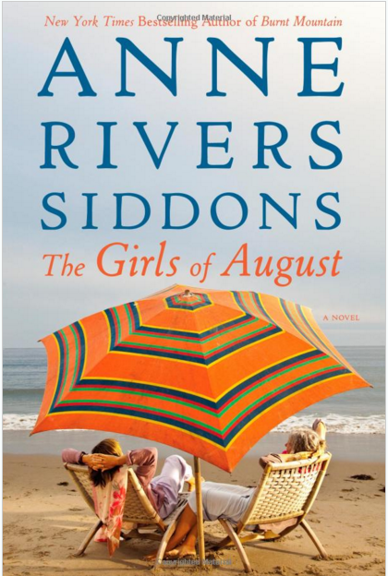
中文书名：《八月女孩》
英文书名：THE GIRLS OF AUGUST
作 者：Anne Rivers Siddons
出 版 社：Grand Central Publishing
代理公司：WME/ANA/Jackie Huang
页 数：272页
出版时间：2016年7月
代理地区：中国大陆、台湾
审读资料：电子稿
类 型：小说

内容简介：
For fifteen years, four "girls of August" would gather together to spend a week at the beach, until tragedy interrupts their ritual. Now they reunite for a startling week of discoveries.
The ritual began when they were in their twenties and their husbands were in medical school, and became a mainstay of every summer thereafter. Their only criteria was oceanfront and isolation, their only desire to strengthen their far-flung friendships. They called themselves the Girls of August. But when one of the Girls dies tragically, the group slowly drifts apart and their vacations together are brought to a halt.
Years later, a new marriage reunites them and they decide to come together once again on a remote barrier island off the South Carolina coast. There, far from civilization, the women uncover secrets that will change them in ways they never expected.

媒体评价：

"One doesn't read Anne Rivers Siddons's books, one dwells in them."―Chicago Tribune
Bravura writing...This is Siddons's best, maybe the book she was born to write."―Stephen King (on Off Season)
"Anne Rivers Siddons's body of work is one of the most impressive in contemporary fiction. And, in her beautifully crafted and dazzling new novel OFF SEASON, Ms. Siddons delivers the goods more powerfully than ever. All her books are terrific, but this one is the best yet."―Pat Conroy
"The lyrical beauty of Siddons's writing shines...an elegant portrait of love, loss, longing; memories and mystery line the path to self-discovery in OFF SEASON....Siddons's fans will savor the story long after the last page has turned."―Charlotte Observer
"Siddons masterfully portrays growing up in a small town outside Atlanta...Even as they age, Siddons' characters focus on their sensations and needs and aspirations, but that single-mindedness coaxes readers to side with her central character. Anyone who appreciates the instant gratification of romance novels - 'Burnt Mountain' seems designed for a few days of beach reading - will be quickly taken in by the quiet and beautiful tomboy...When Thayer Wentworth figures out young that life's nastiest snarls may not all be loosened and smoothed and retied in neat bows, we fret with her. And when everything inevitably does start to work out, we are as relieved as she is."―The Associated Press (on BURNT MOUNTAIN)
"Siddons mixes in a touch of the supernatural to bring the novel to an exciting climax, but what's most appealing here is the layered family drama and the lush world Thayer inhabits...A master storyteller with a remarkable track record, bestselling Siddons returns to her signature Southern setting in her newest blend of emotional realism and a sliver of magic."―Booklist (on BURNT MOUNTAIN)

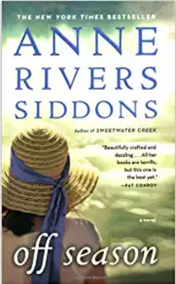
中文书名：《季节后》
英文书名：OFF SEASON
作 者：Anne Rivers Siddons
出 版 社：Grand Central Publishing
代理公司：WME/ANA/Jackie Huang
页 数：384页
出版时间：2009年7月
代理地区：中国大陆、台湾
审读资料：电子稿
类 型：小说

内容简介：

For as long as she can remember, they were Cam and Lilly--happily married, totally in love with each other, parents of a beautiful family, and partners in life. Then, after decades of marriage, it ended as every great love story does...in loss. After Cam's death, Lilly takes a lone road trip to her and Cam's favorite spot on the remote coast of Maine, the place where they fell in love over and over again, where their ghosts still dance. There, she looks hard to her past--to a first love that ended in tragedy; to falling in love with Cam; to a marriage filled with exuberance, sheer life, and safety-- to try to figure out her future.
It is a journey begun with tender memories and culminating in a revelation that will make Lilly re-evaluate everything she thought was true about her husband and her marriage.

媒体评价：

'Anne Rivers Siddons's body of work is one of the most impressive in contemporary fiction. And, in her beautifully crafted and dazzling new novel OFF SEASON, Ms. Siddons delivers the goods more powerfully than ever. All her books are terriffic, but this one is the best yet - Pat Conroy 'I've always enjoyed Anne Rivers Siddon's books, but this is her best, maybe the book she was born to write. It's a double love story, narrated by a woman who has loved both early and late. The story of Lilly and Jon is one of the best stories of adolescent love - its fierceness and sweetness - that I've ever read. There's also a beautifully drawn picture of Maine dressed in her summer finery...and a few ghosts. Summer is maybe the best time to read this book; if you've ever vacationed on the Maine coast (or ever wanted to), this book isn't just the next best thing, it's the real thing. Bravura storytelling' - Stephen King

谢谢您的阅读！
请将回馈信息发至：张滢（Cindy Zhang）
安德鲁﹒纳伯格联合国际有限公司北京代表处
北京市海淀区中关村大街甲59号中国人民大学文化大厦1705室, 邮编：100872
电话：010-82504506
传真：010-82504200
Email: Cindy@nurnberg.com.cn
网址：www.nurnberg.com.cn
微博：http://weibo.com/nurnberg
豆瓣小站：http://site.douban.com/110577/
微信订阅号：ANABJ2002

