新 书 推 荐
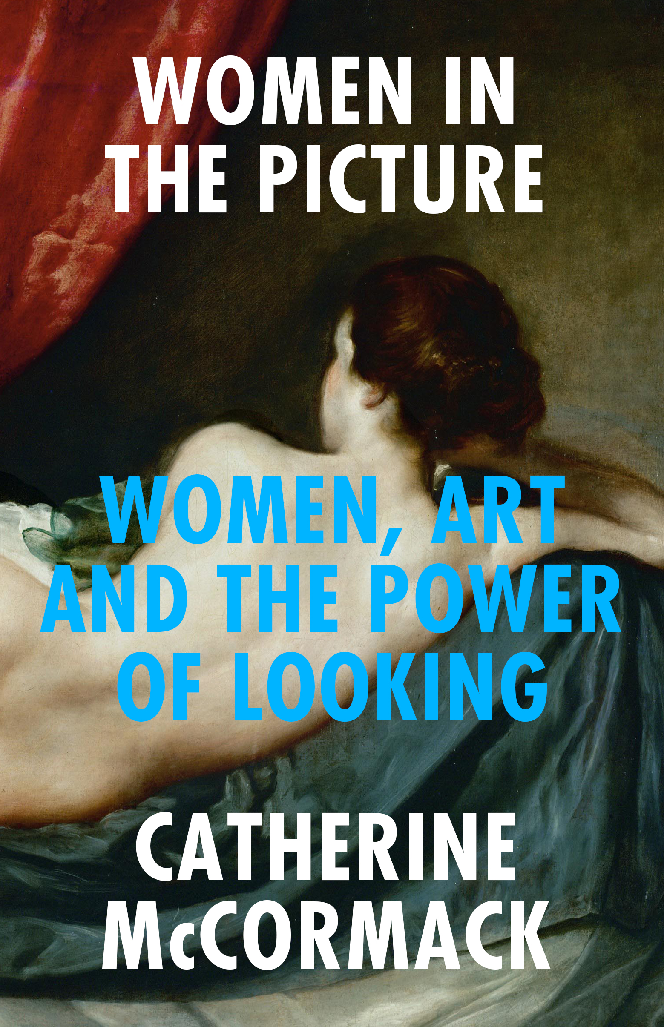
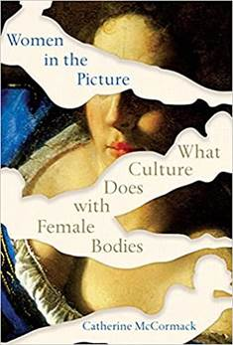
中文书名：《画框里的女性》
英文书名：WOMEN IN THE PICTURE
作 者：Catherine McCormack
出 版 社：Icon
代理公司：Johnson & Alcock/ANA/Claire Qiao
出版时间：2021年5月
代理地区：中国大陆、台湾
页 数：240页
审读资料：电子稿
类 型：大众文化
本书版权已授：韩国，土耳其

英亚排名：
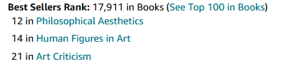
美亚排名 ：
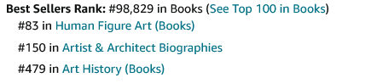
“The misogyny, she writes, is so pervasive that we simply can’t see it anymore. Women in the Picture’s work is to help us regain our vision.”
----Jessica Ferri, Author of Silent Cities in the LA Times (read Ferri’s full interview with McCormack, Nov. ’21)

"Women in the Picture mounts a sensitive and probing critique of the motifs, the preordained poses and affectations of the female figure in art. If feminism aspires to render itself obsolete, McCormack’s project too yearns for a future when critiquing such postures...will no longer be necessary."
----Jasmine Sanders, New York Times Book Review

"[An] illuminating look at how women's bodies have been depicted in the arts…This eye-opening work will leave readers with plenty to ponder."
---- Publishers Weekly (starred)

"A timely, succinct, aesthetic inquiry into debates about sexuality, objectification, and representation."
---- Kirkus Reviews

"On this grand tour of western visual culture, you couldn’t ask for a better guide."
----Bridget Quinn, author of Broad Strokes

"Catherine McCormack succeeds in the nearly impossible task of discussing both the representation of women throughout the history of art as well as how women artists have challenged these male-centric images."
----Kathy Battista, author of New York New Wave

"The art book we’ve all been waiting for."
---- Helen Gorrill, author of Women Can’t Paint

"I’m glad this book was written because it felt like the scales were falling from my eyes as I read it."
---- Jan Patience, Herald

“a provocative and comprehensive read”
---- Inside Hook, Books You Should Be Reading

“ In Women in the Picture: What Culture Does With Female Bodies, Catherine McCormack offers an approachable and refreshing introduction to Western art history and its legacy in pop culture imagery.”
----Bitch Media Interview (where she discusses the hotly debated new book by Emily Ratajkowski, amongst many other things!)

LA Times Fall Preview – 30 most anticipated books for Fall ‘21

Check out also the wonderful piece Catherine did for Harper’s Bazaar in June ’21 and these podcasts Catherine contributed to this year (if you like Katy Hessel of ‘Great Women Artists’, I think you’ll like CM):
Irish Times Women’s Podcast

BBC Radio 4 Women’s Hour – min 48, talking about geriatric millennials and Kim K selfies etc.!

内容简介：

一个完美的美女，一个落难的少女，一个圣洁的母亲，一个女强人……

长期以来，妇女的身份一直被一套有限的原型所扼杀，从艺术史的经典作品到广告图片中随处可见，而女性艺术家一直都被忽视，被阻挡在塑造更有力量的角色之外。

在这本充满激情的书中，翻着我们最喜爱的画像——从提香、波提切利到毕加索及拉斐尔前派的图像，艺术史学家凯瑟琳·麦克康莫克（Catherine McCormack）要求我们重新审视这些画像告诉我们的价值。她还向我们展示了女性艺术家——从伯特·莫里索到碧昂斯，从朱迪·芝加哥到卡拉·沃克——她们是如何为我们提供思考女性身份、性别、种族和权力的新方法。

《画框里的女性》为我们提供了看待旧艺术和为人熟知的画像的新方法，以便我们可以将妇女从这些限制性的角色中解放出来，拥抱妇女视野的宽度。

作者简介：

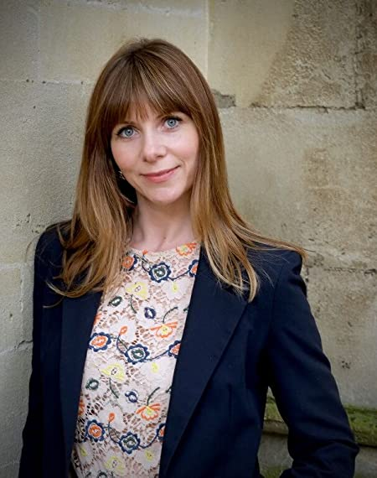
凯瑟琳·麦克康莫克（Catherine McCormack）是一位策展人、艺术史讲师和《仰望的艺术》（The Art of Looking Up）一书的作者。她也是苏富比艺术学院“女性与艺术”研究项目的创始人和课程总监。

谢谢您的阅读！
请将反馈信息发至： 乔明睿（Claire）
安德鲁﹒纳伯格联合国际有限公司北京代表处
北京市海淀区中关村大街甲59号中国人民大学文化大厦1705室, 邮编：100872
电话：010-82449026
传真：010-82504200
手机：15804055576
Email: Claire@nurnberg.com.cn
网址：www.nurnberg.com.cn
微博：http://weibo.com/nurnberg
豆瓣小站：http://site.douban.com/110577/
微信订阅号：ANABJ2002

