新 书 推 荐

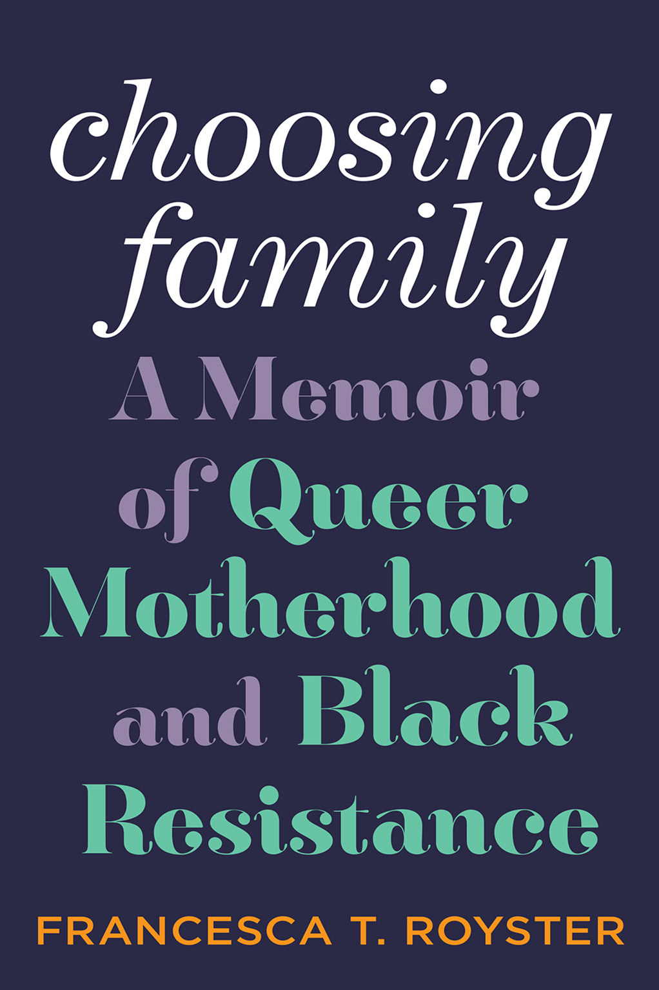
中文书名：《选择家庭：酷儿母亲和黑人反抗的回忆录》
英文书名：CHOOSING FAMILY: A Memoir of Queer Motherhood and Black Resistance
作 者：Francesca T. Royster
出 版 社：Abrams Press
代理公司：ANA/Connie
出版时间：2023年2月
代理地区：中国大陆、台湾
页 数：288页
审读资料：电子稿
类 型：传记回忆录

内容简介：

- FILLS A GAP IN THE MARKET: There is a dearth of memoirs about motherhood written by Black women; Black queer motherhood memoirs are virtually nonexistent. This book is an opportunity to bridge that gap, and Royster is a powerful writer whose motherhood journey will resonate with many readers who do not see themselves represented.
- AUTHOR CONNECTIONS: The author has a burgeoning network of writers who she will call upon to help with promotion, including Salamishah Tillet, Cheryl L. West, Haki Madhubuti, Nadine Kenney Johnstone, Miles Harvey, and more.
- INTERSECTIONAL AND INTERDISCIPLINARY: Choosing Familycombines a powerful personal narrative with queer theory and criticism to discuss adoption and parenthood from a Black, queer, and feminist perspective.

A brilliant literary memoir of chosen family and chosen heritage, told against the backdrop of Chicago’s North and South Sides

As a multiracial household in Chicago’s North Side community of Rogers Park, race is at the core of Francesca Royster and her family's world, influencing everyday acts of parenting and the conception of what family truly means. Like Maggie Nelson’s The Argonauts, this lyrical and affecting memoir focuses on a unit of three: the author; her wife Annie, who's white; and Cecilia, the Black daughter they adopt as a couple in their forties and fifties. Choosing Family chronicles this journey to motherhood while examining the messiness and complexity of adoption and parenthood from a Black, queer, and feminist perspective. Royster also explores her memories of the matriarchs of her childhood and the homes these women created in Chicago’s South Side—itself a dynamic character in the memoir—where “family” was fluid, inclusive, and not necessarily defined by marriage or other socially recognized contracts.
Calling upon the work of some of her favorite queer thinkers, including José Esteban Muñoz and Audre Lorde, Royster interweaves her experiences and memories with queer and gender theory to argue that many Black families, certainly her own, have historically had a “queer” attitude toward family: configurations that sit outside the white normative experience and are the richer for their flexibility and generosity of spirit. A powerful, genre-bending memoir of family, identity, and acceptance,Choosing Family, ultimately, is about joy—about claiming the joy that society did not intend to assign to you, or to those like you.

作者简介：

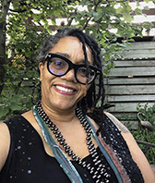
Francesca T. Royster is a native of Chicago’s South Side and a professor of English literature at DePaul University in Chicago, where she teaches classes on African American literature and culture, Shakespeare, and gender and queer theory. She is the author of two academic books,Becoming Cleopatra: The Shifting Image of an Icon and Sounding Like a No-No: Queer Sounds and Eccentric Acts in the Post-Soul Era. She received her PhD in English literature from the University of California, Berkeley. Her essays have appeared in the Los Angeles Review of Books, Chicago Literati, and Feminist Studies, among others. She lives in Chicago.

谢谢您的阅读！
请将回馈信息发至：萧涵糠(Connie Xiao)
安德鲁﹒纳伯格联合国际有限公司北京代表处
北京市海淀区中关村大街甲59号中国人民大学文化大厦1705室, 邮编：100872
电话：010-82449325
传真：010-82504200
Email: Connie@nurnberg.com.cn
网址：www.nurnberg.com.cn
微博：http://weibo.com/nurnberg
豆瓣小站：http://site.douban.com/110577/
微信订阅号：ANABJ2002


