图 书 推 荐

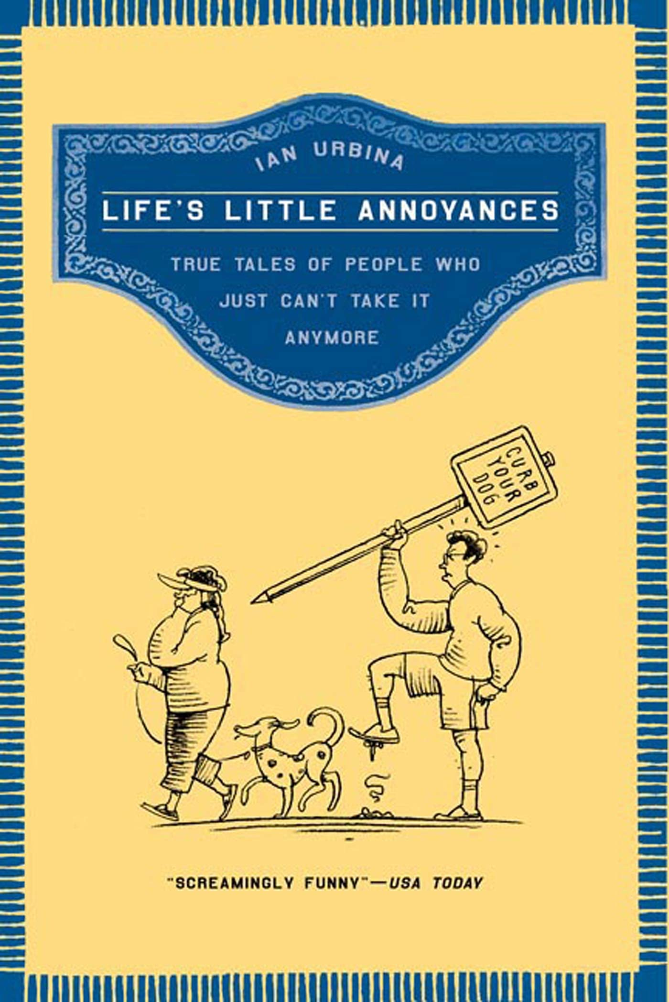
中文书名：《忍受生活中的小烦恼：忍无可忍后发生的真实故事》
英文书名：LIFE’S LITTLE ANNOYANCES: True Tales of People who Just Can’t take it anymore
作 者：Ian Urbina
出 版 社：Times Books
代理公司：Fletcher/ANA/Claire Qiao
页 数：191页
出版时间：2005年11月
代理地区：中国大陆、台湾
审读资料：电子稿
类 型：非小说

内容简介：

忍受生活中令人恼怒的事情，终于到了爆发，这种情况下会发生什么有趣的事情呢？记者伊恩·乌尔维纳（Ian Urbina）将这些事情一一记录下来，并揭示了一些巧妙的方法用以小小地报复这些讨人厌的家伙：电话营销人员、公共场合大声打手机的人、发垃圾邮件发送的人等等，而且这些报复往往多举并行，多管齐下。

作者简介：

伊恩·乌尔维纳（Ian Urbina）是《纽约时报》驻华盛顿分社的记者。他有乔治敦大学和芝加哥大学的历史学学位，作品涵盖国内外政策和日常生活，时常发表在《洛杉矶时报》（Los Angeles Times）、《卫报》（The Guardian）、《哈珀》（Harper's）和其他刊物上。他和妻子、儿子、继女、狗住在华盛顿特区。

媒体评价：

“有趣到让人尖叫！”
——《今日美国》（USA Today）

“一个因果报应性行动纲领、一本极端情况下的礼仪指南，一本生存于现代不文明中的应急避险手册。”
——《多伦多环球邮报》（Toronto Globe and Mail）

LIFE’S LITTLE ANNOYANCES

INTRODUCTION xi

CHAPTER I. WEAPONS OF THE WEAK
Who Turned This Thing On, Anyway? 4
Honk If You Hate This Store 6
A Dog Owner's Ultimate Crime 7
When Pledge Drives Get in the Way 9
Breaking into Fort Knox Is Easier 11
Honku 12
A Gentle Way to Tell Someone to Get Lost 15
When Flying Becomes a Test of Wills and Wits 18

CHAPTER 2. SERVICE WITH A SNARL 23
"No, Seriously, I'm Just Browsing, Thanks" 26
A Medium Coffee, Hold the Lingo 28
Delocator 31
Confusing the Supermarket Spies 33
Breaking Their Script 36
Cheating the Express Aisle 40
Truth or Dare in Credit Card Signatures 41
Road Rage in the Supermarket Aisle 44
The Cashier's Spelling Bee 45

CHAPTER 3. OCCUPATIONAL HAZARDS 47
Using Instant Messenger for Sabotage 50
The Art of Demotivation 52
The Job Application Letter 54
The Cell Phone Prison 57
The Rejection Rejection Letter 58
Bone Appetit 60Putting Directory Assistance in Slow Motion 98
Treat Me Like I'm Crazy and I'II Act Like It 100
Why Should They Be the Only Ones Recording
Our Conversations? 102

CHAPTER 6. VEHICULAR MISANTHROPY 105
Guerrilla Warfare in the Parking Lot 108
Since Slamming on the Brakes Is Not an Option 111
The Parking Meter Fairies 114
Stuttering at Stop Signs 117
When Bumpers Become Pulpits 119
Make Yourself the Delivery 121

CHAPTER 7. RAGE AGAINST THE MACHINE 123
Urgent and Confidential 126
Putting Spammers on the Receiving End 131
Mad Libs as Revenge Tool 133
The Beauty of Wrong Turns on the
Information Superhighway 135
The Invisible Hand 137
When Common Sense Stops at the Wrist 139
The Legal Implications of Just Saying "Hi" 143
Return to Sender 146

CHAPTER 8. BILLS, BANKS, AND BILE 149
Unbalancing the Books 152
Like Kryptonite for Bank Checks 154
Making the Late-Payment Notice Work for You 156
Giving His Two Cents and Getting Something Back 157
When Frustration Becomes a Class Project 160
No Comment 162
The Little Jab That Woke Up a Goliath 163

CHAPTER 9. TURNABOUT IS FAIR PLAY 167
Regifting as Tactic and Annoyance 170
Forgetting to Turn Off the Alarm Clock 172
The Reminder Call 174
Reversing the Language Snobbery 176
Love Thy Neighbor, When He Is Quiet 177
Pay Now or Pay Later 180
Car Horns That Double as Doorbells 182
Jehovah's Witness, Meet Hari Krishna 183
Crashing the Party 185

EPILOGUE 187
A NOTE TO THE READER 189
ACKNOWLEDGMENTS 191

谢谢您的阅读！
请将反馈信息发至： 乔明睿（Claire）
安德鲁﹒纳伯格联合国际有限公司北京代表处
北京市海淀区中关村大街甲59号中国人民大学文化大厦1705室, 邮编：100872
电话：010-82449026
传真：010-82504200
手机：15804055576
Email: Claire@nurnberg.com.cn
网址：www.nurnberg.com.cn
微博：http://weibo.com/nurnberg
豆瓣小站：http://site.douban.com/110577/
微信订阅号：ANABJ2002

