新 书 推 荐
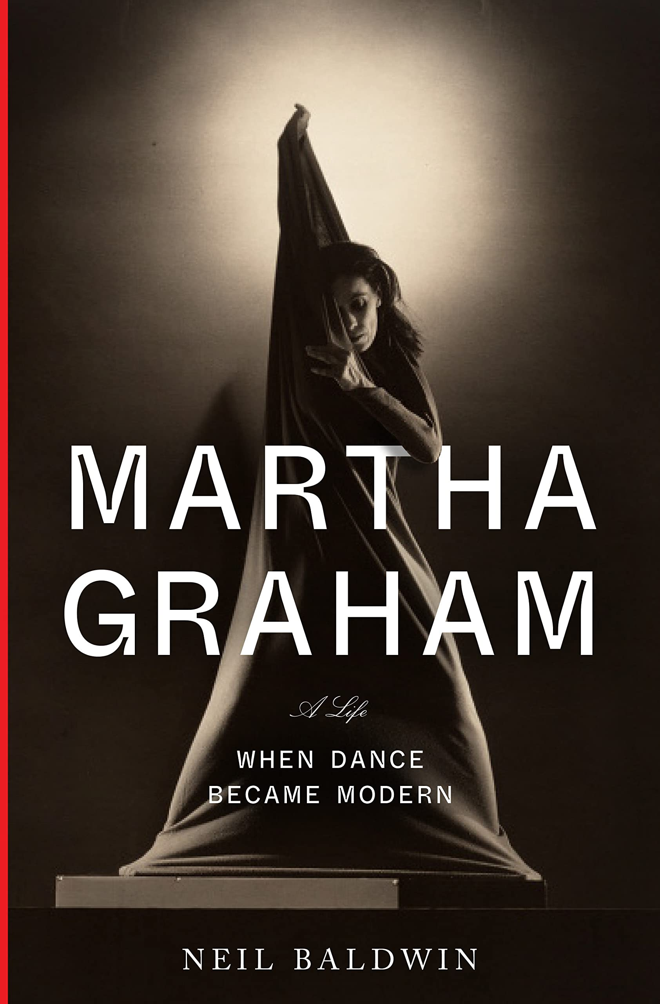
中文书名：《玛莎·葛兰姆：当舞蹈走向现代》
英文书名：MARTHA GRAHAM: When Dance Become Modern
作 者：Neil Baldwin
出 版 社：Knopf
代理公司：WME/ANA/Lauren Li
页 数：576页
出版时间：2022年10月
代理地区：中国大陆、台湾
审读资料：电子稿
类 型：传记和回忆录

内容简介：

这本书深入探讨了一位舞蹈先驱的生活，她几乎是凭空塑造了现代舞蹈，创作了永远展望未来的不朽之作。然而，《玛莎·葛兰姆》不仅仅会吸引现代舞的粉丝；更会吸引那些寻找沉浸式的历史、精心制作的传记、或关于艺术创作的励志故事的人。

玛莎·葛兰姆（Martha Graham）是一位传奇舞蹈家和编舞家。她颠覆了舞蹈，将这种艺术形式推向了现代，至今仍给人们带来深远和开创性的影响。她的技巧被世界各地的舞蹈公司采用，成为古典芭蕾舞风格的第一个长期替代。葛兰姆的先锋运动，加上她独特的训练体系，是现代主义的缩影。60多年来，她编导了180多部作品，这些作品始终令人惊叹、鼓舞人心。

在《玛莎·葛兰姆》（Martha Graham）中，鲍德温带领我们从她的童年到成为异域风格芭蕾舞明星，再到32岁时创办自己的舞蹈公司（至今仍在运营）。他描绘了在20世纪中叶，纽约的文艺领域爆发式增长的背景下，该公司是如何蓬勃发展的。他讲述了她伟大而波澜壮阔的人生，她被冲突、竞争和孤独所困扰，也充满了热情和灵感、动力、激情、奉献精神，以及在工作和舞蹈创作中的牺牲。

作者简介：

尼尔·鲍德温（Neil Baldwin）是著名的文化历史学家、传记作家和获奖作家。他目前是蒙克莱尔州立大学（Montclair State University）戏剧与舞蹈系的教授，也是该校舞蹈档案馆的创始人和馆长。

媒体评价：

“Mesmerizing… The trailblazing Graham seemingly sculpted modern dance out of thin air, creating indelible works like Heretic, Lamentation, and Primitive Mysteries, always looking to the future. Provocative and passionate as the dynamo herself, this richly detailed and insightful page-turner will delight dance aficionados.”
----Publishers Weekly (starred)

“Neil Baldwin’s majestic biography of Martha Graham comes at a time in these comic book days when our souls need to be inspired by the austere passion of this American pioneer, this fanatical ‘prophetess’, whose dances unleashed primitive sacred energies in the earth and created a new vocabulary for the human body. Baldwin’s meticulously researched, immensely readable biography puts Graham shoulder to shoulder with those other avatars of the Modern, Frank Lloyd Wright and Gertrude Stein, who created frontiers that still demand exploration.”
----John Guare

“Comprehensive and engaging . . . Baldwin includes detailed descriptions of specific recitals, Graham’s jersey-fabric dance wear, the lives of her dance colleagues (Ruth St. Denis; Ted Shawn; Lincoln Kirstein) and artists of the time (sculptor Isamu Noguchi; composer Aaron Copland). Side trips into Graham’s sometimes-complicated personal life broaden the book’s appeal.”
----Kirkus Reviews

“Neil Baldwin’s definitive biography of pioneering dancer Martha Graham is a compelling and brilliant study of a complicated, dedicated woman who gave everything she had to modern dance. Baldwin reminds us what a modernist Graham was: she brought dance directly from the domination of ballet into a modern American idiom. Baldwin brings his incisive knowledge of the stars in the panoply of modernism—from Mabel Dodge Luhan to Lincoln Kirstein—to a dramatic narrative of Graham’s development and success. Just as Graham made the many parts of a modern dance piece, from music to costumes, and, of course, her own brilliant vison for the piece, and performance--work together, so Neil Baldwin brings together all the elements of Graham’s colorful life, writing with wit, verve, critical discernment, and a powerful lyricism. I greatly enjoyed this book and learned a lot.”
----Mary Dearborn

谢谢您的阅读！
请将反馈信息发至：李文浩（Lauren Li）
安德鲁·纳伯格联合国际有限公司北京代表处
北京市海淀区中关村大街甲59号中国人民大学文化大厦1705室
邮编：100872
电话：010-82449901
传真：010-82504200
Email：Lauren@nurnberg.com.cn
网址：http://www.nurnberg.com.cn
微博：http://weibo.com/nurnberg
豆瓣小站：http://site.douban.com/110577/
新浪微博：安德鲁纳伯格公司的微博_微博 (weibo.com)
微信订阅号：ANABJ2002


