新 书 推 荐

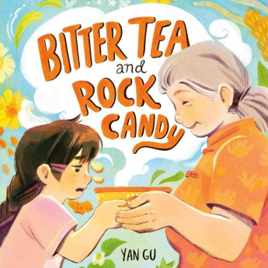
中文书名：《苦茶与冰糖》
英文书名：BITTER TEA AND ROCK CANDY​
作 者：Yan Gu
出 版 社：Henry Holt BYR
代理公司：SJGA/ANA
页 数：40页
出版时间：2025年9月
代理地区：中国大陆
审读资料：电子稿
类 型：故事绘本

- 生动描绘了隔代亲情与爱的不同表达方式，触及了“接纳不同口味”、“尝试新事物”以及“理解与共情”等普世成长主题。
- 在温情叙事中自然融入了中国文化元素，为海内外读者提供了了解中国家庭传统与生活哲学的亲切窗口。

内容简介：

A humorous and heartfelt tale about the bitterness of liangcha, a popular tea from traditional Chinese medicine, and the sweetness of a Waipo (grandmother).

This tender and warm picture book is a touching ode to grandparents and family traditions—even picky eating.

Mimi's Waipo loves liangcha, but Mimi thinks her grandmother's favorite tea is just too bitter.

It burns her lips, it tastes sour on her tongue, and it smells like her grandfather's socks—yuck!

Mimi secretly feeds her liangcha to the fish, and hides it in a plant, and pours it down the sink—anything to avoid drinking it again. But Waipo has an idea. One morning, she makes a new batch of liangcha for them to share. Will Waipo's secret ingredient be enough to win Mimi over?

This book is about two different flavors of love. Other marketing points: a little knowledge about TCM (traditional Chinese medicine), and intergenerational love between a grandmother and granddaughter. Not to mention: gorgeous illustrations.

媒体评论：

"A great story for libraries looking for representation of Chinese culture, of intergenerational relationships, and of trying new things; it's also something of an ode to the fact that grandmothers were once young"—School Library Journal

"Warm peachy and yellow tones cast a cozy glow over this multigenerational exchange of a culturally specific family tradition...A stirring addition to the rapidly expanding collection of diverse food stories."—Booklist

"The depiction of affection between a grandparent and grandchild and the importance of empathy . . . are universal. A heartwarming tribute to intergenerational connection."—Kirkus

作者简介：

Yan Gu is an illustrator from Shanghai. She graduated from RISD in 2022. In her free time, she loves plein-air painting. A BOWL OF BITTER TEA AND A PIECE OF ROCK CANDYis her first picture book.

内页插图：
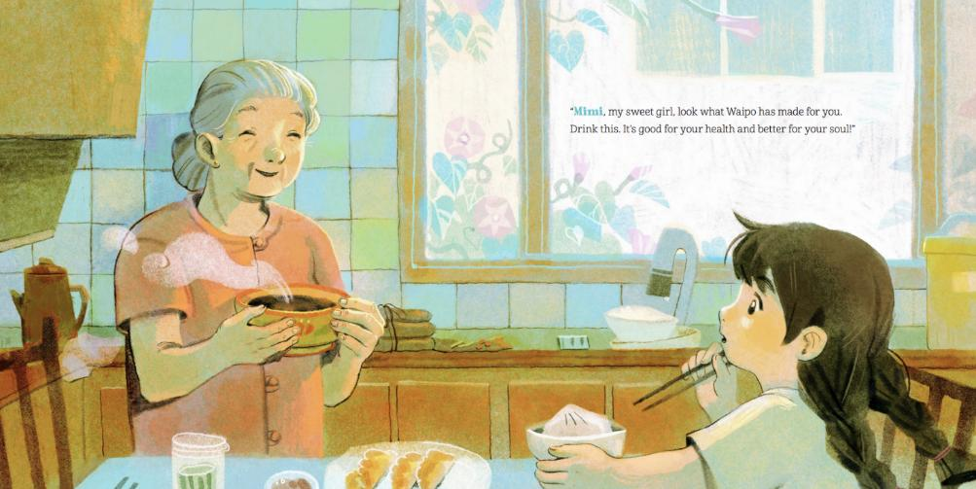

请将反馈信息发至：版权负责人
Email：Rights@nurnberg.com.cn
安德鲁·纳伯格联合国际有限公司北京代表处
北京市海淀区中关村大街甲59号中国人民大学文化大厦1705室, 邮编：100872
电话：010-82504106, 传真：010-82504200
公司网址：http://www.nurnberg.com.cn
书目下载：http://www.nurnberg.com.cn/booklist_zh/list.aspx
书讯浏览：http://www.nurnberg.com.cn/book/book.aspx
视频推荐：http://www.nurnberg.com.cn/video/video.aspx
豆瓣小站：http://site.douban.com/110577/
新浪微博：安德鲁纳伯格公司的微博_微博 (weibo.com)
微信订阅号：安德鲁纳伯格联合国际北京代表处

