新 书 推 荐

中文书名：《卡车会滚动》（Hello!Lucky 动手互动书）
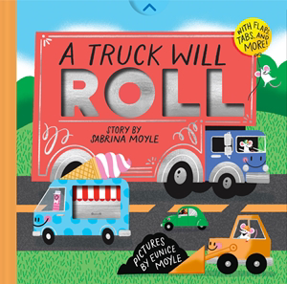
英文书名：A Truck Will Roll(A Hello!Lucky Hands-On Book)
作 者：Sabrina Moyle and Eunice Moyle
出 版 社：Abrams
代理公司：Abrams/ANA
页 数：14页
出版时间：2026年8月
代理地区：中国大陆
审读资料：电子稿
类 型：故事绘本

- 醒目插图：全书采用第五种专色油墨设计印刷，封面烫印闪亮银箔，整体包装极具视觉吸引力。
- 卓越销量：Hello!Lucky 系列累计销量超过200万册！姊妹书《一颗种子会成长！》(A Seed Will Grow) 目前已售出超过22,000册。
- 强大粉丝基础：Hello!Lucky 在 Instagram 上拥有超过75,000名粉丝，在 Pinterest 上拥有近70,000名粉丝。
- 豪华互动式纸板书：向小读者介绍多种卡车——准确来说共有25种！——并以一个精彩的四折页大拉页作结，展开后呈现一个热闹的乡村集市场景，所有卡车与司机都参与了建设。通过挖掘、运输大量货物以及整理收尾，不同类型的卡车在每一跨页中依次亮相。读者会喜欢寻找各种专业车辆，从邮政卡车到垃圾车，再到冰淇淋车。
- 特别机关设计：每一页都包含互动元素（如可转动车轮、拉页标签或可掀翻页），非常适合好奇的小手操作。巧妙的互动设计，如可转动车轮、拉页标签以及多个可掀起的翻页，让读者看到每辆卡车内部的货物，展现从“货物”到“节庆”的转变过程。结尾为壮观的四联展开大场景。

内容简介：

From Sabrina and Eunice Moyle—also known as Hello!Lucky—the superstar creators of My Mom is Magical! and My Dad is Amazing! comes a brand–new novelty board book for little truck lovers, with tabs to pull and wheels to turn.

Dump trucks move dirt into piles.

Trucks haul goods for miles and miles!

Filled with exuberant illustrations in Hello!Lucky’s inimitable style, A Truck Will Roll is a deluxe, interactive board book that introduces young readers to a wide variety of trucks—25 to be exact!—and ends with a brilliant quadruple gatefold that opens up to showcase a bustling county fair that all the trucks and their drivers have helped to build.

With a little digging, a lot of cargo carrying, and a good bit of tidying up, different trucks are highlighted on every spread. Readers will love spotting all the specialized vehicles, from mail trucks to garbage trucks to ice–cream trucks. Clever interactive elements such as wheels, pull–tabs, and multiple flaps that readers can lift to reveal the cargo inside each truck, highlight the cargo–to–festival transformation. A fifth color of construction–site orange ink throughout as well as shiny chrome–colored foil on the front cover are sure to catch the eye of truck–loving kids and educators alike!

作者简介：

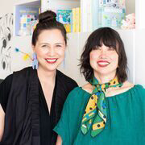
Hello!Lucky is all about using creativity to spread joy, fun, and kindness. Founded by sisters Eunice and Sabrina Moyle in 2003, Hello!Lucky is an award–winning letterpress greeting card and design studio working with dozens of partners to create products, including Abrams’ pun–derful children’s books: My Mom Is Magical!; My Dad Is Amazing!; My Grandma Is Great!; My Grandpa Is Grand!; My Brother Is the Best!; My Sister Is Super!; Super Pooper and Whizz Kid: Potty Power!; Kindness Rules!; Christmas Is Awesome!; Sloth and Smell the Roses; Go Get ‘Em, Tiger!; Thanks a Ton!; School Is Cool!; Bananas for You!; Halloween Is a Treat!; A Seed Will Grow!; You Are Fantastic!; Preschool is Cool!; Easter is Egg–cellent!; My Box of Feelings, and the Astrid and Stella graphic novel series. They also offer gifts, ceramics, stationery, kids’ partyware, and more. Hello!Lucky is based in San Francisco. Find them @helloluckykids.

内页插图：
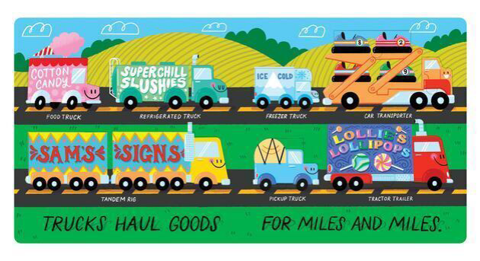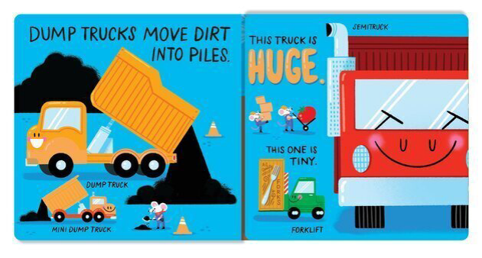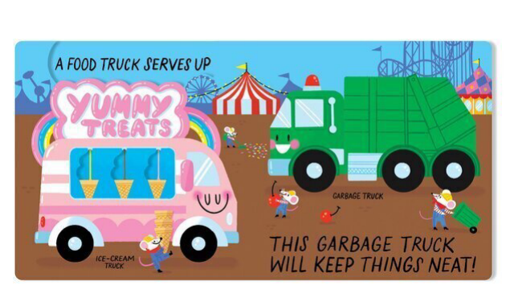

请将反馈信息发至：版权负责人
Email：Rights@nurnberg.com.cn
安德鲁·纳伯格联合国际有限公司北京代表处
北京市海淀区中关村大街甲59号中国人民大学文化大厦1705室, 邮编：100872
电话：010-82504106, 传真：010-82504200
公司网址：http://www.nurnberg.com.cn
书目下载：http://www.nurnberg.com.cn/booklist_zh/list.aspx
书讯浏览：http://www.nurnberg.com.cn/book/book.aspx
视频推荐：http://www.nurnberg.com.cn/video/video.aspx
豆瓣小站：http://site.douban.com/110577/
新浪微博：安德鲁纳伯格公司的微博_微博 (weibo.com)
微信订阅号：安德鲁纳伯格联合国际北京代表处

