新 书 推 荐

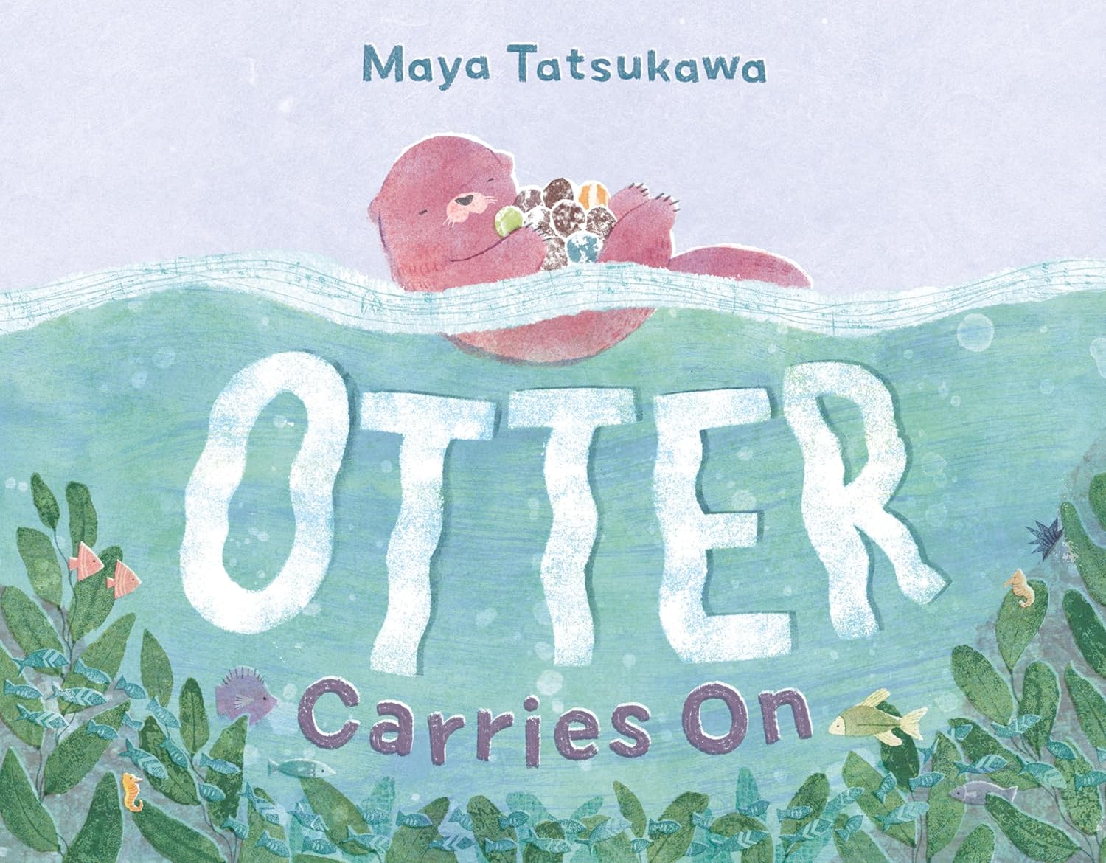
中文书名：《水獭继续前行》
英文书名：OTTER CARRIES ON
作 者：Maya Tatsukawa
出 版 社：Holt Books for Young Readers
代理公司：SJGA/ANA
页 数：40页
出版时间：2025年2月
代理地区：中国大陆、台湾
审读资料：电子稿
类 型：知识绘本
版权已授：韩国 (Greatbooks)

- 本书出自西奥多·苏斯·盖泽尔奖(Theodore Seuss Geisel Award)获奖作品《我家有只熊》(THE BEAR IN MY FAMILY)作者之手。作者作品还有《水獭继续前行》(OTTER CARRIES ON)与《鼹鼠并不孤单》(MOLE IS NOT ALONE)。
- 本书讲述了一只固执的水獭、在试图独自完成一切的过程中学到宝贵一课的故事。
- 配以精美的海底插图、温馨的叙事以及一群惹人喜爱的角色，这本甜美而动人的图画书向读者展示：向朋友寻求帮助是完全可以的。

内容简介：

In this gentle and encouraging picture book, an independent Otter learns to ask for help after getting lost at sea.

Otter loves floating and collecting pretty, heavy rocks all by themself. When a storm comes, Otter has so many rocks that they can't swim home―and soon, they're lost at sea. But when a few rocks accidentally slip away, Otter feels...lighter. And with the help of a new friend, Otter realizes that maybe they don't need to carry everything alone.

With gorgeous undersea illustrations, cozy storytelling, and a group of lovable characters, this sweet and beautiful picture book shows readers that it's okay to ask for help from a friend.

媒体评论：

"An ocean of tiny details, depicted in a soft palette of grays, blues, and greens ... visually immersive." ―Kirkus

"The graceful movement of waves and water, speech balloons that present the story in dialogue, and the low fear factor... all enliven this buoyant story about accepting the advice of others versus finding out for oneself." ―Publishers Weekly

"Important lessons gently delivered with animals and serene artwork is Tatsukawa’s forte, and she has excelled at it once more via this absurdly cute otter protagonist."―BCCB

作者简介：

Maya Tatsukawa is a children’s book illustrator and designer residing just out of Boston with her cat/studio manager. When she's not designing, illustrating, or thinking about children's books, you can find her baking cream puffs, eating ice cream, or searching for the perfect scone. She is the author and illustrator of Sunday Pancakes and The Bear in My Family.

内页插图：

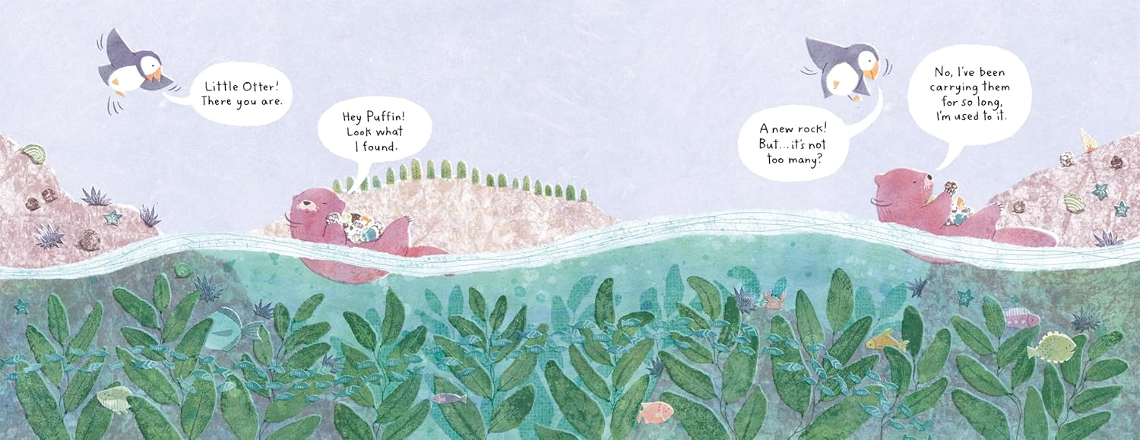
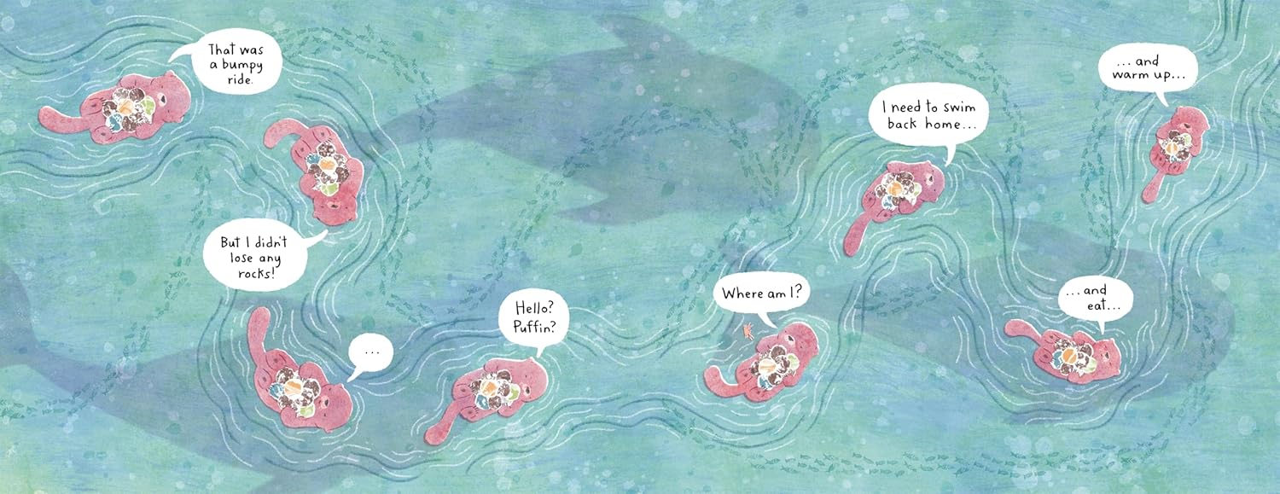
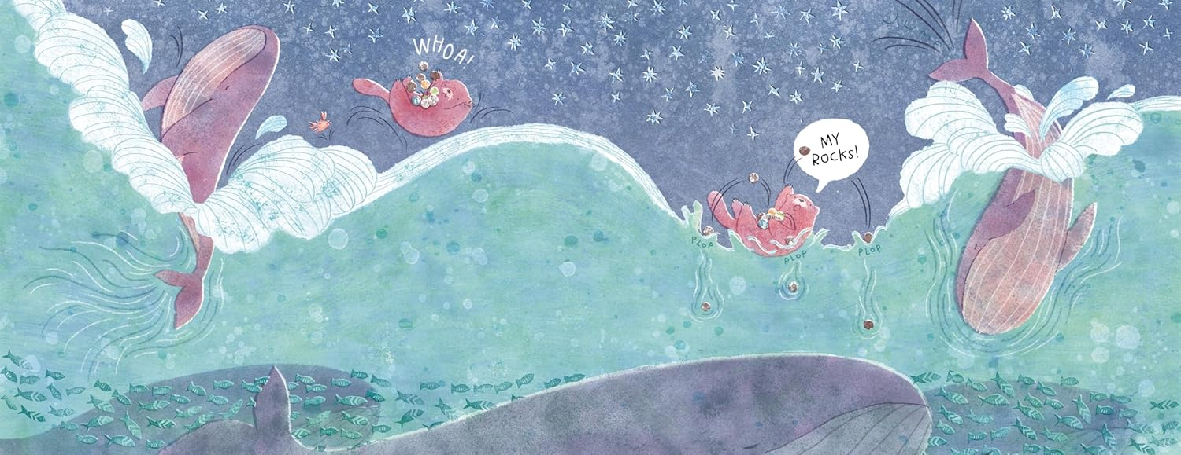
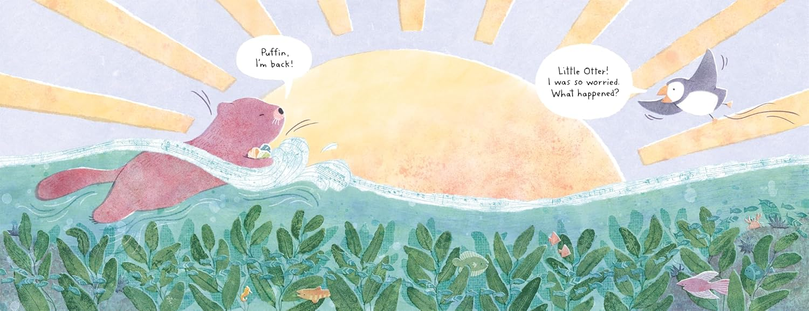

请将反馈信息发至：版权负责人
Email：Rights@nurnberg.com.cn
安德鲁·纳伯格联合国际有限公司北京代表处
北京市海淀区中关村大街甲59号中国人民大学文化大厦1705室, 邮编：100872
电话：010-82504106, 传真：010-82504200
公司网址：http://www.nurnberg.com.cn
书目下载：http://www.nurnberg.com.cn/booklist_zh/list.aspx
书讯浏览：http://www.nurnberg.com.cn/book/book.aspx
视频推荐：http://www.nurnberg.com.cn/video/video.aspx
豆瓣小站：http://site.douban.com/110577/
新浪微博：安德鲁纳伯格公司的微博_微博 (weibo.com)
微信订阅号：安德鲁纳伯格联合国际北京代表处

