新 书 推 荐
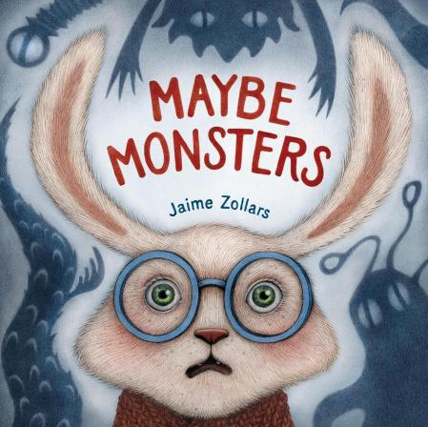
中文书名：《也许有怪兽》
英文书名：MAYBE MONSTERS
作 者：Jaime Zollars
出 版 社：Little Brown
代理公司：Little Brown
页 数：48页
出版时间：2026年9月
代理地区：中国大陆、台湾
审读资料：电子稿
类 型：故事绘本

对未知的预想与焦虑，往往比现实本身更可怕
本书描绘了小兔子西蒙被迫走出家门、勇敢面对未知世界所带来的各种可能性与挑战
这不仅是一本适合大声朗读的趣味绘本
更能帮助那些容易紧张不安的小读者们理解一个道理——
走出舒适区，既能带来紧张感，也能创造激动人心的全新体验

内容简介：

An anxious rabbit imagines all kinds of scary maybes outside his front door...until he discovers an unexpected world of wonders.

Simon is comfortable in his quiet house, surrounded by familiar sounds, smells, and sights. Outside is another story. Outside, he imagines all the awful maybes that could be lurking in the unknown: Bullies! Rattlesnakes! Martians! But when Simon is forced to venture from his home, he sees that not everything is quite what he expected. If the worst thing ever is out there waiting for him, maybe the best thing ever is, too?

In this richly illustrated story about expectations and embracing new experiences, Jaime Zollars offers young readers a way to explore feelings of uncertainty—and reminds them that what if? is a question with many happy answers.

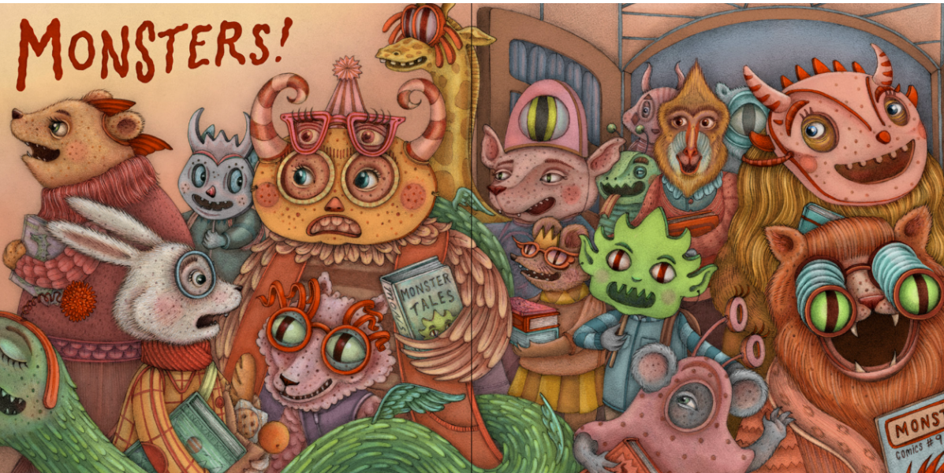

作者简介：

Jaime Zollars is the creator of The Truth About Dragons and the illustrator of The Night Frolic. Her art has been recognized by American Illustration, Communication Arts, the Society of Illustrators, and the Society of Children’s Book Writers and Illustrators, among others. She lives in Southern California.

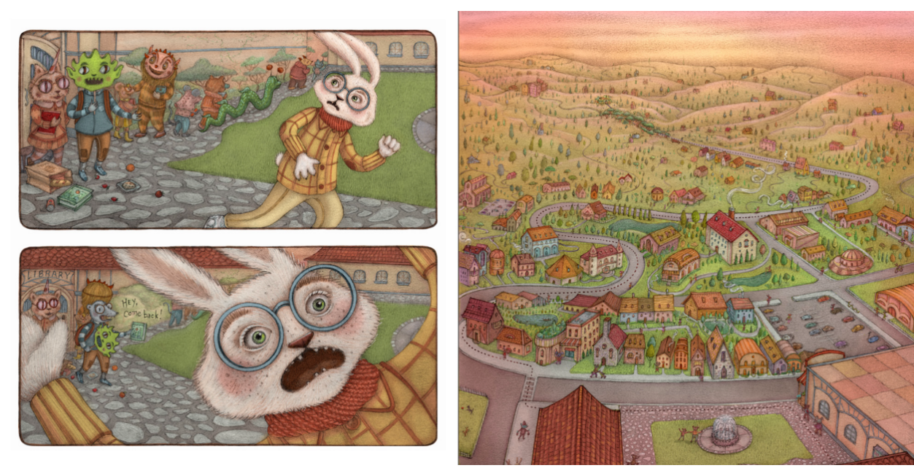

请将反馈信息发至：版权负责人
Email：Rights@nurnberg.com.cn
安德鲁·纳伯格联合国际有限公司北京代表处
北京市海淀区中关村大街甲59号中国人民大学文化大厦1705室, 邮编：100872
电话：010-82504106, 传真：010-82504200
公司网址：http://www.nurnberg.com.cn
书目下载：http://www.nurnberg.com.cn/booklist_zh/list.aspx
书讯浏览：http://www.nurnberg.com.cn/book/book.aspx
视频推荐：http://www.nurnberg.com.cn/video/video.aspx
豆瓣小站：http://site.douban.com/110577/
新浪微博：安德鲁纳伯格公司的微博_微博 (weibo.com)
微信订阅号：安德鲁纳伯格联合国际北京代表处

