新 书 推 荐

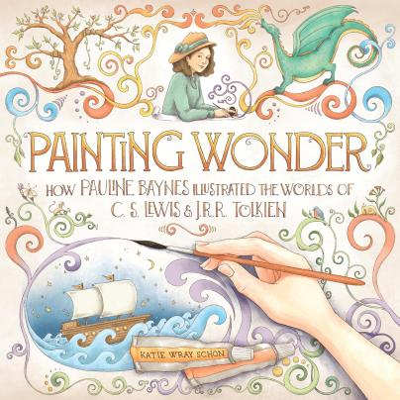
中文书名：《绘出奇迹》
英文书名：Painting Wonder
作 者：Katie Wray Schon
出 版 社：Waxwing Books
代理公司：Transatlantic/ANA
页 数：48页
出版时间：2025年4月
代理地区：中国大陆
审读资料：电子稿
类 型：故事绘本

- 这是一部迷人的图画书传记，讲述了那位让C. S. Lewis与J. R. R. Tolkien作品世界栩栩如生的插画家。

内容简介：

Just in time for the 75th anniversary of The Lion, the Witch, and the Wardrobe comes Painting Wonder, an enchanting picture book biography about the artist whose illustrations brought the worlds of C. S. Lewis and J. R. R. Tolkien to life.

Young Pauline Baynes lives in India, a land of towering mountains, sparkling lakes, and bright flowers. She even has a pet monkey that joins her for tea.

Then her life takes a turn, and Pauline is sent to dreary England. Books bring light and color to her world, so she sets out to paint the stories she loves. Years later, two iconic authors see her paintings and know she’s the illustrator for their stories―of fire-breathing dragons, towering giants, a golden lion, and four brave children.

Follow Pauline into some of the most beloved and prominent landscapes in all of children’s literature: the magical lands of J.R.R. Tolkien and C. S. Lewis.

媒体评论：

★ “It’s a beautiful tribute. An accessible and inspiring mini-biography, delightfully illustrated.” ---- Kirkus Reviews (Starred Review)

作者简介：
Katie Wray Schon is an author/illustrator who loves making beautiful books. She grew up in RhodeIsland, but now lives in Texas, where she can usually be found with a paintbrush in hand. She has awonderful husband and three inspiring children. Together they love art, biking, and reading booksabout magical lands.

内页插图：

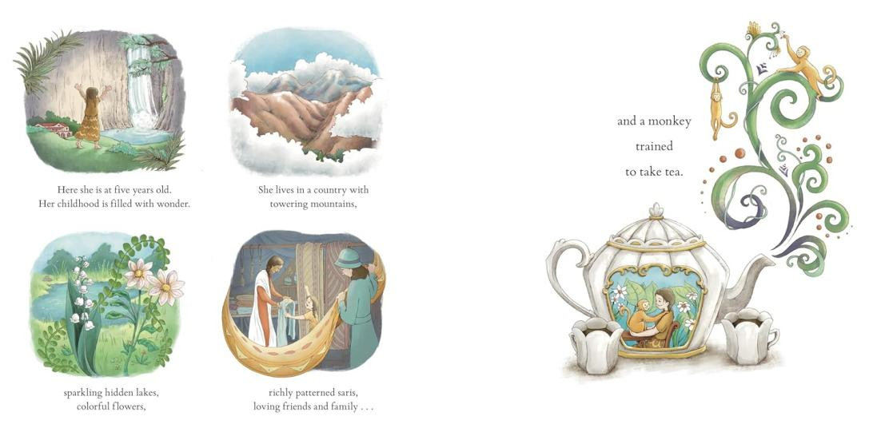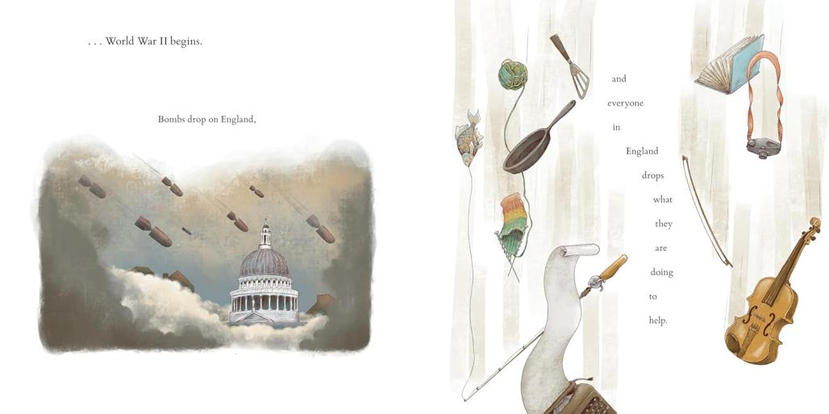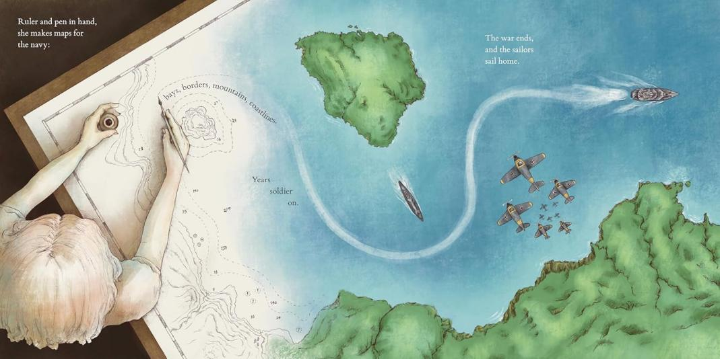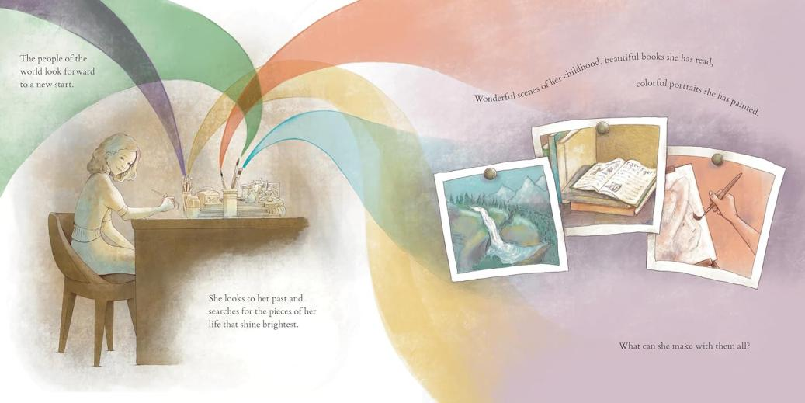

请将反馈信息发至：版权负责人
Email：Rights@nurnberg.com.cn
安德鲁·纳伯格联合国际有限公司北京代表处
北京市海淀区中关村大街甲59号中国人民大学文化大厦1705室, 邮编：100872
电话：010-82504106, 传真：010-82504200
公司网址：http://www.nurnberg.com.cn
书目下载：http://www.nurnberg.com.cn/booklist_zh/list.aspx
书讯浏览：http://www.nurnberg.com.cn/book/book.aspx
视频推荐：http://www.nurnberg.com.cn/video/video.aspx
豆瓣小站：http://site.douban.com/110577/
新浪微博：安德鲁纳伯格公司的微博_微博 (weibo.com)
微信订阅号：安德鲁纳伯格联合国际北京代表处

