新 书 推 荐

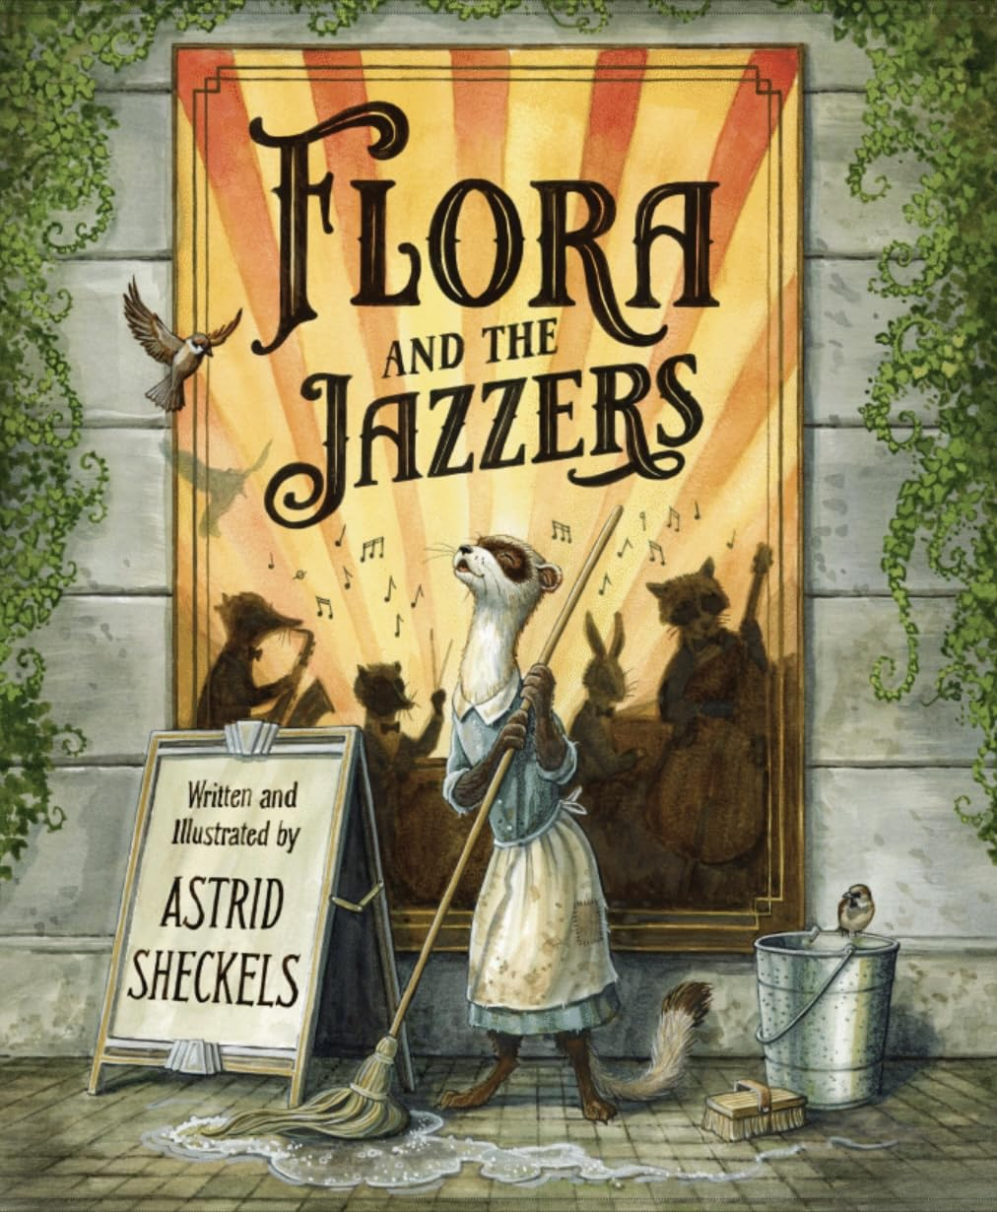
中文书名：《芙洛拉与爵士乐手》
英文书名：Flora and the Jazzers
作 者：Astrid Sheckels
出 版 社：Waxwing Books
代理公司：Transatlantic/ANA
页 数：40页
出版时间：2025年10月
代理地区：中国大陆
审读资料：电子稿
类 型：故事绘本
版权已授：北美英语(Waxwing Books)、乌克兰语(Chitarium LLC)

入选亚马逊2025年度最佳儿童图书之一
- 《芙洛拉与爵士乐手》是一部画面华丽、以“爵士时代”为背景的“灰姑娘”式故事，讲述了一颗不会被压抑的心——以及一个不会被压制的声音，由Astrid Sheckels创作并绘制。

内容简介：

What will become of the music in Flora’s heart?

Flora the ferret longs to attend a concert someday, but she is only a lowly scullery maid. She must save every penny. When she discovers that the Jazzers, her favorite band, are performing at the hotel where she works, Flora is determined to hear them. But her manager forbids her from going. “Music is not for someone like you,” he tells her.

It turns out, however, that the Jazzers have a problem, and Flora might be just the one to help.

Flora and the Jazzers is a lush, Jazz Age Cinderella story about a heart–and a voice–that won’t be silenced, written and illustrated by Astrid Sheckels.

媒体评论：

"A sumptuously illustrated Jazz Age Cinderella story." - Kirkus Reviews (starred review)

"A triumph of hope, heart, and harmony―a picture book to treasure." - The Children's Book Review

作者简介：
Astrid Sheckels spent her childhood playing outside, using her imagination, and drawing, especiallypictures of well-dressed animals. She lives in Massachusetts and is the author and illustrator ofnumerous books, including the award-winning Hector Fox and Friends picture book series.

内页插图：

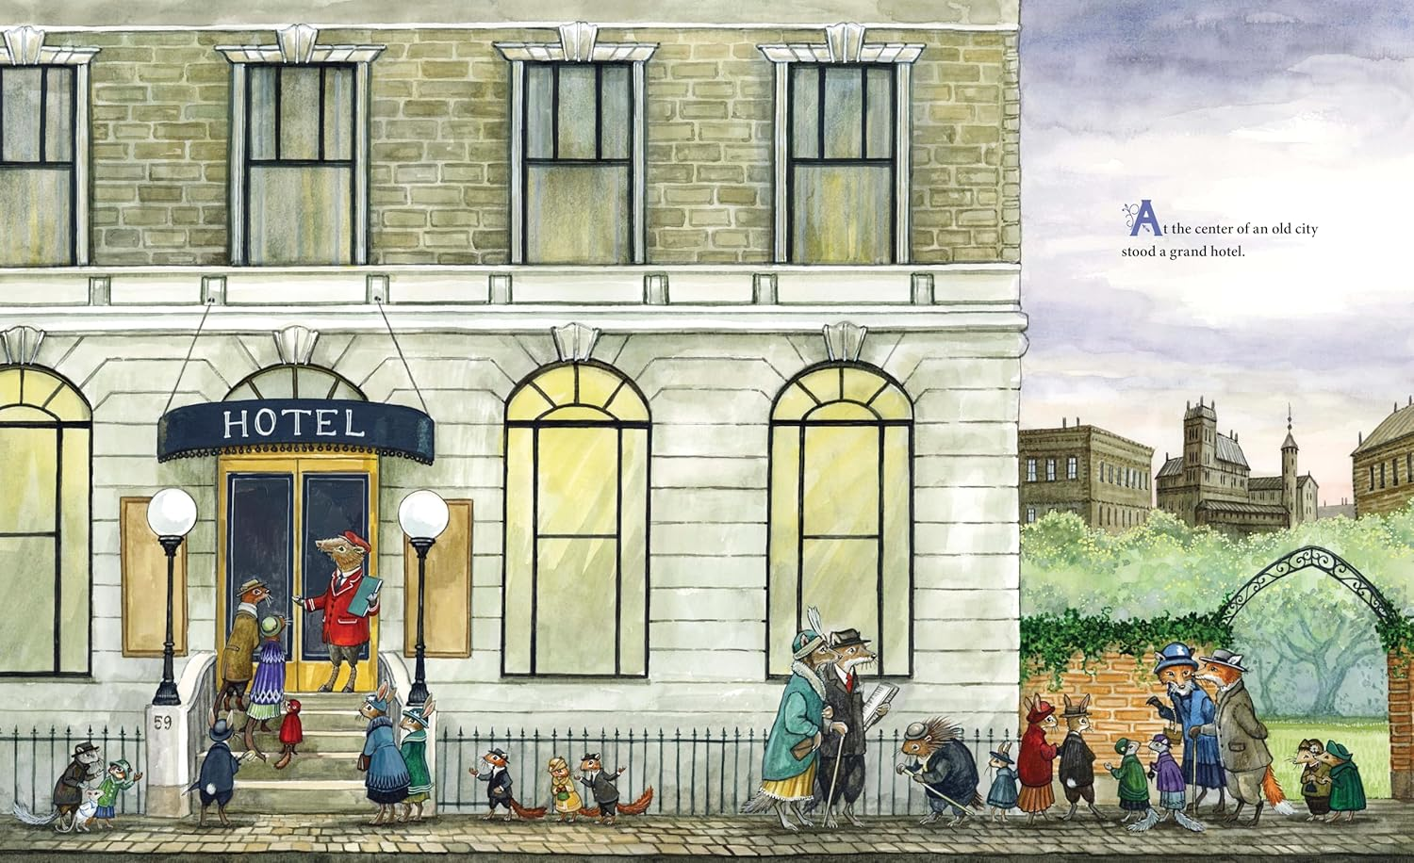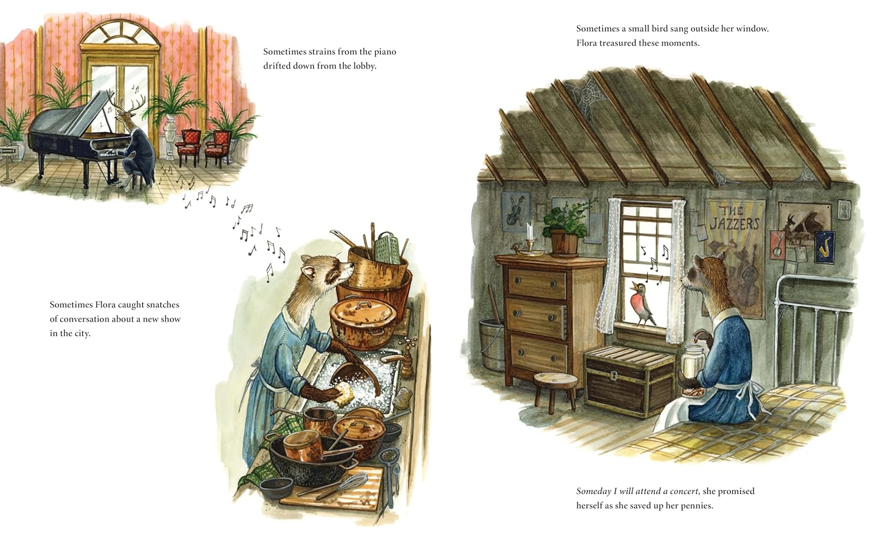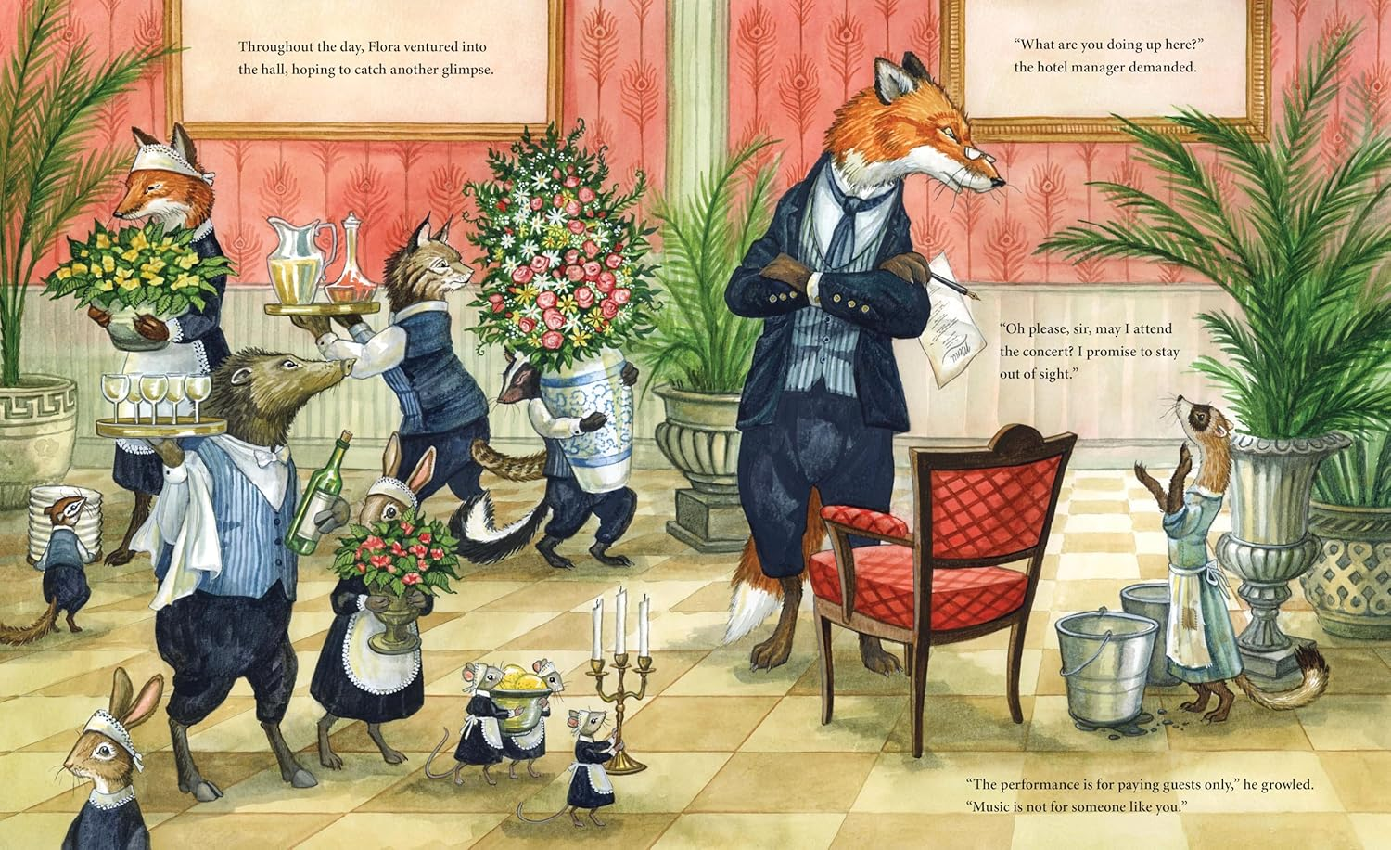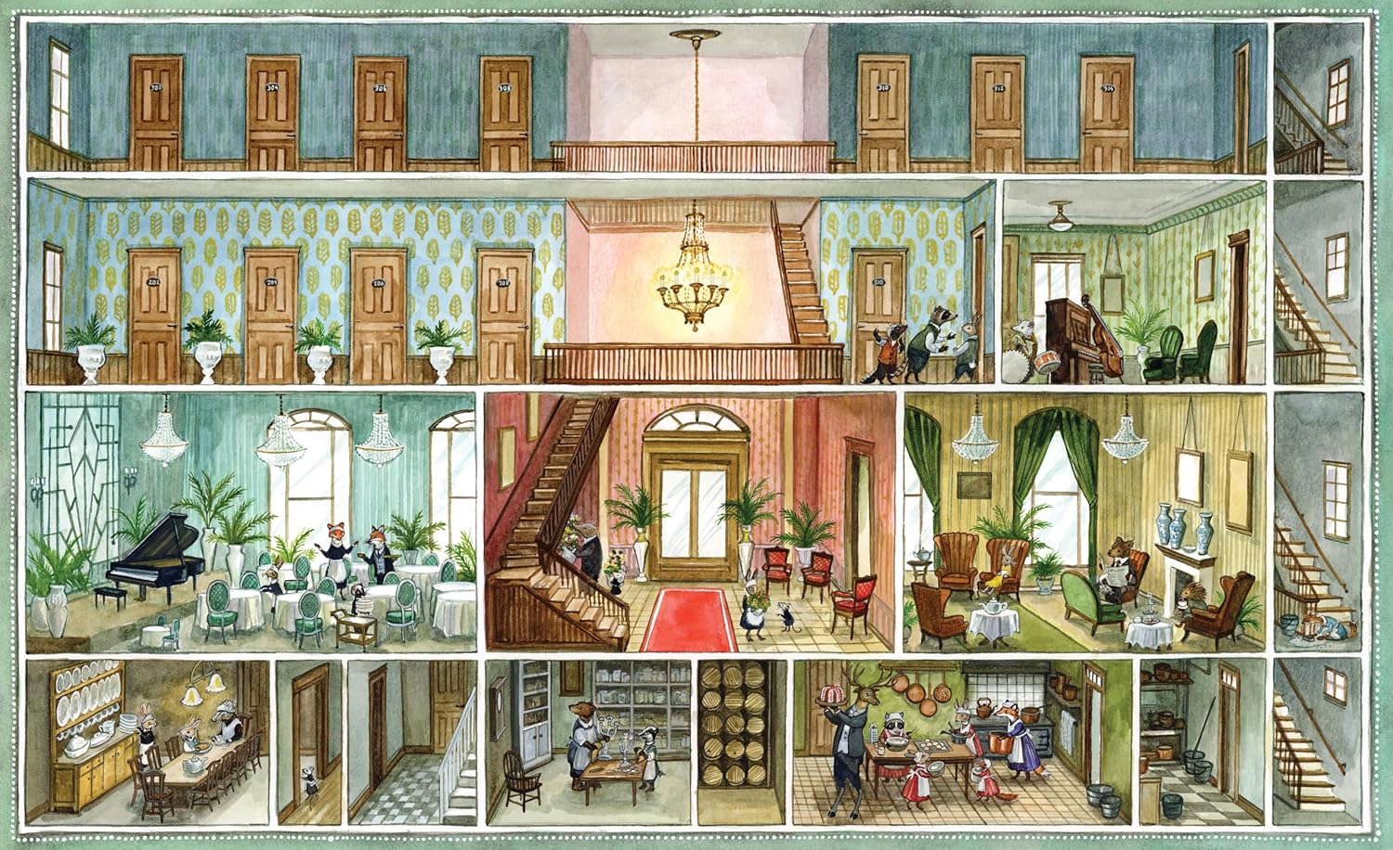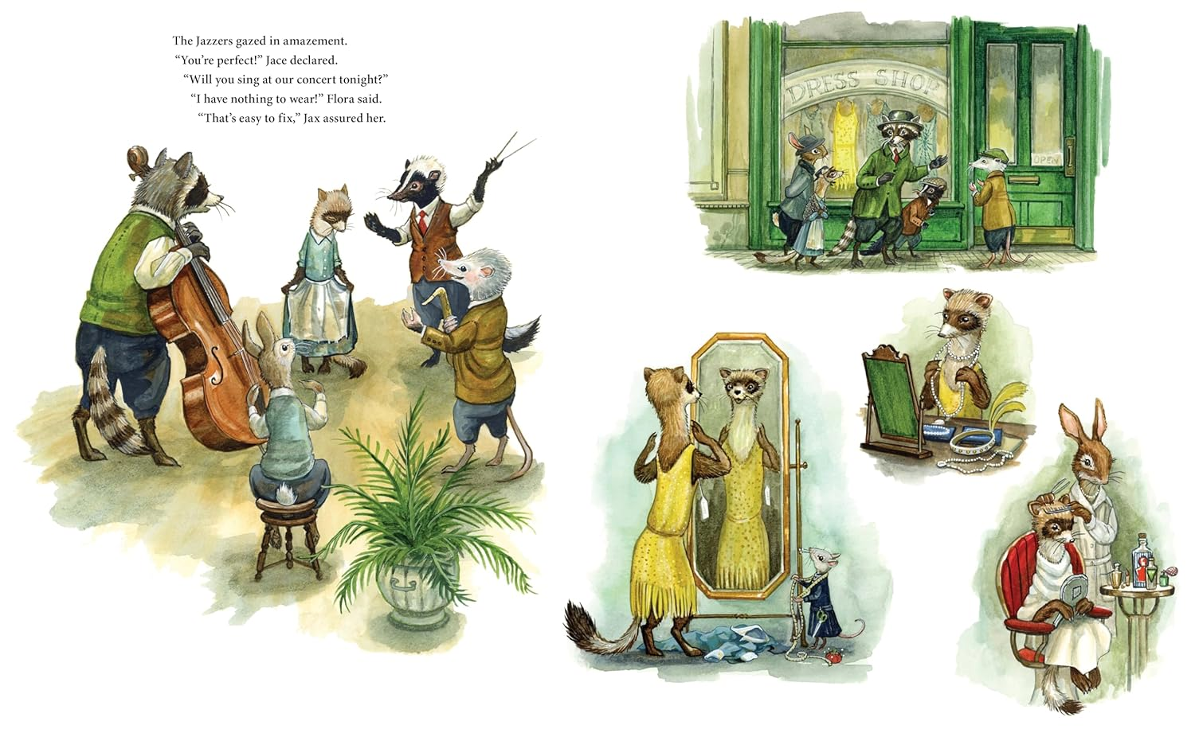
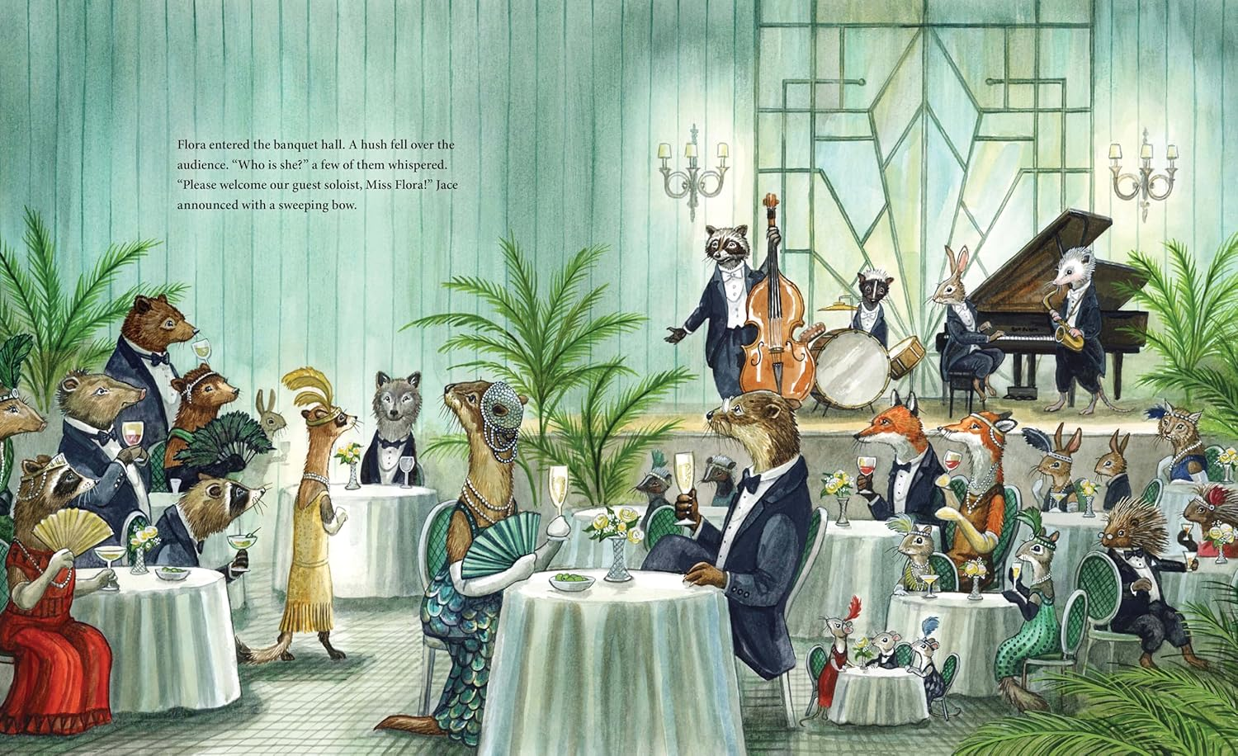

请将反馈信息发至：版权负责人
Email：Rights@nurnberg.com.cn
安德鲁·纳伯格联合国际有限公司北京代表处
北京市海淀区中关村大街甲59号中国人民大学文化大厦1705室, 邮编：100872
电话：010-82504106, 传真：010-82504200
公司网址：http://www.nurnberg.com.cn
书目下载：http://www.nurnberg.com.cn/booklist_zh/list.aspx
书讯浏览：http://www.nurnberg.com.cn/book/book.aspx
视频推荐：http://www.nurnberg.com.cn/video/video.aspx
豆瓣小站：http://site.douban.com/110577/
新浪微博：安德鲁纳伯格公司的微博_微博 (weibo.com)
微信订阅号：安德鲁纳伯格联合国际北京代表处

