新 书 推 荐

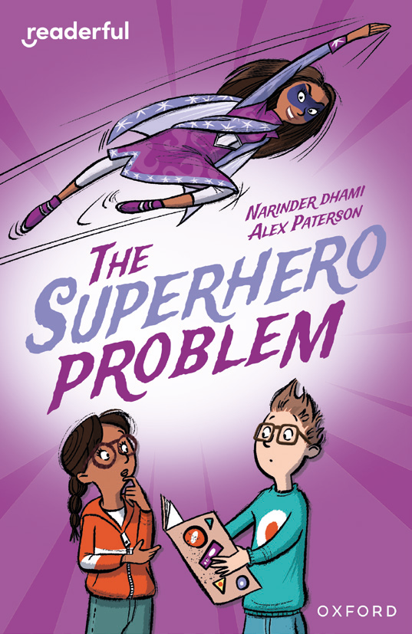
中文书名：《超级英雄难题》
英文书名：The Superhero Problem
作 者：Narinder Dhami and Alex Paterson
出 版 社：OUP
代理公司：OUP/ANA
页 数：96页
出版时间：未定
代理地区：中国大陆、台湾
审读资料：电子稿
类 型：桥梁书
版权已授：土耳其语

- 当一个善意的小谎言说得太过，扎拉(Zara)发现自己遇到了一个超级英雄难题……
- 由广受欢迎的儿童作家Narinder Dhami撰写，配有Alex Paterson绘制的充满个性的有趣插图。
- 探讨家庭与友谊的互动关系。

内容简介：

Zara creates a superhero and a world of adventures to cheer up her little brother, Rocky. But it soon becomes clear that Rocky believes superhero Suzy Sharma is real, and coming to their school! Can Zara and her new friend solve the superhero problem?

作者简介：

Narinder Dhami is a British children’s author. She studied at the University of Birmingham and worked as a teacher for several years before becoming a full-time writer.Dhami has written a wide range of books for children and young readers, including the popular Bindi Babes series and the novelisation of the hit film Bend It Like Beckham. She has also contributed to the internationally successful Rainbow Magic series under a shared pen name. Her writing often reflects multicultural life in modern Britain.

Alex Paterson is a UK-based children’s illustrator who has worked with major publishers such as Oxford University Press, HarperCollins, and Hachette. His work includes illustrations for books, educational materials, and editorial projects.He has illustrated numerous children’s titles and his artwork has been exhibited at institutions such as the Cartoon Museum in London. In addition to publishing work, he has also created illustrations and animations for organizations including the UK Parliament and major companies.

内页插图：

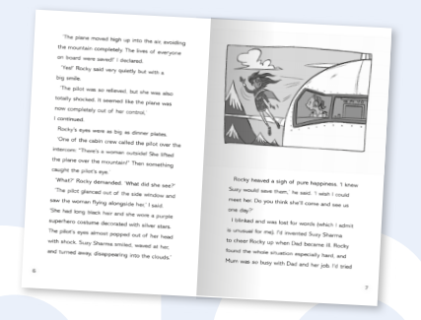

请将反馈信息发至：版权负责人
Email：Rights@nurnberg.com.cn
安德鲁·纳伯格联合国际有限公司北京代表处
北京市海淀区中关村大街甲59号中国人民大学文化大厦1705室, 邮编：100872
电话：010-82504106, 传真：010-82504200
公司网址：http://www.nurnberg.com.cn
书目下载：http://www.nurnberg.com.cn/booklist_zh/list.aspx
书讯浏览：http://www.nurnberg.com.cn/book/book.aspx
视频推荐：http://www.nurnberg.com.cn/video/video.aspx
豆瓣小站：http://site.douban.com/110577/
新浪微博：安德鲁纳伯格公司的微博_微博 (weibo.com)
微信订阅号：安德鲁纳伯格联合国际北京代表处

