新 书 推 荐

中文书名：《布罗迪与比恩：飞行工坊》
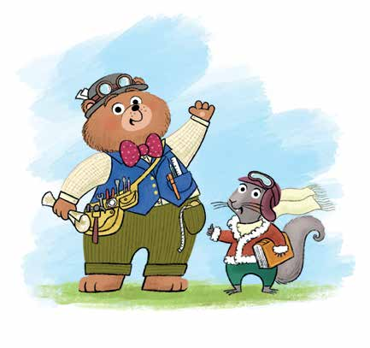
英文书名：Brodie and Bean: The Flying Workshop
作 者：Tracey Corderoy and Steven Lenton
出 版 社：Bloomsbury
代理公司：Bloomsbury/ANA
页 数：32页
出版时间：2027年5月
代理地区：中国大陆、台湾
审读资料：电子稿
类 型：故事绘本

全新精彩系列第一册
- 由畅销系列Shifty McGifty的创作者带来全新系列，该系列仅在英国已售出超过160,000册。
- 爱上你新的最爱角色：热情积极的小熊Brodie，以及善良聪明的松鼠Bean。
- 内含Steven Lenton精美插图，呈现一个充满蒸汽朋克风格的奇妙工坊，并融入大量潜移默化的STEM主题。

内容简介：

The first book in a fantastic new series by Tracey Corderoy andSteven Lenton. Get ready to meet your new favourite duo, Brodieand Bean!

Brodie and Bean are best friends, whose flying workshop takes themeverywhere - into dark jungles, up snowy mountains and into thedeepest depths of the murky ocean. So when their magic spannerstarts sparkling, ready to whisk them away to their next adventure,they're surprised to find themselves transported all the way... home?What could possibly need fixing in Babblebrook Wood?

Join Brodie and Bean, and their friends Badger and Bobble, in thisfantastically fun story about kindness, friendship and forgiveness.

作者简介：

Tracey Corderoy is an award-winningchildren's writer who has published over 60books since 2010, including the Shifty McGiftyand Hubble Bubble series.


Steven Lenton is a multi-award-winningillustrator, working from his studios in Brightonand London with his dog, Big Eared Bob. He hasillustrated many children's books including HeadKid by David Baddiel and the Shifty McGifty series.

内页插图：

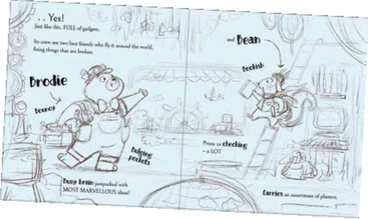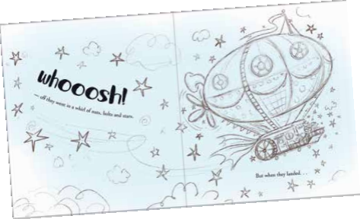

请将反馈信息发至：版权负责人
Email：Rights@nurnberg.com.cn
安德鲁·纳伯格联合国际有限公司北京代表处
北京市海淀区中关村大街甲59号中国人民大学文化大厦1705室, 邮编：100872
电话：010-82504106, 传真：010-82504200
公司网址：http://www.nurnberg.com.cn
书目下载：http://www.nurnberg.com.cn/booklist_zh/list.aspx
书讯浏览：http://www.nurnberg.com.cn/book/book.aspx
视频推荐：http://www.nurnberg.com.cn/video/video.aspx
豆瓣小站：http://site.douban.com/110577/
新浪微博：安德鲁纳伯格公司的微博_微博 (weibo.com)
微信订阅号：安德鲁纳伯格联合国际北京代表处

