新 书 推 荐

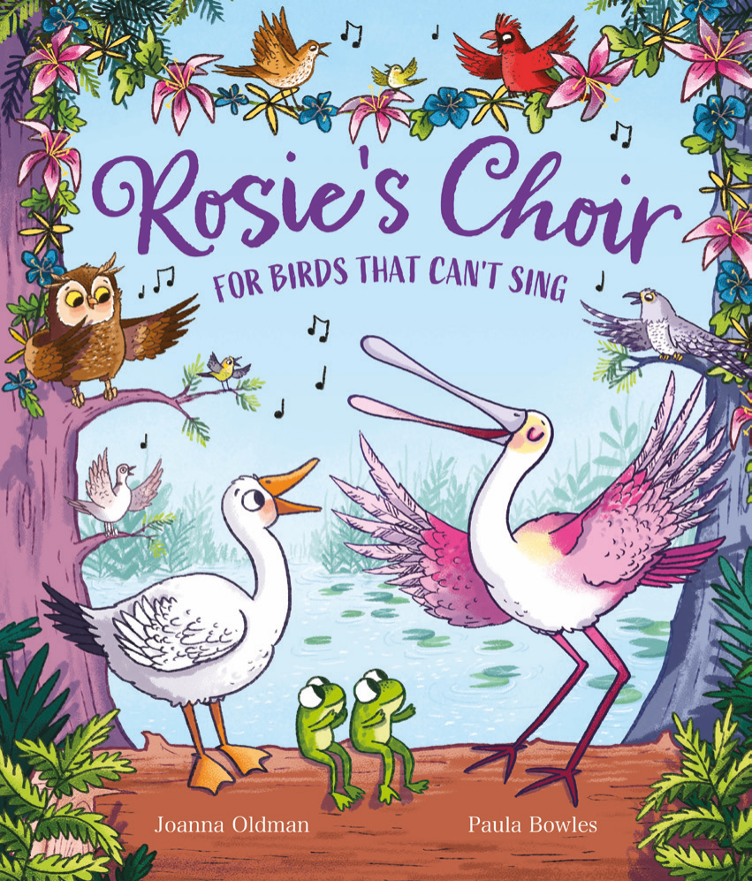
中文书名：《罗茜的合唱团》
英文书名：Rosie’s Choir
作 者：Joanna Oldman and Paula Bowles
出 版 社：OUP
代理公司：OUP/ANA
页 数：32页
出版时间：2027年2月
代理地区：中国大陆、台湾
审读资料：电子稿
类 型：故事绘本

- Joanna Oldman的首部图画书是一部充满喜悦的作品，关于一起快乐歌唱的温暖故事，赞颂歌唱将我们凝聚在一起的力量！
- 通过“合唱团属于每一个人”故事，探讨了包容性的重要性。
- 琵鹭罗茜及其一群羽毛朋友由《马夫》(Marv)系列的畅销插画家生动呈现。

内容简介：

Rosie the spoonbill’s dreams are coming true—she’s conducting a choir of beautiful birdsong! All birds are welcome in Rosie’s choir—at least that’s the idea. But when Julie, a snow goose with a honking voice, wants to join, Rosie only reluctantly agrees.

However, Julie proves herself to be an indispensable member of the group, providing encouragement and snacks, and soothing the others’ stage fright. But on the night of their big concert, Julie is nowhere to be seen. At first, Rosie is relieved, but without Julie there to calm them, the other birds lose confidence and insist they can’t sing without her, so Rosie sets off to find Julie.

Julie tells Rosie that she was right—she knows she sounds terrible and she doesn’t want to perform in front of a crowd. Rosie apologizes for making her feel like she didn’t belong and explains that Julie is the glue that holds the choir together.

Julie kicks off the concert with her loudest and honkiest note. All the birds join in and together they make the most beautiful song in their fabulous choir for ALL!

作者简介：


Joanna Oldman graduated from Edinburgh University with an MA in English Literature. Since then, she has worked in various roles in the medical and charitable sectors. An amateur bird enthusiast, nature lover, and seeker of joy in the little things, she loves to travel and has been lucky enough to visit some of the wondrous worlds in which her books are set. She is based in South-west London.


Paula Bowles is is an awardwinning children’s book illustrator based in Westonsuper-Mare, UK. She graduated from Falmouth University in 2007 and her publishers include Simon & Schuster, Nosy Crow, Welbeck, OUP, Little Tiger Press, Barrington Stoke, and The National Trust. Paula is the illustrator of the Marv series by Alex Falase-Koya.

内页插图：

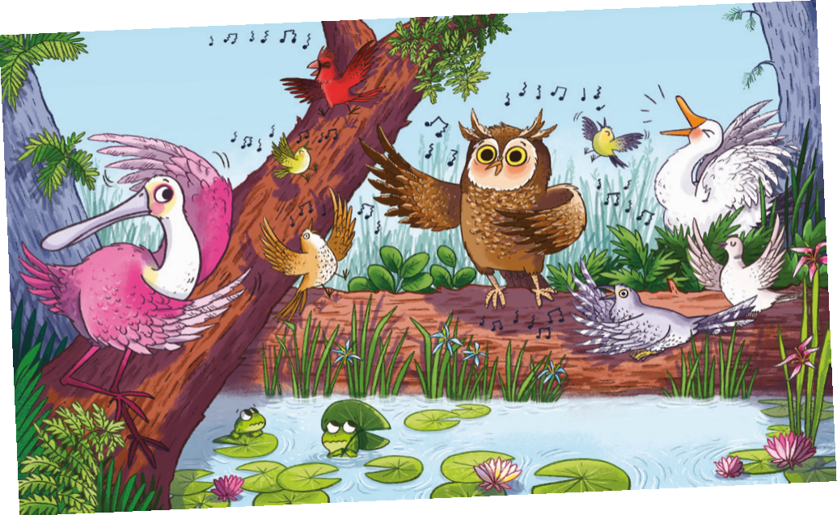
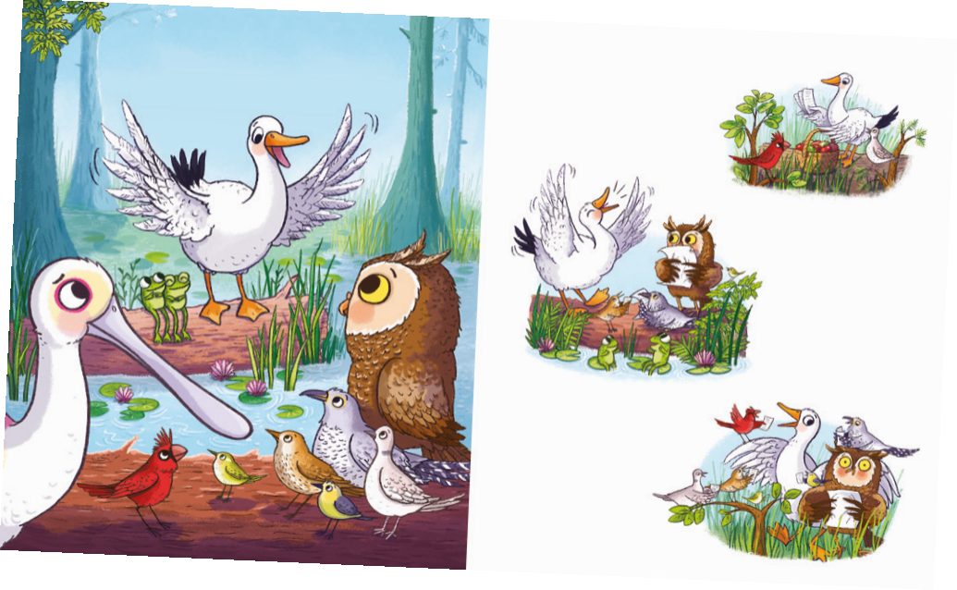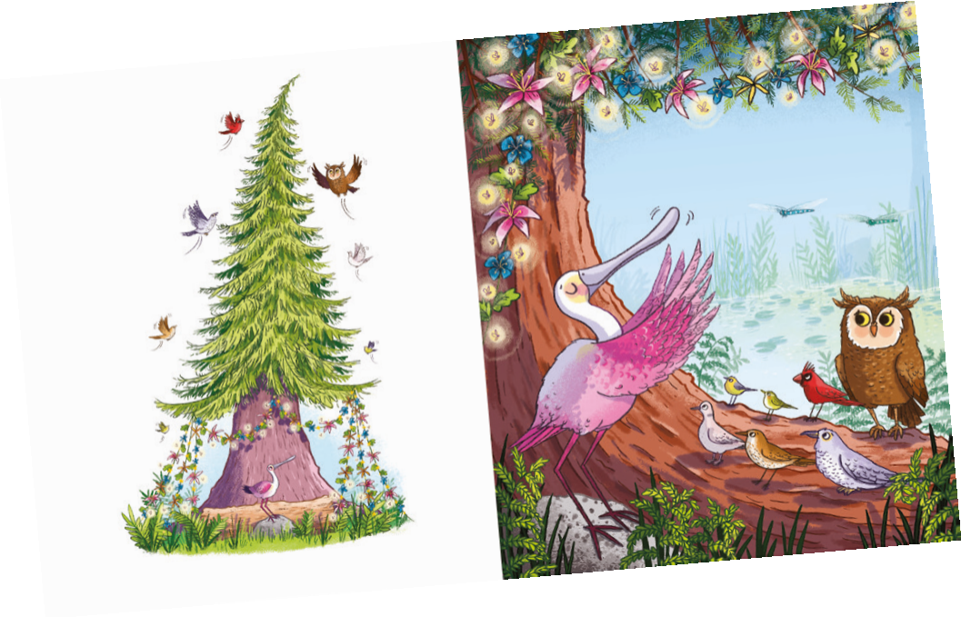

请将反馈信息发至：版权负责人
Email：Rights@nurnberg.com.cn
安德鲁·纳伯格联合国际有限公司北京代表处
北京市海淀区中关村大街甲59号中国人民大学文化大厦1705室, 邮编：100872
电话：010-82504106, 传真：010-82504200
公司网址：http://www.nurnberg.com.cn
书目下载：http://www.nurnberg.com.cn/booklist_zh/list.aspx
书讯浏览：http://www.nurnberg.com.cn/book/book.aspx
视频推荐：http://www.nurnberg.com.cn/video/video.aspx
豆瓣小站：http://site.douban.com/110577/
新浪微博：安德鲁纳伯格公司的微博_微博 (weibo.com)
微信订阅号：安德鲁纳伯格联合国际北京代表处

