新 书 推 荐

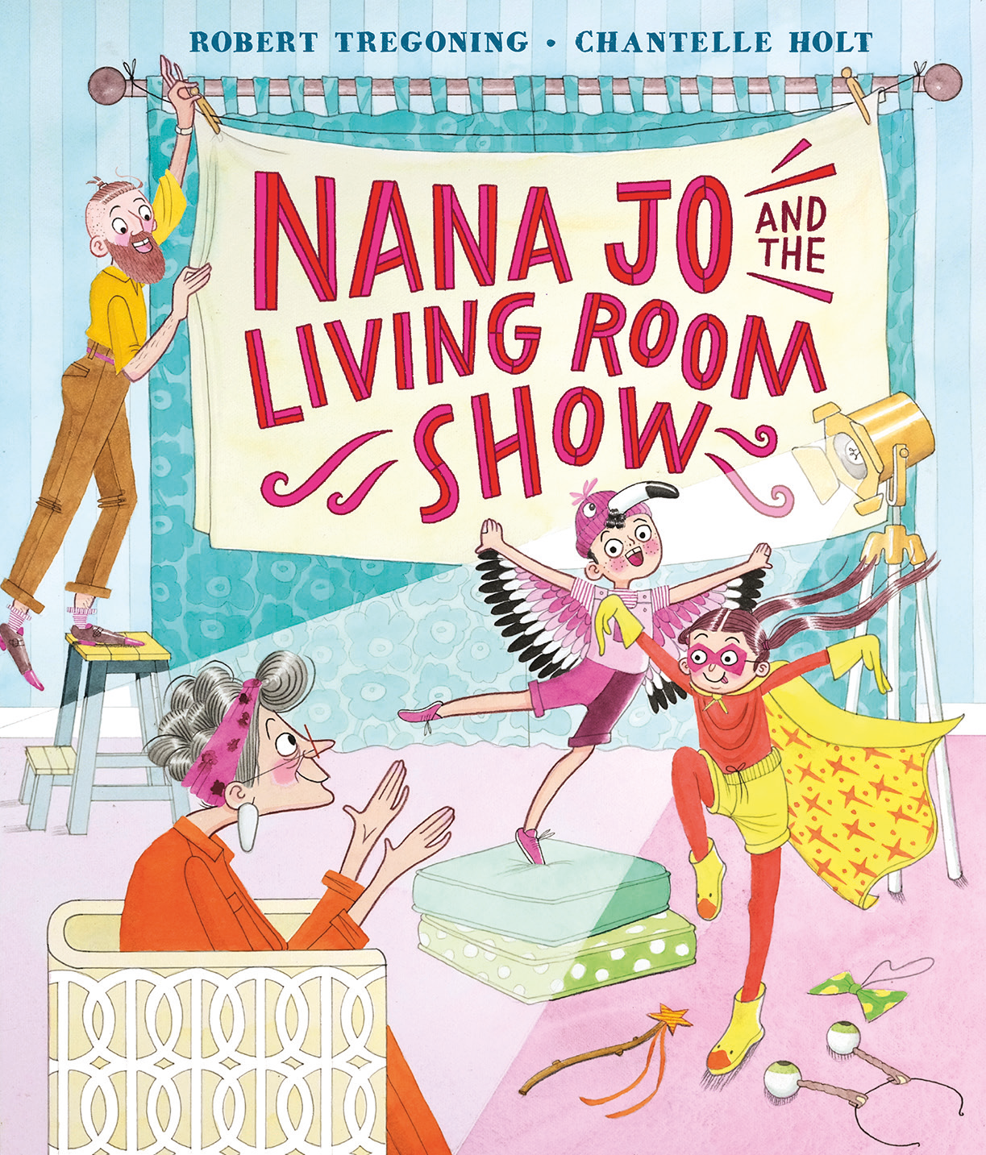
中文书名：《娜娜·乔与客厅演出》
英文书名：Nana Jo and the Living Room Show
作 者：Robert Tregoning and Chantelle Holt
出 版 社：OUP
代理公司：OUP/ANA
页 数：32页
出版时间：2027年4月
代理地区：中国大陆、台湾
审读资料：电子稿
类 型：故事绘本

- 一本温情的图画书，来自《橱窗里的裙子》(The Dress in the Window)的作者，这本细腻书写的作品探讨了衰老以及祖辈与孙辈之间的纽带主题，背景设定在护理院中。
- 受到作者与其姐妹一起表演节目的记忆，以及其祖辈患上痴呆症的经历的启发，这个故事赞颂了戏剧与表演带来欢乐的力量。
- 首次创作图画书的插画家Chantelle Holt以高度成熟的插画为这个温暖人心的故事带来了风格与活力。

内容简介：

Harry and Jessica love putting on a show for Nana Jo every Sunday. Sometimes they are fairies and sometimes they are cats, and sometimes they are spies wearing big coats and hats!

But when Nana Jo needs to move to a place where she can receive specialist care, the children are worried about her. Nana Jo soon makes new friends, but Harry and Jessica can’t help but feel that the care home needs a bit of showbiz. The Living Room Show must go on!

The show is a smash and it helps Nana Jo’s new friends to recall some wonderful memories: Norma remembers her ice-skating routines, Kate thinks of treks through a green paradise, and Pete recalls a walk on the beach with his wife, Grace. Nana Jo is so proud of her two little stars who’ve brought so much joy to her new community!

作者简介：

Robert Tregoning studied at the Glasgow School of Art before leaping into a career on the West End stage. He has appeared in Charlie and the Chocolate Factory and the Royal Shakespeare Company’s Matilda the Musical. The stories Robert writes are often stories he wishes he could have read as a child. He is the author of The Dress in the Window, Flow with the Snow, The Rock Family Band, and Dylan, Daisy, and the Disco Ball.

Chantelle Holt is a UK-based illustrator whose work is humorous, dramatic, colourful, and full of fun characters. She loves working in traditional mediums with digital edits. Nana Jo and the Living Room Show is her debut picture book.

内页插图：

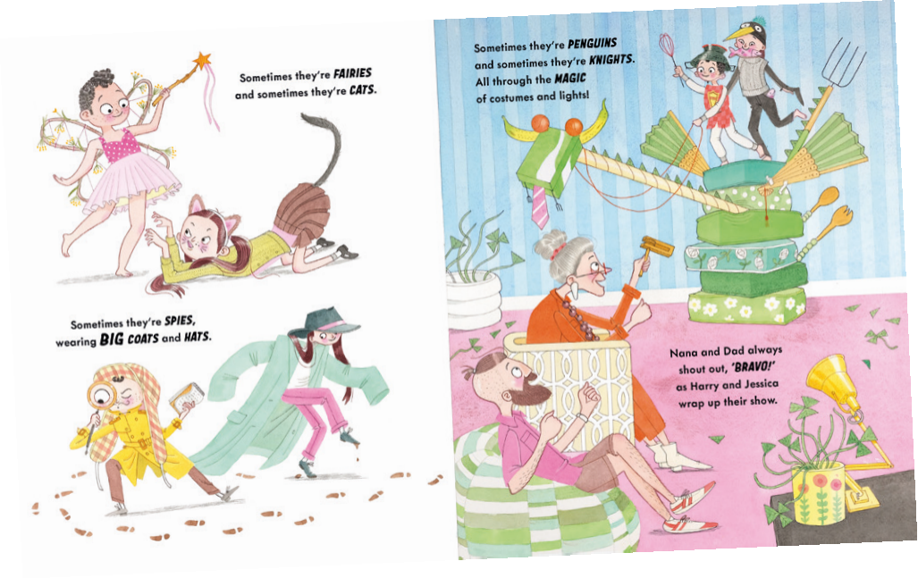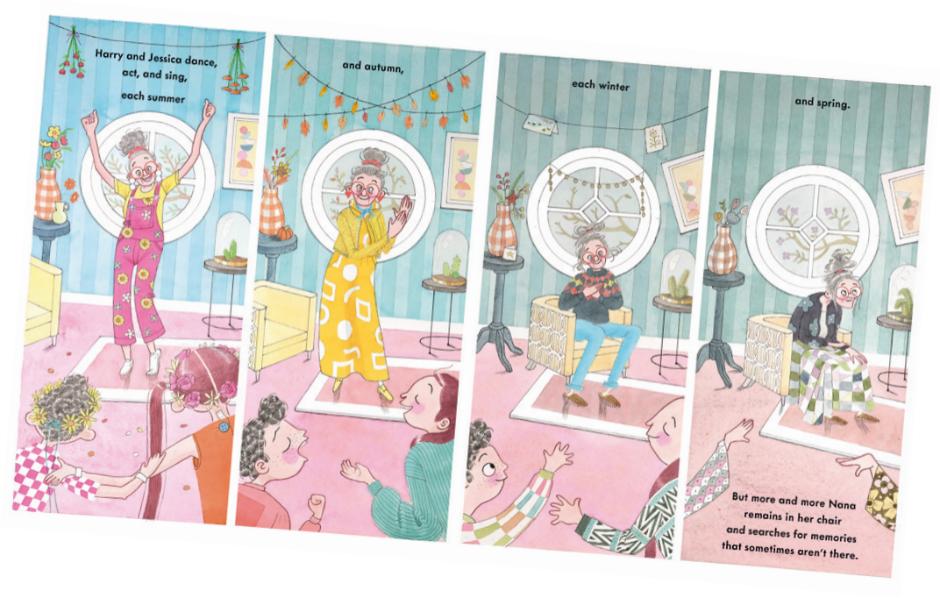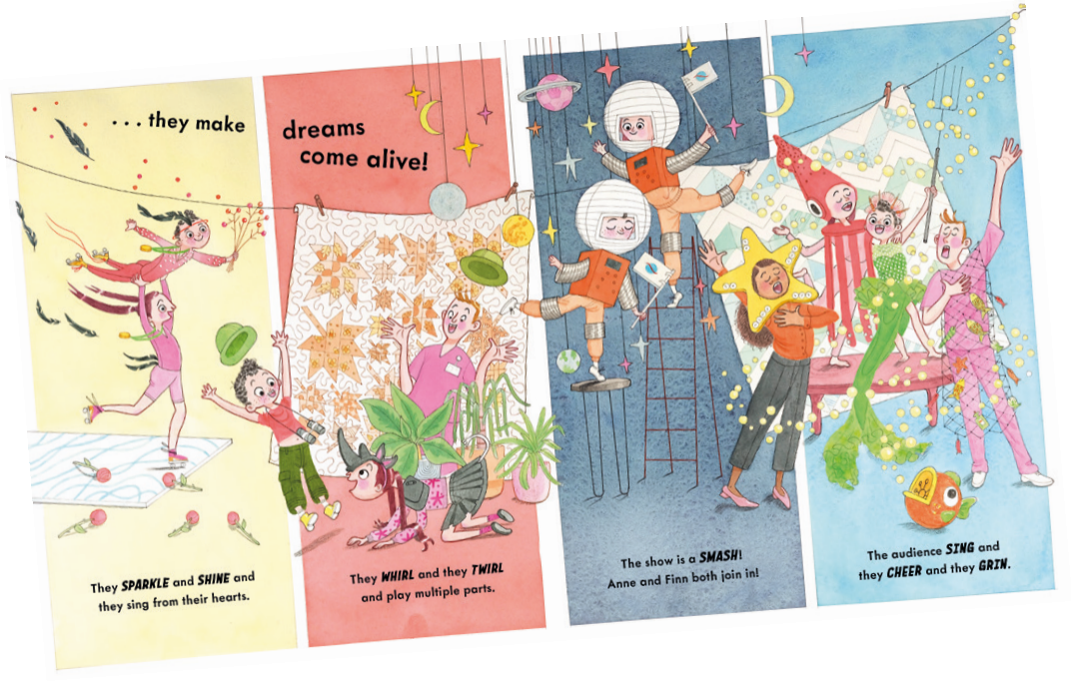

请将反馈信息发至：版权负责人
Email：Rights@nurnberg.com.cn
安德鲁·纳伯格联合国际有限公司北京代表处
北京市海淀区中关村大街甲59号中国人民大学文化大厦1705室, 邮编：100872
电话：010-82504106, 传真：010-82504200
公司网址：http://www.nurnberg.com.cn
书目下载：http://www.nurnberg.com.cn/booklist_zh/list.aspx
书讯浏览：http://www.nurnberg.com.cn/book/book.aspx
视频推荐：http://www.nurnberg.com.cn/video/video.aspx
豆瓣小站：http://site.douban.com/110577/
新浪微博：安德鲁纳伯格公司的微博_微博 (weibo.com)
微信订阅号：安德鲁纳伯格联合国际北京代表处

