新 书 推 荐

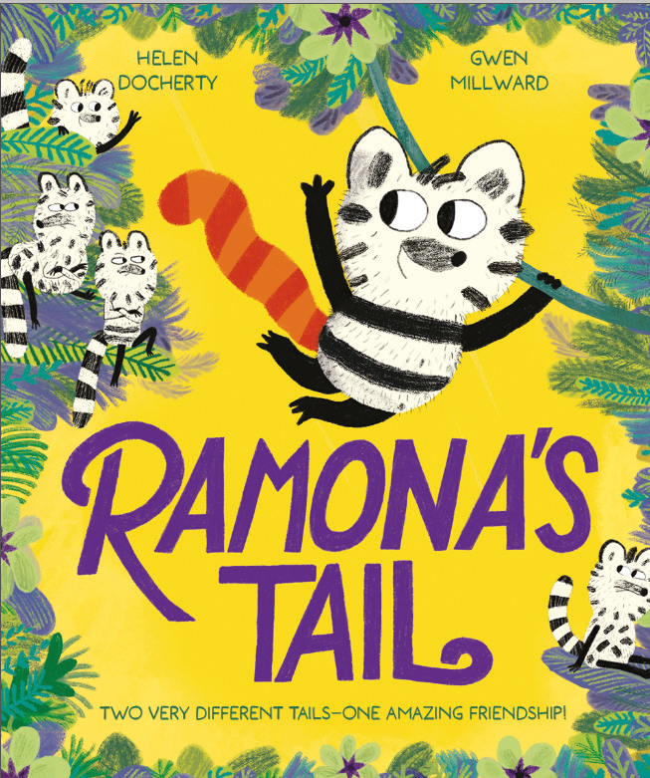
中文书名：《雷梦娜的尾巴》
英文书名：Ramona’s Tail
作 者：Helen Docherty and Gwen Millward
出 版 社：OUP
代理公司：OUP/ANA
页 数：32页
出版时间：2027年5月
代理地区：中国大陆、台湾
审读资料：电子稿
类 型：故事绘本

- 来自《麻烦鸟》(The Kerfuffle Bird)创作者的又一力作。
- 以一种易于年轻读者理解的方式探索了包容与排斥的主题。颂扬跨越差异，以及当我们拆除分隔彼此的藩篱时所能找到的快乐。
- The Nimbles和它们的森林世界在Gwen Millward引人注目的插图中变得栩栩如生。

内容简介：

Ramona’s tail has bright orange stripes, but all the other Nimbles’ tails are black and white. The other Nimbles find Ramona’s tail too bright and don’t want to play with her, except for her friend Dylan.

Ramona feels ashamed that the other Nimbles tease Dylan for playing with her, so she paints her tail black and white to fit in, but the others just laugh at her. Ramona is so embarrassed that she runs away. She can’t believe her luck when she finds a group of Nimbles with tails just like her own!

Meanwhile, Dylan is missing Ramona so goes to find her. Ramona is playing happily with her new friends and now it’s Dylan who’s the odd one out. Through Ramona’s courage, the Nimbles find a way to overcome their differences and all play together!

作者简介：


Helen Docherty is an internationally award-winning picture book author whose work has been translated into 27 languages, adapted for the stage, and set to music. Her acclaimed picture books include Snatchabook (Alison Green Books), The Knight Who Wouldn’t Fight (Alison Green Books), and Blue Baboon Finds Her Tune (Sourcebooks). Helen has lived and worked in France, Spain, Cuba, and Mexico, and now lives in Swansea, Wales.


Gwen Millward studied illustration in Edinburgh and is best known as the illustrator of The Bog Baby by Jeanne Willis (Puffin). She is also the illustrator of The Kerfuffle Bird by Helen Docherty as well as Guess What I Found in Dragon Wood? (Bloomsbury) and Stories from Bug Garden (Candlewick). Gwen lives in Bristol, UK.

内页插图：

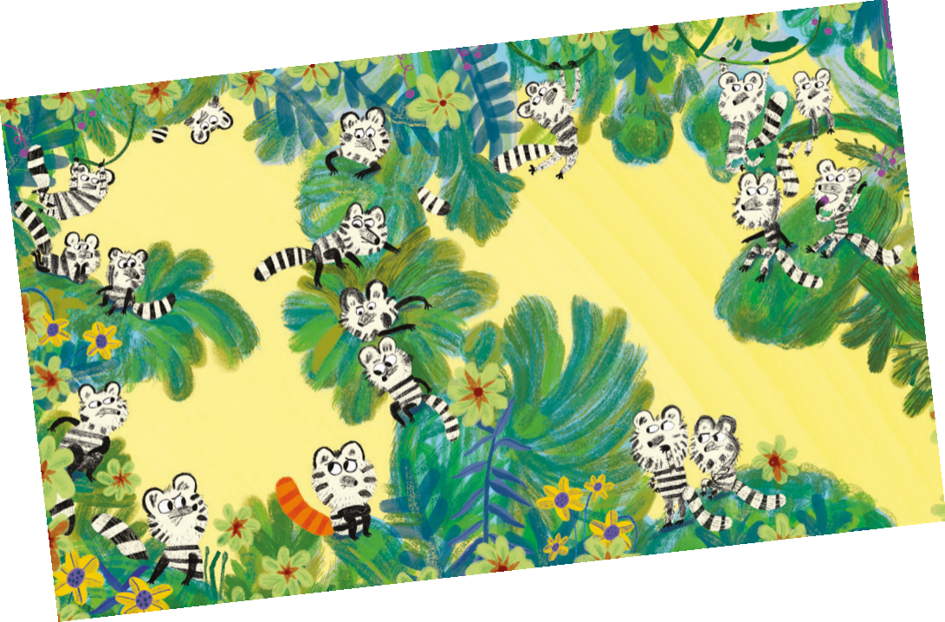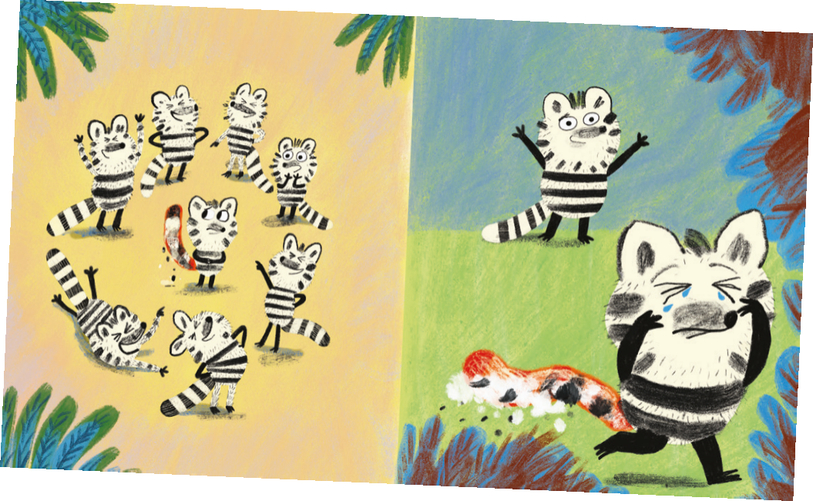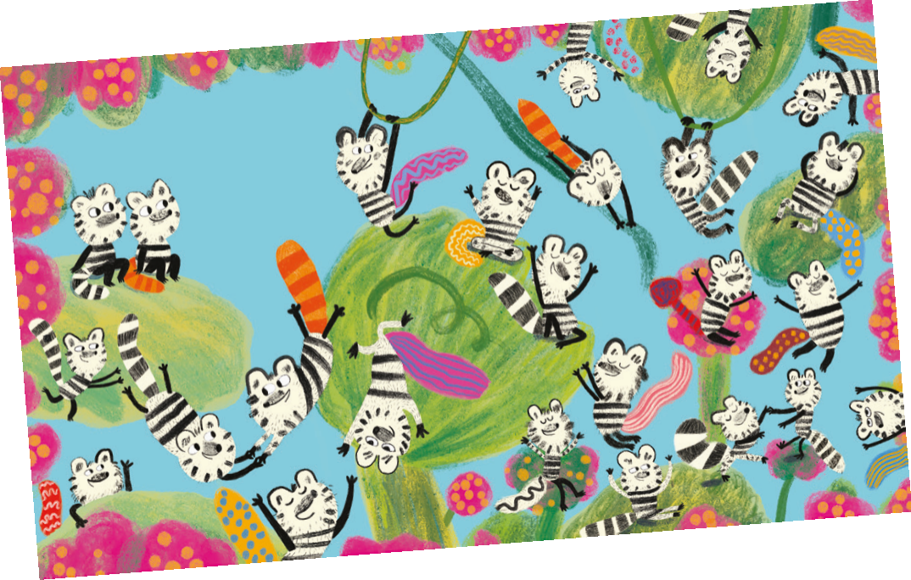

请将反馈信息发至：版权负责人
Email：Rights@nurnberg.com.cn
安德鲁·纳伯格联合国际有限公司北京代表处
北京市海淀区中关村大街甲59号中国人民大学文化大厦1705室, 邮编：100872
电话：010-82504106, 传真：010-82504200
公司网址：http://www.nurnberg.com.cn
书目下载：http://www.nurnberg.com.cn/booklist_zh/list.aspx
书讯浏览：http://www.nurnberg.com.cn/book/book.aspx
视频推荐：http://www.nurnberg.com.cn/video/video.aspx
豆瓣小站：http://site.douban.com/110577/
新浪微博：安德鲁纳伯格公司的微博_微博 (weibo.com)
微信订阅号：安德鲁纳伯格联合国际北京代表处

