新 书 推 荐

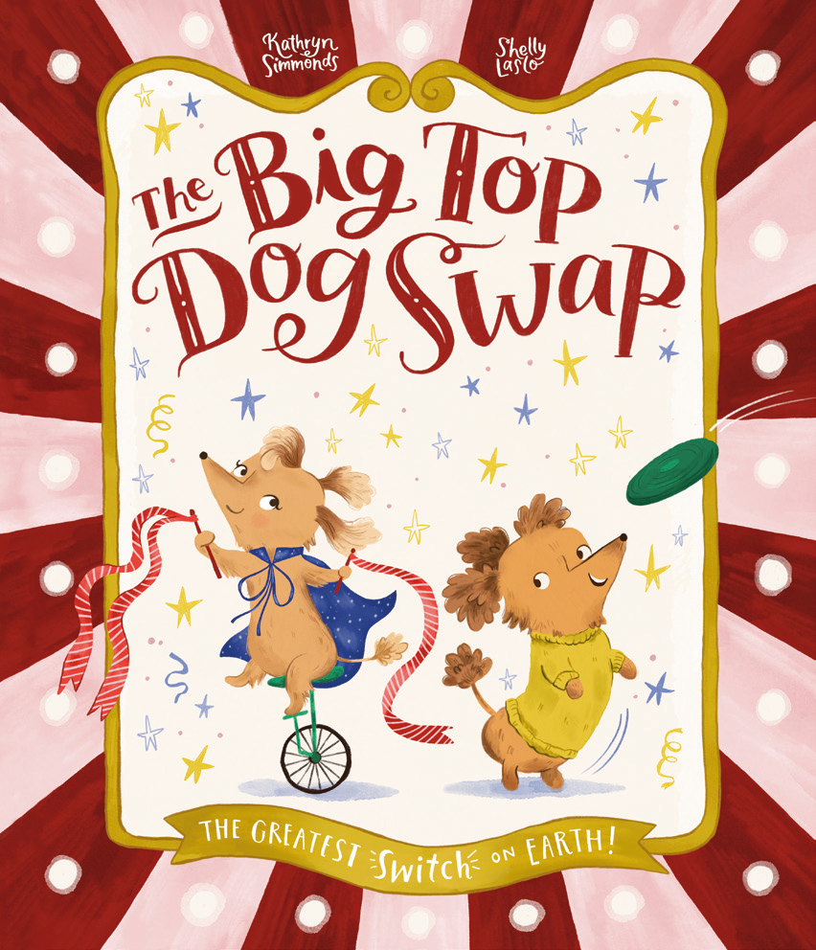
中文书名：《马戏团大顶棚狗狗互换》
英文书名：The Big Top Dog Swap
作 者：Kathryn Simmonds and Shelly Laslo
出 版 社：OUP
代理公司：OUP/ANA
页 数：32页
出版时间：2027年8月
代理地区：中国大陆、台湾
审读资料：电子稿
类 型：故事绘本

- 一个关于两只狗、一座马戏团，以及一次巨大互换的滑稽冒险故事！
- Kathryn Simmonds充满动作感的文本将使图画书读者着迷。她是2008年科斯塔诗歌奖入围的诗人，并于2022年出版最新诗集。
- Shelly Laslo的插画通过对光线和透视的创造性运用，使马戏团场景栩栩如生。
- 对爱狗人士极具吸引力，并传达了一个关于在玩耍之外也要找到休息时间的温柔信息。

内容简介：

Pickle is the kind of pup who likes to take it easy. But one day, as she looks around the park, she spots zooming dogs, woofing dogs, and chasing dogs. Surrounded by all this action, Pickle begins to wonder if her life could get a little more interesting. Luckily, the circus is in town...

Meanwhile, in the circus tent, Zelinda’s life is full of action. She twirls, she swirls, she shoots out of cannons. Sometimes Zelinda wonders if she should try to take it easy. Luckily, Pickle has come for an autograph, and the two dogs look like twins... It’s time for the Big Top Dog Swap!

So, these adorable dogs swap places. Pickle tries her paws at a hard week of work in the circus. Zelinda puts her paws up in Pickle’s basket. But the problem is, they both miss a bit of their old lives, too. When Zelinda returns to watch the circus, she realizes Pickle is in terrible danger and only she can help. She zooms up the ladder, swooshes along the flying trapeze, and sticks an incredible landing - saving Pickle and stunning the crowds. Safely back on the ground, the puppy pals are more than ready to swap back to their real lives, but maybe they can learn from one another to find a little more balance . . .

作者简介：


Kathryn Simmonds has been writing poetry for many years. She was short-listed for the Costa Poetry Award in 2008 and released her most recent collection in 2022. More recently, she has ventured into writing for children, and The Big Top Dog Swap is her fourth picture book. Kathryn lives in Norwich with her family.


Shelly Laslo is an illustrator based in ever-sunny Israel, where she happily juggles art and young motherhood. Shelly has recently begun her journey as a children’s book illustrator, and she thinks there is no smell lovelier than the inside of a new book.

内页插图：

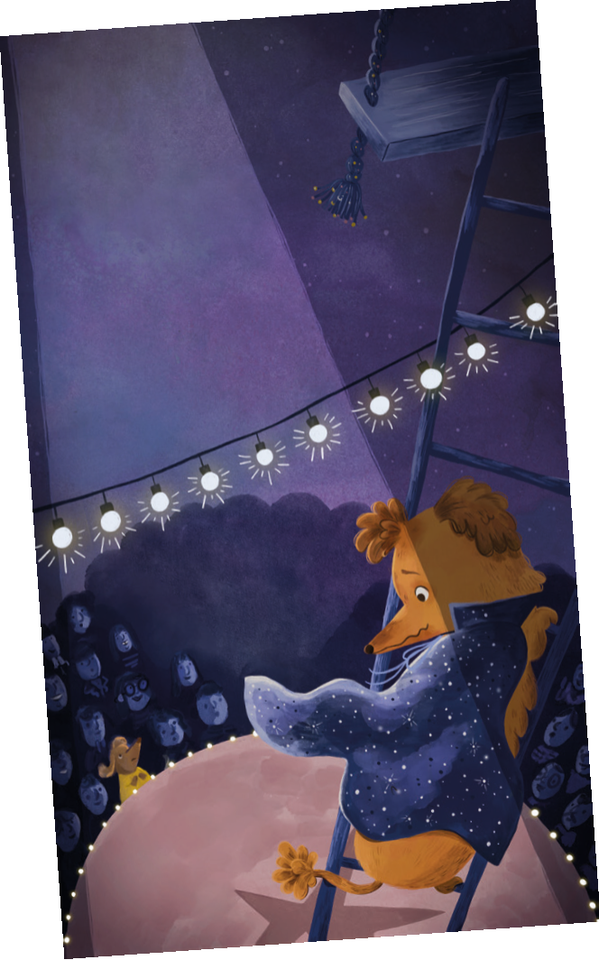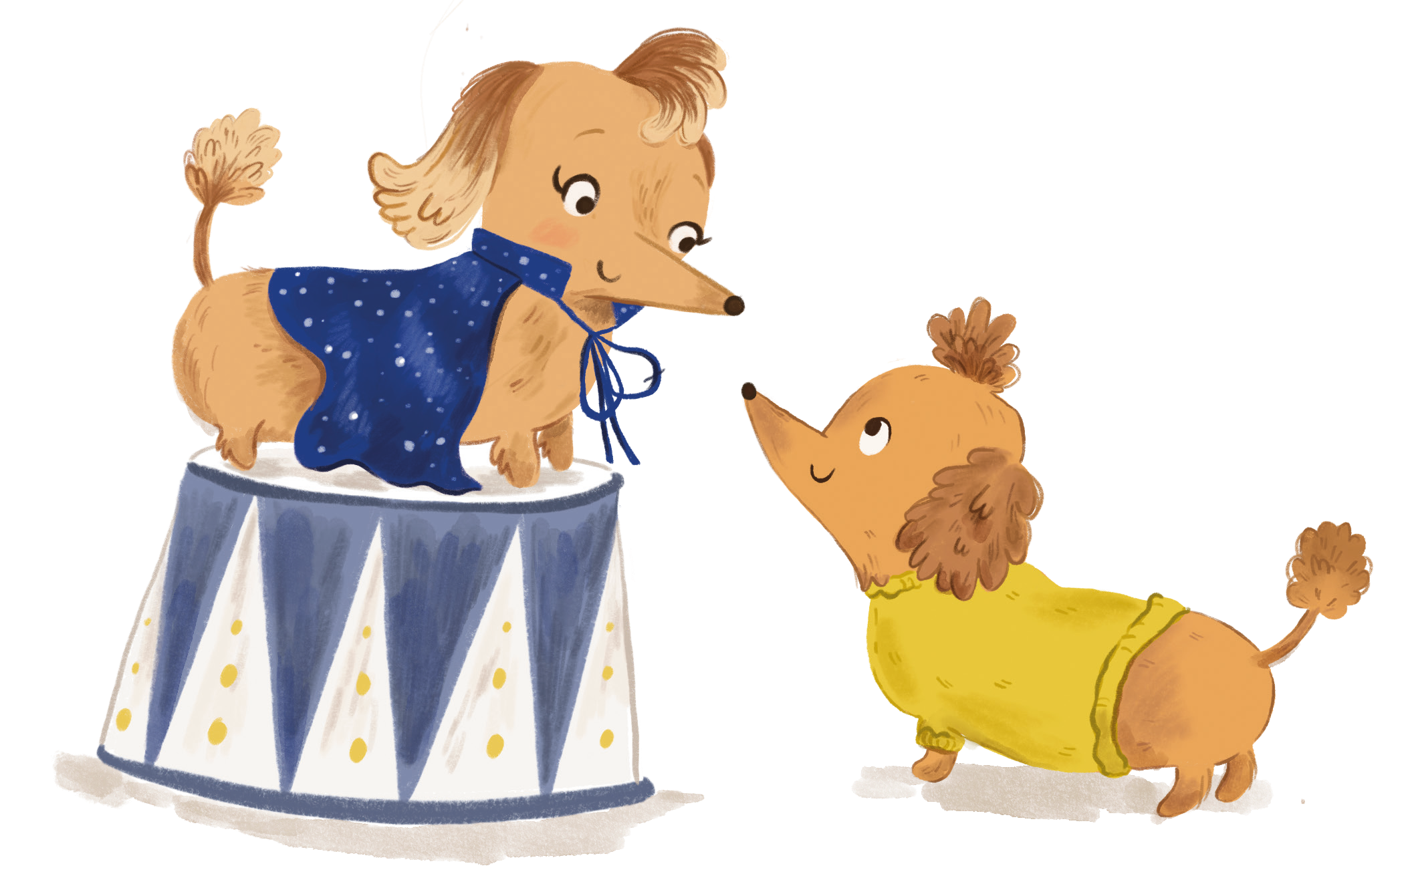
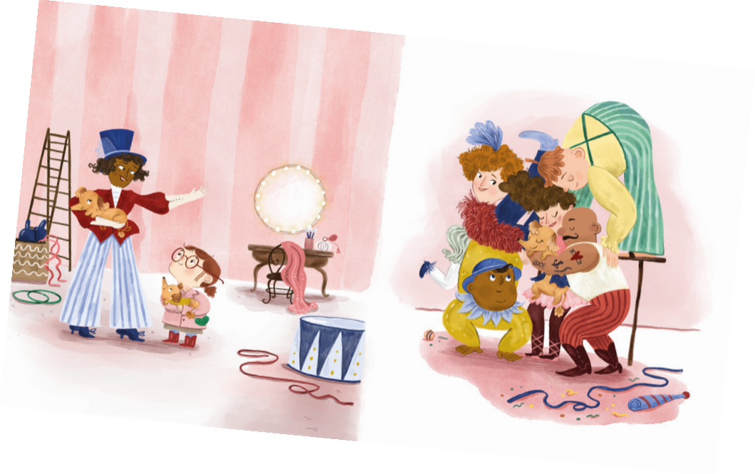

请将反馈信息发至：版权负责人
Email：Rights@nurnberg.com.cn
安德鲁·纳伯格联合国际有限公司北京代表处
北京市海淀区中关村大街甲59号中国人民大学文化大厦1705室, 邮编：100872
电话：010-82504106, 传真：010-82504200
公司网址：http://www.nurnberg.com.cn
书目下载：http://www.nurnberg.com.cn/booklist_zh/list.aspx
书讯浏览：http://www.nurnberg.com.cn/book/book.aspx
视频推荐：http://www.nurnberg.com.cn/video/video.aspx
豆瓣小站：http://site.douban.com/110577/
新浪微博：安德鲁纳伯格公司的微博_微博 (weibo.com)
微信订阅号：安德鲁纳伯格联合国际北京代表处

