新 书 推 荐
《我才不是鱼》
I am NOT a Fish

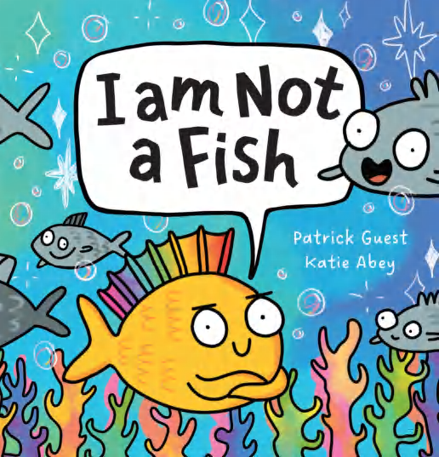
中文书名：《我才不是鱼》
英文书名：I am NOT a Fish
作 者：Patrick Guest
插 画 师：Katie Abey
出 版 社：Scholastic Aus
代理公司：Scholastic Aus
页 数：24页
出版时间：2026年4月
代理地区：全球版权（除ANZ）
审读资料：电子稿
类 型：儿童故事绘本

“就算逆流而上，也要闪闪发光做自己！”
获奖作家携手人气插画师，用明快幽默的故事告诉孩子：接纳独特的自己，就是最棒的成长
充满欢乐与力量，教会孩子自信、勇敢与自我认同，适合亲子共读传递成长正能量

本书卖点：

·明快温暖成长故事，内核积极有力：以幽默轻快的方式探讨自信、快乐与自我接纳，告诉孩子：就算与众不同、逆流而上，也要勇敢做自己。
·获奖作家执笔，文字灵动诙谐：由获奖作家帕特里克・格斯特精心创作，文字风趣有温度，节奏轻快，极易吸引孩子阅读与共情。
·人气插画师加盟，画风奇趣治愈：由极具人气的特色插画师凯特・艾比绘制，画风怪趣可爱、色彩明亮，让故事更具感染力。
·赞美独特自我，鼓励每个孩子闪光：用欢乐的故事赞美每一个人的独特之处，帮助孩子建立自信，接纳自我，充满正向力量。
·主题丰富多元，教育价值突出：涵盖自信、自我认同、独特性、动物、幽默等多重主题，兼具阅读趣味与成长引导意义。

内容简介：

‘I’m NOT a fish. No way.
That’s NOT me.’

A joyful story about embracing your unique self . . .
even when you have to swim against the tide.

作者简介：

Patrick Guest’s childhood consisted of footy, floundering, running through tea tree, bone collecting, and ten part harmonies in the family’s spluttering combi van. Even back then he was writing stories that were a hit with his parents and rabbit Snowball. Patrick found half of his career calling in Sports Physiotherapy, and after his first son Noah was born, followed by Reuben and Grace, he found the second half of his career—as a storyteller.

插画师简介：

Katie Abey is a creative human committed to the idea that she can make a positive difference to the world by drawing perturbed animals and lots of rainbows for a living. She used to view her deeply sensitive traits as a flaw but has now harnessed those characteristics into the superpower they are! Her work is created to uplift and support and she is passionate about making people feel proud of their individuality and all of the things that set them apart from others. Embrace your weirdness!

内页插图：

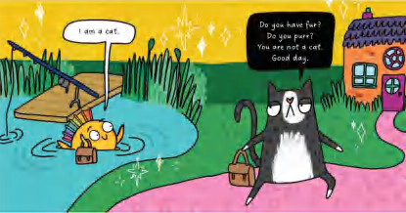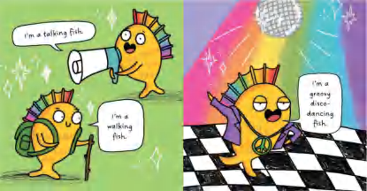

请将反馈信息发至：版权负责人
Email：Rights@nurnberg.com.cn
安德鲁·纳伯格联合国际有限公司北京代表处
北京市海淀区中关村大街甲59号中国人民大学文化大厦1705室, 邮编：100872
电话：010-82504106, 传真：010-82504200
公司网址：http://www.nurnberg.com.cn
书目下载：http://www.nurnberg.com.cn/booklist_zh/list.aspx
书讯浏览：http://www.nurnberg.com.cn/book/book.aspx
视频推荐：http://www.nurnberg.com.cn/video/video.aspx
豆瓣小站：http://site.douban.com/110577/
新浪微博：安德鲁纳伯格公司的微博_微博 (weibo.com)
微信订阅号：安德鲁纳伯格联合国际北京代表处

