新 书 推 荐

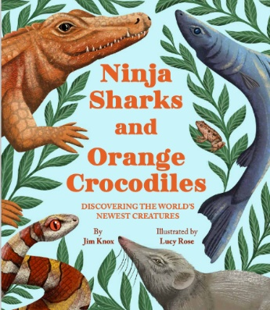
中文书名：《忍者鲨与橙色鳄鱼》
英文书名：NINJA SHARKS AND ORANGE CROCODILES
作 者：Jim Knox and Luck Rose
出 版 社：Little Brown
代理公司：Little Brown/ANA
页 数：40页
出版时间：2027年
代理地区：中国大陆、台湾
审读资料：电子稿
类 型：儿童知识绘本

- 权威专家创作，科普内容严谨可信：作者 Jim Knox 是资深野生动物专家、动物园教育馆长，拥有野外科考、媒体科普等丰富经验，内容经专业调研，给孩子最靠谱的自然科普。
- 揭秘全球新物种，点燃儿童探索欲：收录全球最新发现的神奇生物，从忍者灯笼鲨到粉色鬣蜥，覆盖海洋、火山等多样栖息地，满足孩子对未知世界的好奇，拓宽全球认知视野。
- 趣味科普形式，轻松解锁科学知识：以故事化讲述替代枯燥理论，搭配新奇物种的独特习性，让孩子在阅读中快乐吸收生物知识，培养自然科学素养。
- 传递公民科学理念，赋能成长价值观：打破 “科学探索只属于科学家” 的认知，告诉孩子普通人也能观察自然、发现新物种，培养观察力、好奇心与科学探索精神。
- 复古美学插画，视觉阅读双享受：插画师 Lucy Rose 以复古风格绘制，画面质感独特，图文结合赏心悦目，在学知识的同时提升孩子审美能力。

内容简介：

Each year, the world sadly loses scores of animal species to extinction, but few of us are aware that more than 20,000 new species are discovered by scientists, and amazingly, often by citizen scientists—ordinary people whose curiosity drives them to observe the natural world around them.

In this carefully researched book, renowned wildlife expert Jim Knox takes kids around the world to introduce some of the most amazing newly discovered creatures. From a pink iguana to a mouse that survived the Ice Age, kids and their caregivers will delight in exploring fascinating new species of animals across different countries with the turn of a page. Ninja Sharks and Orange Crocodiles allows young budding zoologists to be among the first to learn of these new species, their habits, and their habitats: ranging from the darkest depths of the ocean to the rocky slopes of remote volcanoes.

作者简介：

Jim Knox serves as the Curator of Education for Connecticut’s Beardsley Zoo where he directs educational programming and conducts field conservation for this AZA accredited institution. He has tracked gray wolves in Yellowstone National Park, conducted field research on Alaskan brown bears, field conservation for Atlantic Salmon, and written for the U.S. Fish and Wildlife Service and for Natural History magazine. Jim has served as a TEDx Presenter and an on-camera wildlife expert for The Today Show and The CBS Early Show.

Lucy Rose graduated from Falmouth University in 2015 with a degree in Illustration. She is inspired by vintage prints, art deco posters and textile pattern, influencing her choice of muted/vintage colors and pattern-like compositions. Living in Devon, England, she takes huge inspiration from the countryside and sea that is on her doorstep.

内页插图：
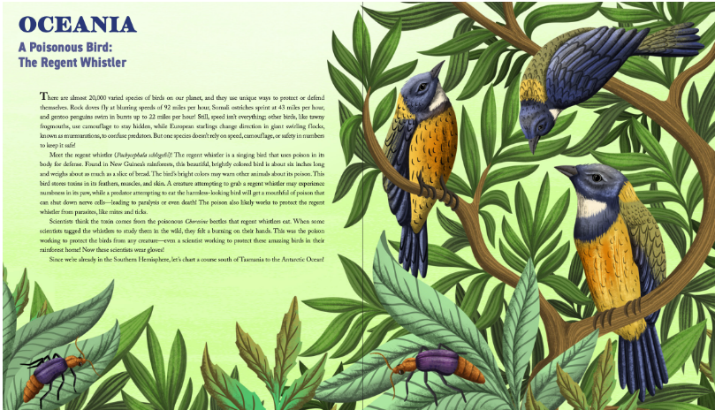
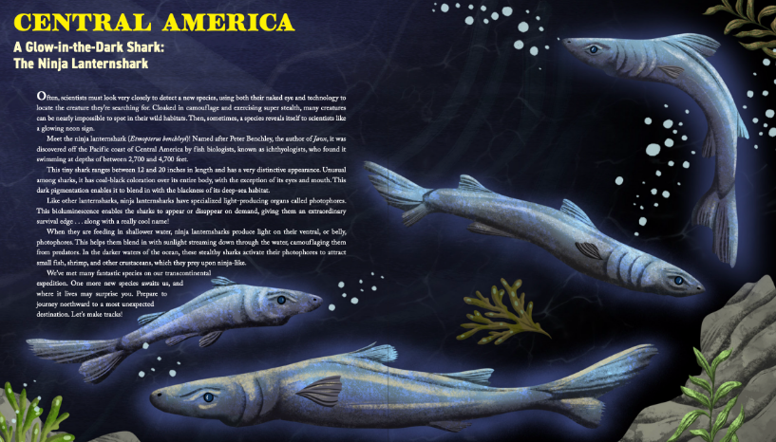

感谢您的阅读！
请将反馈信息发至：版权负责人
Email：Rights@nurnberg.com.cn
安德鲁·纳伯格联合国际有限公司北京代表处
北京市海淀区中关村大街甲59号中国人民大学文化大厦1705室, 邮编：100872
电话：010-82504106, 传真：010-82504200
公司网址：http://www.nurnberg.com.cn
书目下载：http://www.nurnberg.com.cn/booklist_zh/list.aspx
书讯浏览：http://www.nurnberg.com.cn/book/book.aspx
视频推荐：http://www.nurnberg.com.cn/video/video.aspx
豆瓣小站：http://site.douban.com/110577/
新浪微博：安德鲁纳伯格公司的微博_微博 (weibo.com)
微信订阅号：ANABJ2002


