新 书 推 荐

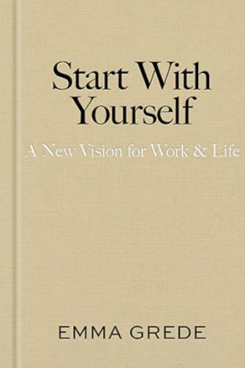
中文书名：《自我启航：工作与生活新视野》
英文书名：Start With Yourself: A New Vision for Work & Life
作 者：Emma Grede
出 版 社：Avid Reader Press / Simon & Schuster
代理公司：WME/ANA/Jessica
页 数：320页
出版时间：2026年4月
代理地区：中国大陆、台湾
审读资料：电子稿
类 型：经管
版权已授：希腊、乌克兰、塞尔维亚

- 上市即登上《纽约时报》畅销书榜第2位、《星期日泰晤士报》畅销书榜第2位，首月销量突破7万册。
- 艾玛做客《奥普拉播客》，该期节目播放量已超220万次，点击此处观看。

Amazon Best Sellers Rank: #258 in Books
#1 in Biographies of Business & Industrial Professionals
#1 in Women & Business (Books)
#5 in Success Self-Help

内容简介：

她是市值达50亿美元品牌Skims的创始人之一，白手起家打造了Good American品牌，如今更写下了这本全球女性翘首以盼的作品。本书一经推出，便引发了空前轰动。艾玛・格雷德（Emma Grede）在中国市场已具备相当高的知名度与影响力，Skims品牌也即将正式进入中国市场。

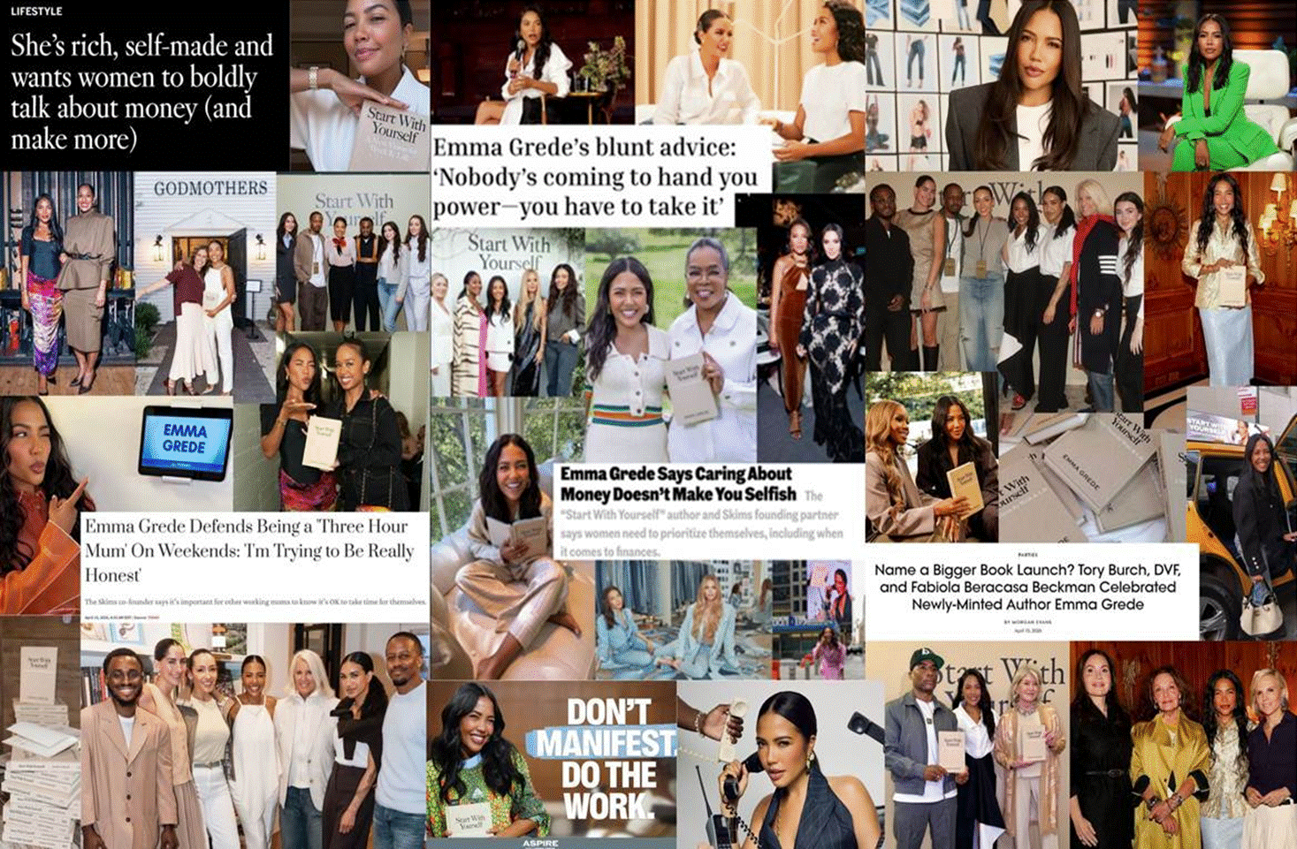

艾玛录制的视频精准诠释了本书的核心定位：这并非一本回忆录，而是给每一位女性的“底气许可”，支持她们打造自己理想的职业生涯。

《自我启航》是一部颠覆传统的真诚指南，为所有追求自定义成功的人提供变革性框架。本书来自逆袭传奇女性艾玛·格雷德的亲身淬炼——这位白手起家的连续创业者、定义文化的全球品牌联合创始人、非营利先锋及《与艾玛·格雷德共启航》播客主理人，将直授解锁人生与事业潜能的思维工具。而这一切成就，与她养育四名子女的家庭生活并行不悖。

追溯其早年经历——东伦敦工人区单亲家庭出身的高中辍学生——无人能料想艾玛·格雷德将成为美国最富白手起家女性之一。

这份独特性恰恰印证了她坚信的普适真理：《自我启航》拆解其思维模式与商业哲学，化为即学即用的行动指南，助你即刻赋能正在构筑的事业与人生。

格雷德最具灼见的洞察之一，是揪出所谓"陈旧思维"：那些关于工作生活平衡、金钱庸俗论、野心不合时宜的文化痼疾——它们实非金科玉律。她坚称这些系统谬误必须从脑海清除，方能重掌日常与长期目标的主动权。

最终，这部作品献给所有厌倦在自我人生中充当旁观者的灵魂。格雷德提供立即可行的解决方案，构建情绪管理、思路厘清与行动指引的思维系统——始终以积极心态照亮前路。

它关乎挫败后的自我重整，承担责任亦懂得自我宽宥。不冀求捷径却从不羞于把握机遇，为胜利全力拼搏且永不为梦想致歉。

最重要的是，格雷德呈现了鼓励全球读者为自身思维负责的工作生活新视野，指引通往最高阶个人与职业成就的路径。

作者简介：

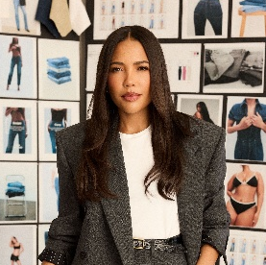
艾玛·格雷德（Emma Grede）是将宏大构想转化为当代最具影响力消费品牌的现代巨头。作为Good American联合创始人兼CEO、SKIMS创始合伙人，艾玛现通过播客传递思想。这位心怀使命的领袖亦投身公益，任奥巴马基金会与非盈利儿童组织Baby2Baby董事，新近出任国王信托大使。她的人生轨迹印证成功与内涵永伴共生，现与丈夫延斯及四名子女居洛杉矶。

全书目录：

引言

第一部：愿景蓝图
年度规划体系

第二部：情绪驾驭
愤怒
恐惧
愧疚
悲伤
喜悦

第三部：陈旧思维
得失权衡
金钱观念
职业迷思
家庭认知
品牌与创业
领导力误区

第四部：即刻行动
成功基本法则

致谢
注释
商业生活荐读书单
思想集萃
索引

市场推广：

TV/Video
Emma Grede of Skims, Good American, on how women can win in business and at work – CNBC
Emma Grede talks new book, 'Start With Yourself' – Good Morning America
Emma Grede on work-life balance and ambition – Morning Joe
Emma Grede Talks Entrepreneurship Advice in ‘Start With Yourself’ – TODAY Show (video interview)
Emma Grede talks new book, 'Start With Yourself' – ABC News (video interview)
Emma Grede talks new book, setbacks & more – NBC Los Angeles

Podcast
Start with Yourself: A New Vision for Work & Life with Emma Grede and Oprah – The Oprah Podcast
Emma Grede on Her Unpopular (but Not Untrue) Work and Life Philosophies – Nice Talk With Nikki Ogunnaike (Marie Claire)
Emma Grede's Rule Of Thirds For Navigating Leadership Challenges – Forbes Iconoclast
Emma Grede Sparks Debate About Being A '3 Hour Mom' – The Breakfast Club
Emma Grede on Building a Billion-Dollar Brand…and Raising Four Kids – How to Fail with Elizabeth Day
Emma Grede Explains How To Be Direct Without Apologizing – The Jefferson Fisher Podcast
Ambition requires discomfort | Emma Grede on Broadlines – The Female Quotient
Emma Grede on Owning Your Ambition – Baby, this is Keke Palmer
Emma Grede – Reclaiming with Monica Lewinsky
Start With Yourself: The Mindset That Built an Empire | Emma Grede – The School of Greatness
She partnered with Kim Kardashian to build SKIMS into a $5B brand — and now she's reinventing retail – CNBC Changemakers and Power Players Podcast
No Excuses, Just Business with Emma Grede – Let’s Be Honest with Kristin Cavallari
Stop Playing Small, Darling w/ Emma Grede – Women Evolve with Sarah Jakes Roberts
Emma Grede Gets Personal On The Cost of Ambition, Self Mastery, & The Truth About Success – The Bossticks
Emma Grede Wears All Her Own Brands – The Good Buy podcast, Harper’s Bazaar
How to Invest Like Emma Grede – She’s So Lucky

Print + Digital Media
Emma Grede says her $5 billion Skims empire started with a cold call to Kris Jenner: ‘The difference between me and someone else is I made it happen’ – Forbes
Emma Grede Defends Being a 'Three Hour Mum' On Weekends: 'I'm Trying to Be Really Honest' – TODAY.com
Op-Ed: Skims Exec Emma Grede Defends Being A 'Max 3-Hour Mom' And I Don’t Blame Her – Essence
Name a Bigger Book Launch? Tory Burch, DVF, and Fabiola Beracasa Beckman Celebrated Newly-Minted Author Emma Grede – Vogue
The Pervasive Myth of “Mom Guilt” – Marie Claire (excerpt)
Emma Grede Responds to Recent Backlash Over Her Comments About Being a 'Three-Hour Mom' on Weekends – People
Loves of My Life: Emma Grede – Who What Wear
Emma Grede was criticized for saying she's a 'three-hour' mom. We asked 4 ambitious working moms what they think. – Business Insider
8 Wealth-Building Lessons From the Woman Behind Good American and SKIMS – Dear Media
Emma Grede's 4 Rules for Making Your Brand Actually Matter on Social – AdWeek
Emma Grede on the Career Rules That Hold Women Back at Work – NewsWeek
Emma Grede Says Caring About Money Doesn’t Make You Selfish – Inc.
Emma Grede addresses backlash over her comments about being ‘three-hour mom’ on weekends – The Independent US
How can women get paid what they’re worth? Stop being so helpful, says Skims co-founder Emma Grede – Moneywise
10 new releases from Black authors you should be reading right now – The Grio
Good American to Skims: Emma Grede’s 5 Lessons in Building a Brand – Vogue
Emma Grede says caring about money doesn’t make you selfish – Fast Company
Why women stay broke—and how to change it, according to Emma Grede – Fast Company
Emma Grede’s unfiltered take on modern leadership – Fast Company
She’s rich, self-made and wants women to boldly talk about money (and make more) – LA Times
Emma Grede On Money, Mindset, And The Habits Keeping Too Many Black Women Playing Small – Essence
Forbes 250 The Greatest Self-Made Americans – Forbes
Emma Grede Built a Multibillion-Dollar Brand Empire by Starting With Herself – AdWeek
The 2026 Brand Genius Creators: Innovating How to Connect With Audiences – AdWeek
Good American Cofounder Emma Grede Says She’s a ‘Max 3-Hour Mom’ of 4 Kids With Husband Jens Grede – Us Weekly
Emma Grede’s Book Launch Was A Glimpse Into Her Inner Circle – The Zoe Report
‘Euphoria’ Hits Hollywood, ‘Hacks’ Returns for Final Season and This Week’s Best Events – The Hollywood Reporter
Nine Favorite Things – Half Baked Harvest
Entrepreneur Emma Grede Celebrates Debut Book, ‘Start With Yourself’ – Los Angeles Magazine
Emma Grede Sparks Debate on Work-From-Home Impact – Ebony
Plot Twist newsletter: This self-help book has hit the zeitgeist – The Economist
The Daily Beast’s Power 100 Luncheon Returns to L.A., Honoring Emma Grede – The Daily Beast

感谢您的阅读！
请将反馈信息发至：版权负责人
Email：Rights@nurnberg.com.cn
安德鲁·纳伯格联合国际有限公司北京代表处
北京市海淀区中关村大街甲59号中国人民大学文化大厦1705室, 邮编：100872
电话：010-82504106, 传真：010-82504200
公司网址：http://www.nurnberg.com.cn
书目下载：http://www.nurnberg.com.cn/booklist_zh/list.aspx
书讯浏览：http://www.nurnberg.com.cn/book/book.aspx
视频推荐：http://www.nurnberg.com.cn/video/video.aspx
豆瓣小站：http://site.douban.com/110577/
新浪微博：安德鲁纳伯格公司的微博_微博 (weibo.com)
微信订阅号：ANABJ2002


