新 书 推 荐
《小松鼠画出大情绪》
SQUIRREL DRAWS BIG FEELINGS

中文书名：《小松鼠画出大情绪》
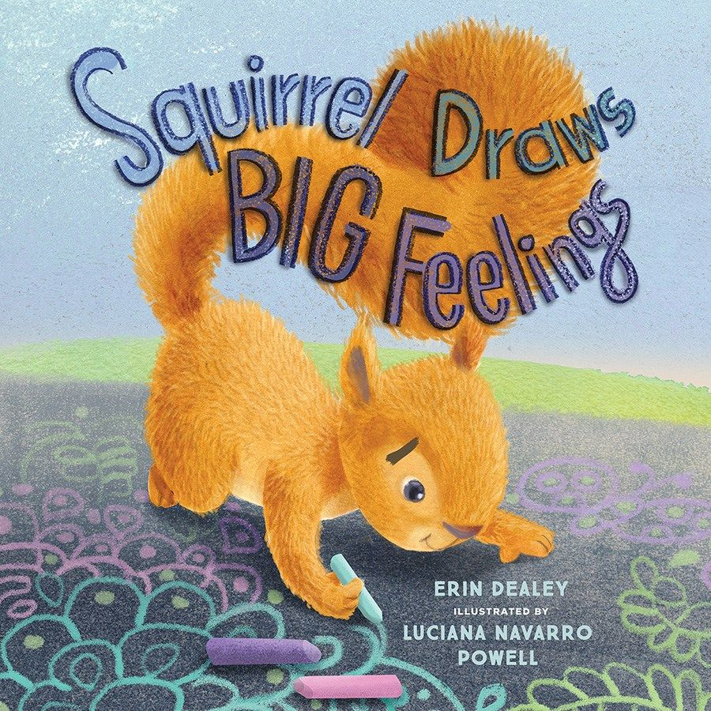
英文书名：Squirrel Draws Big Feelings
作 者：Erin Dealey
插 画 师：Luciana Navarro Powell
出 版 社：Beaming Books
代理公司：Defiore
页 数：32页
出版时间：2026年4月
代理地区：中国大陆、台湾
审读资料：电子稿
类 型：4-7岁故事绘本

以趣味方式，帮助孩子表达难以言说的情绪
情绪启蒙+艺术疗愈
rhyme韵律文本+精美插画，传递情绪表达与友谊的力量
适配4-7岁儿童，适配家长与教育者引导使用
作者Erin Dealey拥有数十年语言艺术和戏剧教师经验
著有《亲爱的地球……来自5号教室的朋友们》（纽约州阅读协会夏洛特奖）和《雪球心愿》（安娜·杜德尼共读荣誉图书）

本书卖点：

·实用价值突出：聚焦儿童情绪表达痛点，提供“艺术表达”这一具体情绪疏导方式，是家长和教育者引导孩子管理情绪的实用工具。

·形式生动易懂：采用押韵文本，语言朗朗上口，适配低幼儿童阅读习惯；混合媒体插画鲜活有张力，增强故事的趣味性与感染力。

·内核多元正向：不仅引导儿童认识、表达自身的“大情绪”，还传递友谊陪伴、分享互助的理念，让孩子明白情绪疏导与友谊都是重要的成长技能。

·创作团队优质：作者是获奖作家，拥有数十年教育经验，擅长创作贴合儿童成长的作品；插画师经验丰富，画风灵动，贴合故事温暖治愈的基调。

内容简介：

Adorable illustrations and an important message about the power of expression make Squirrel Draws Big Feelings a valuable addition to the toolbox of parents and educators.

"Uh oh! Sometimes, when Squirrel felt BIG feelings he couldn't stop racing around."

Squirrel feels squirrelly all the time! Porcupine gets the pricklies when things don't go the way she expects them to. And Bear only knows how to express his feelings ROARfully.

When Squirrel is having a hard time controlling his emotions and his body, his squirrelly behavior causes such a commotion that Porcupine gets all prickly and Bear has a ROARful day. No one is having fun and everyone is overwhelmed. Until Squirrel turns to chalk art to express his big feelings: "With each squiggly line, Squirrel felt better. Art felt like a quiet hug." After some initial hesitation and insecurity over whether they can make art too, Porcupine and Bear join Squirrel in drawing their hearts out. Turns out, friendship and sharing are coping skills too.

With rhyming text and dynamic, mixed-media illustrations, Squirrel Draws Big Feelings will help readers understand that even when we don't have the words to express how we feel, we don't need to get stuck there.

作者简介：

Erin Dealey is an award-winning children's author and playwright. Erin has published dozens of books celebrating kindness and community, including Dear Earth. . . From Your Friends in Room 5 (NYSRA Charlotte Award) and Snow Globe Wishes (Anna Dewdney Read Together Honor Book). With decades of experience as a language arts and theater teacher, she loves motivating kids to read, write, and make art. She lives in Northern California with her husband.

插画师简介：

Luciana Navarro Powell grew up and started her illustration career in Brazil before moving to the United States in 2002. She worked as an art buyer for an educational publisher in the Chicago area, before moving to California and becoming a full-time illustrator. She now lives in Washington state and has illustrated more than 20 children's books. In her free time, she loves to go hiking with her family and paint en plein air.

请将反馈信息发至：版权负责人
Email：Rights@nurnberg.com.cn
安德鲁·纳伯格联合国际有限公司北京代表处
北京市海淀区中关村大街甲59号中国人民大学文化大厦1705室, 邮编：100872
电话：010-82504106, 传真：010-82504200
公司网址：http://www.nurnberg.com.cn
书目下载：http://www.nurnberg.com.cn/booklist_zh/list.aspx
书讯浏览：http://www.nurnberg.com.cn/book/book.aspx
视频推荐：http://www.nurnberg.com.cn/video/video.aspx
豆瓣小站：http://site.douban.com/110577/
新浪微博：安德鲁纳伯格公司的微博_微博 (weibo.com)
微信订阅号：安德鲁纳伯格联合国际北京代表处

