新 书 推 荐
《小猫大战幼儿园》
KITTY VS. KINDERGARTEN

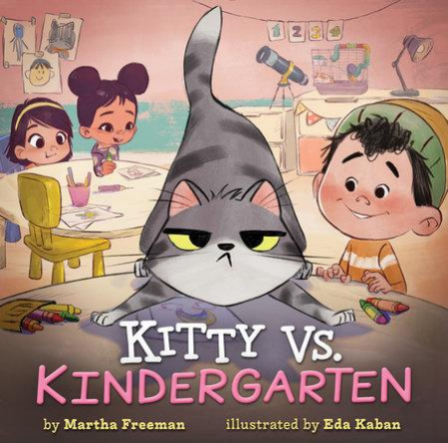
中文书名：《小猫大战幼儿园》
英文书名：KITTY VS. KINDERGARTEN
作 者：Martha Freeman
插 画 师：Eda Kaban
出 版 社：Disney Hyperion
代理公司：Defiore
页 数：48页
出版时间：2025年6月
代理地区：中国大陆、台湾
审读资料：电子稿
类 型：3-7岁故事绘本

优质创作团队+成长适配，以萌猫的幼儿园奇遇，引导孩子接纳新变化、尝试新事物，适配低龄儿童，贴合入园启蒙需求
作者Martha Freeman作品获埃德加奖提名、《学校图书馆期刊》星级评论

本书卖点：

·创作团队优质：作者Martha Freeman曾为记者、教师，创作经验丰富，作品获埃德加奖提名、《学校图书馆期刊》星级评论，擅长打造贴合低龄儿童的成长故事；插画师Eda Kaban经验丰富，曾为多部热门儿童绘本绘图，画风贴合故事萌趣基调。

·主题贴合成长痛点：聚焦“新环境适应”核心，以小猫抗拒幼儿园、最终接纳新事物的过程，精准戳中低龄儿童入园焦虑，引导孩子学会尝试新事物、接纳变化，兼具趣味性与教育性。

·角色设定萌趣吸睛：主角小猫傲娇又可爱，坚守自己的生活节奏，其抗拒新环境的小情绪的小情绪极易引发低龄儿童共鸣，后续的转变也能给予孩子正向引导。

·风格幽默治愈：情节轻松诙谐，语言简洁易懂、充满童趣，插画生动传神，精准捕捉小猫的情绪变化，适合家庭共读、幼儿园朗读，帮助孩子缓解入园焦虑。

·适配场景广泛：既适合即将入园、有入园焦虑的低龄儿童阅读，也可作为家庭亲子共读读物，传递“尝试新事物不可怕”的理念，适配多场景使用需求。

内容简介：

Kitty knows three things. He is the center of the universe. He likes it that way. Nothing should ever change. But to Kitty’s everlasting surprise and annoyance, things continue to change around him!

Kitty has everything he could ever want—breakfast at 7:00, supper at 4:00, and his favorite raggedy mouse toy. When Kitty goes to sleep, he dreams of a so-cozy life exactly the same as his own because same is what Kitty likes. But Kitty’s world is rocked when his good, nice boy announces that Kitty will be going to kindergarten.

At kindergarten, Kitty is not able to do the things he usually does. He can’t watch his nature shows, sharpen his claws, or hunt for snacks. But with the help of his good, nice boy and the teacher, Kitty learns that he can enjoy trying new things…and still get home in time for supper.

作者简介：

Martha Freeman worked as a reporter and teacher before becoming a full-time writer of books for young readers, including the Edgar Award–nominated Zap!, Born Curious, The Secret Cookie Club series, Who Stole Halloween?, and Effie Starr Zook Has One More Question, which School Library Journal called “accessible and exciting” in a starred review. She also collaborated with NASA astronaut Mark Kelly on the Astrotwins books. Martha lives in Oregon.
Learn more at MarthaFreeman.com.

插画师简介：

Eda Kaban has illustrated many popular books for children, including Pirates Don't Go to Kindergarten, Even Superheroes Have Bad Days, and Robb Pearlman's Pink Is For Boys. Born and raised in Turkey, Eda now lives in Oakland, California, with her husband, small son, and two Siamese cats.

请将反馈信息发至：版权负责人
Email：Rights@nurnberg.com.cn
安德鲁·纳伯格联合国际有限公司北京代表处
北京市海淀区中关村大街甲59号中国人民大学文化大厦1705室, 邮编：100872
电话：010-82504106, 传真：010-82504200
公司网址：http://www.nurnberg.com.cn
书目下载：http://www.nurnberg.com.cn/booklist_zh/list.aspx
书讯浏览：http://www.nurnberg.com.cn/book/book.aspx
视频推荐：http://www.nurnberg.com.cn/video/video.aspx
豆瓣小站：http://site.douban.com/110577/
新浪微博：安德鲁纳伯格公司的微博_微博 (weibo.com)
微信订阅号：安德鲁纳伯格联合国际北京代表处

