新 书 推 荐
《大脚怪和朋友们：相信自己》
BIGFOOT AND FRIENDS: Believe in Yourself
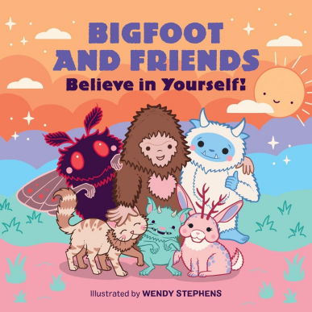
中文书名：《大脚怪和朋友们：相信自己》
英文书名：BIGFOOT AND FRIENDS: Believe in Yourself
作 者：Wendy Stephens
出 版 社：RPK&WK
代理公司：RPK&WK
页 数：24页
出版时间：2026年2月
代理地区：中国大陆、台湾
审读资料：电子稿
类 型：故事绘本

以大脚怪和神秘生物朋友们的故事为线索，传递“相信自己、接纳自我”的内核，适配0-3岁婴幼儿阅读，兼具萌趣性与启蒙意义
插画师Wendy Stephens拥有15年以上平面设计从业经验，为企鹅兰登书屋和阿歇特出版社创作插画
适合亲子共读、睡前阅读，传递相信自己、接纳自我的正向理念，同时帮助宝宝认识多种神秘生物

本书卖点：

·适配0-3岁低幼宝宝，纸板书材质坚固耐撕，贴合宝宝抓握与阅读习惯，文字极简、节奏舒缓，适合家长朗读、亲子共读与睡前阅读。

·英国插画师Wendy Stephens创作，pastel柔和色调插画萌趣治愈，角色形象可爱圆润，色彩柔和不刺眼，契合0-3岁宝宝视觉发育特点，极易吸引宝宝注意力。

·主题简洁正向，聚焦0-3岁宝宝自信启蒙与自我接纳，故事温馨简单，没有复杂情节，潜移默化中引导宝宝相信自己、热爱自己，助力宝宝建立自我认同。

·融入多种神秘生物角色，既能让宝宝感受萌趣乐趣，又能帮助宝宝初步认识不同的神秘生物，兼顾启蒙性与趣味性，丰富宝宝认知。

·插画师客户涵盖企鹅兰登书屋、阿歇特出版社，创作实力有保障，画面质感优良，兼具颜值与启蒙意义。

内容简介：

Practice self-confidence with Bigfoot and his cryptid friends as they learn to believe in themselves in this darling and empowering board book.

Even the most mysterious of creatures need a reminder to have confidence in themselves. Bigfoot is a cryptid, but some people don't believe in these mysterious creatures! He turns to his friends, Mothman, El Chupacabra, Kraken, Werewolf, Loch Ness Monster, Fresno Nightcrawler, Thunderbird, Wampus Cat, Yeti, and Jackalope, for support.

Filled with sweet pastel illustrations of each spooky and mysterious friend, Bigfoot learns it's okay to have big feet, enjoy napping, and play with other cryptids. Bigfoot and his friends encourage even the littlest creatures to love who they are and believe in themselves.

作者简介：

Wendy Stephens is a UK based artist, designer and illustrator. After dedicating over 15 years to her graphic design business, she pivoted to illustration, eager to explore her passion for all things cute and spooky. In her world haunted houses are pink, ghosts and pumpkins are cute and cuddly, and demons, vampires and werewolves can be pin-up girls. Her illustration clients include Penguin Random House and Hachette. She lives in Hertfordshire with her partner, daughter, and her indispensable coffee machine.

内页插图：

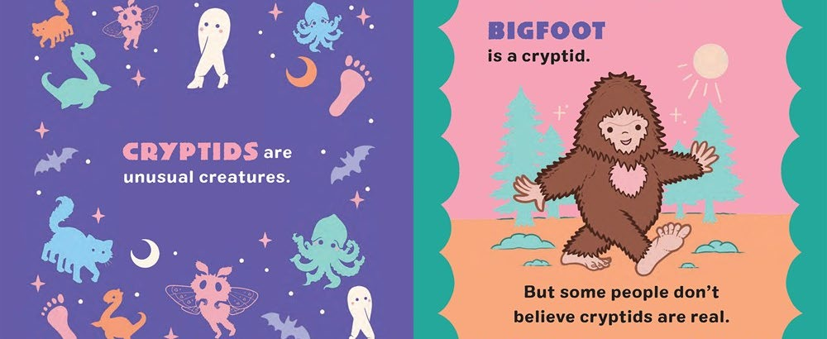

请将反馈信息发至：版权负责人
Email：Rights@nurnberg.com.cn
安德鲁·纳伯格联合国际有限公司北京代表处
北京市海淀区中关村大街甲59号中国人民大学文化大厦1705室, 邮编：100872
电话：010-82504106, 传真：010-82504200
公司网址：http://www.nurnberg.com.cn
书目下载：http://www.nurnberg.com.cn/booklist_zh/list.aspx
书讯浏览：http://www.nurnberg.com.cn/book/book.aspx
视频推荐：http://www.nurnberg.com.cn/video/video.aspx
豆瓣小站：http://site.douban.com/110577/
新浪微博：安德鲁纳伯格公司的微博_微博 (weibo.com)
微信订阅号：安德鲁纳伯格联合国际北京代表处

