新 书 推 荐
《小狗害羞》
SHY
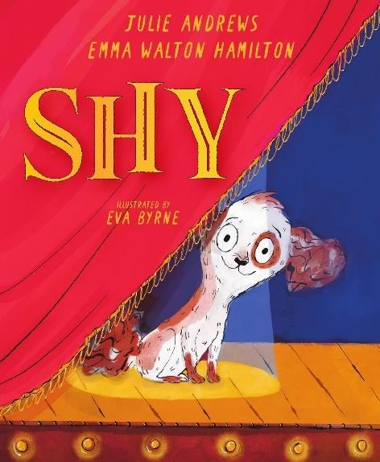
中文书名：《小狗害羞》
英文书名：SHY
作 者：Julie Andrews and Emma Walton Hamilton
出 版 社：Amulet/Abrams
代理公司：WME
页 数：待定
出版时间：2026年8月11日
代理地区：中国大陆、台湾
审读资料：电子稿
类 型：故事绘本

以害羞小狗的成长为线索，传递“勇敢发声、绽放自我”的内核，适配低龄儿童及亲子共读
《纽约时报》畅销书母女组合原创+传奇女星加持+治愈成长绘本，结合真实经历创作，聚焦自我发声
作者Julie Andrews与Emma Walton Hamilton是《纽约时报》畅销书母女组合，朱莉·安德鲁斯是传奇艺人，职业生涯涵盖百老汇、伦敦舞台、电影、电视等多个领域，被英国女王授予大英帝国女爵士勋章，以表彰其在艺术与人文学科的终身成就
艾玛·沃尔顿·汉密尔顿是获奖作家、制片人和艺术教育家，与母亲合作创作了35余本儿童及青少年书籍，创作经验丰富

本书卖点：

·由《纽约时报》畅销书母女组合朱莉·安德鲁斯与艾玛·沃尔顿·汉密尔顿创作，朱莉·安德鲁斯作为传奇艺人，自带影响力，作品质量有保障

·灵感来源于真实经历（朱莉·安德鲁斯的“会唱歌”的小狗），故事真实温暖，极易引发孩子情感共鸣，传递自我接纳与勇敢发声的理念

·文字温暖易懂、充满力量，贴合低龄儿童认知，引导孩子面对胆怯、接纳自我，学会大胆分享自己的天赋

·适合低龄儿童独立阅读及亲子共读，既能带给孩子温暖的阅读体验，又能传递自信、勇敢的正向价值观，兼具教育意义与温度

内容简介：

From New York Times bestselling mother-daughter duo Julie Andrews & Emma Walton Hamilton and bestselling illustrator Eva Byrne comes an empowering tale of finding your voice—starring a shy puppy who discovers the magic of music.

Shy is the smallest and quietest pup at the shelter. The world feels big, loud, and a bit scary to her sweet and gentle soul.

But when a man with kind eyes brings her home, she feels safe with her new best friend—and keeps him company while he practices at his piano. Beautiful, unfamiliar sounds dance in the air when the piano man plays, and something inside her begins to stir. The piano man has an important performance ahead—but it may be a performance no one, especially the piano man, ever expected.

Inspired by Julie Andrews’s real-life “singing” dog, this uplifting picture book invites readers to find their voice and share their talents with the world.

作者简介：

Julie Andrews has a legendary career that encompasses the Broadway and London stages, as well as multiple films, television shows, album releases, concert tours, directing assignments, and the world of children’s publishing. In 2000 the title of Dame Commander of the British Empire was bestowed upon her by Queen Elizabeth II for lifetime achievements in the arts and humanities. She was married to film director Blake Edwards for forty-one years, and the couple have five children, ten grandchildren, and three great-grandchildren. She invites you to visit her online at @julieandrews on both Instagram and Twitter.

Emma Walton Hamilton is an award-winning writer, producer, and arts educator. Together with her mother, Julie Andrews, she has written over thirty-five books for children and young adults, including the New York Times bestselling Very Fairy Princess series, Waiting in the Wings, and The First Notes: The Story of Do, Re, Mi. Her first book of poetry, Door to Door, was published in 2022. Emma is a longtime faculty member of Stony Brook University’s MFA in Creative Writing and invites you to visit her online at @ewhamilton on both Instagram and Twitter.

请将反馈信息发至：版权负责人
Email：Rights@nurnberg.com.cn
安德鲁·纳伯格联合国际有限公司北京代表处
北京市海淀区中关村大街甲59号中国人民大学文化大厦1705室, 邮编：100872
电话：010-82504106, 传真：010-82504200
公司网址：http://www.nurnberg.com.cn
书目下载：http://www.nurnberg.com.cn/booklist_zh/list.aspx
书讯浏览：http://www.nurnberg.com.cn/book/book.aspx
视频推荐：http://www.nurnberg.com.cn/video/video.aspx
豆瓣小站：http://site.douban.com/110577/
新浪微博：安德鲁纳伯格公司的微博_微博 (weibo.com)
微信订阅号：安德鲁纳伯格联合国际北京代表处

