新 书 推 荐

中文书名：《友谊长椅》
英文书名：THE FRIENDSHIP BENCH
作 者：Wendy Meddour
出 版 社：OUP
代理公司：ANA
页 数：32页
出版时间：2022年4月
代理地区：中国大陆、台湾
审读资料：电子稿
类 型：故事绘本

- 故事聚焦小女孩提莉搬家、转学后的全新生活，精准捕捉孩子面对陌生校园、陌生同学时的孤独与胆怯。提莉习惯了海边和家人、小狗的陪伴，步入新学校后被迫与熟悉的一切隔绝，独自玩耍的状态，完美复刻了孩子转学、入园的真实情绪。全书以温柔细腻的叙事，借助“友谊长椅”这一温暖载体，引导孩子直面社交恐惧，教会孩子主动破冰、结交新朋友，温柔治愈孩童的社交内耗与陌生环境适应焦虑。
- 本书出自英国文学博士、屡获国际童书大奖的温迪·梅多尔之手，作者深耕儿童成长文学多年，擅长以轻松、风趣的笔触解读孩子的成长难题。区别于生硬的说教，本作将社交成长、勇敢独立的成长内核，融入简单纯粹的孩童日常，让孩子在沉浸式阅读中潜移默化学会社交、收获勇气。

内容简介：
Tilly has just moved to a new house, by the splash and curl of the sea. She loves doing cartwheels in the sand and playing catch with Mummy and Shadow the dog. But when it is time to start her new school, Shadow and Mummy must stay outside. And inside is full of strangers. 'Why don't you try The Friendship Bench?' says her teacher, when Tilly is playing alone. 'It helps children find new friends to play with.' But when Tilly gets there, somebody is already on it . . .

作者简介：

Wendy Meddour is a Doctor of English Literature and an award-winning children's author. Her debut children's book, A Hen in the Wardrobe, was shortlisted for the Branford Boase Award for 'Outstanding First Novel', was selected as one of the Guardian's 'Best 50 diverse Children's Books since the 1950s' and won the John C Laurence Award for 'improving relations between the races'. Wendy is also the author of several picture books, including the highly acclaimed Lubna and Pebble-a TIME Magazine '10 Best YA and Children's Books of 2019'. Daniel Egneus is a multiple award-winning artist known for his rich, magical and vibrant illustration style. He has successfully collaborated with writers such as Neil Gaiman on his American Gods quartet, as well as regularly illlustrating for fashion labels such as Chanel.

内页插图：
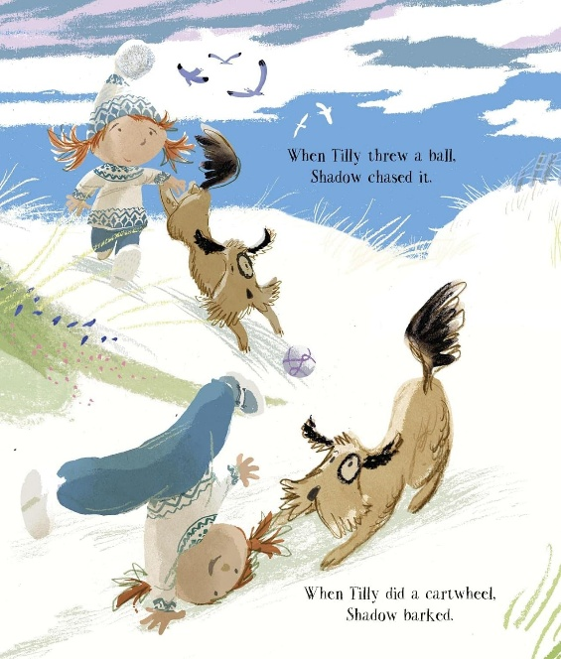

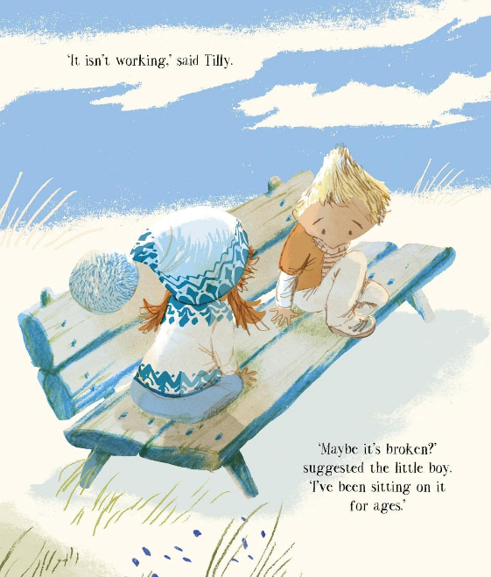

感谢您的阅读！
请将反馈信息发至：版权负责人
Email：Rights@nurnberg.com.cn
安德鲁·纳伯格联合国际有限公司北京代表处
北京市海淀区中关村大街甲59号中国人民大学文化大厦1705室, 邮编：100872
电话：010-82504106, 传真：010-82504200
公司网址：http://www.nurnberg.com.cn
书目下载：http://www.nurnberg.com.cn/booklist_zh/list.aspx
书讯浏览：http://www.nurnberg.com.cn/book/book.aspx
视频推荐：http://www.nurnberg.com.cn/video/video.aspx
豆瓣小站：http://site.douban.com/110577/
新浪微博：安德鲁纳伯格公司的微博_微博 (weibo.com)

