新 书 推 荐

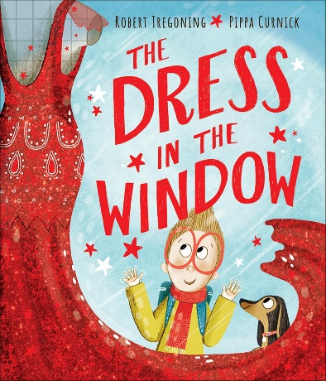
中文书名：《橱窗里的裙子》
英文书名：THE DRESS IN THE WINDOW
作 者：Robert Tregoning, Pippa Curnick
出 版 社：OUP
代理公司：ANA
页 数：32页
出版时间：2024年3月
代理地区：中国大陆、台湾
审读资料：电子稿
类 型：故事绘本

- 本作跳出传统儿童故事的叙事框架，以孩童视角诠释独一无二的自我表达。区别于常规成长绘本的固化剧情，故事以橱窗红裙为情感载体，真实还原孩子纯粹的审美喜好与内心期许。
- 男孩为心爱之物主动努力、奔赴向往的设定，展现了孩童本真的生命力与鲜活天性。整部作品摒弃刻板的成长规训，鼓励每一位小读者遵从本心、大胆展现自我，尊重每个人与众不同的热爱与特质。
- 绘本构建科学正向的亲子引导模式，传递劳动务实的成长理念。面对孩子对红裙子的执着喜爱，母亲没有轻易满足孩子的心愿，也没有否定孩子的特殊喜好，而是采用合理的引导方式，让孩子通过劳动换取心爱之物。这种有原则的教育方式，潜移默化培养孩子的责任心与行动力，让热爱与成长双向并行。

内容简介：

A young boy longs for a dress that he sees in a shop window and rejoices when his mother gifts it to him for his birthday.

That dress! It shimmers, so radiant and red. As the boy stares at it, full of wonder, he has just one wish: to put on that dress and to swirl and to swish. He’ll do anything to earn enough to buy it from the secondhand shop, but he’ll have to hurry. There’s just one red dress in the window!

This playful and imaginative story of self-expression brims with the infectious joy that comes when a child’s individuality is met with wholehearted support and love.

作者简介：

Robert Tregoning performed in London’s renowned West End theaters before he began writing children’s books. Robert writes the stories he wishes he’d read as a child, hoping to provide a voice of recognition, validation, and kindness. He lives in the United Kingdom.

Pippa Curnick is the author and illustrator of numerous children’s books, including the award-winning Indigo Wilde series. When Pippa isn’t painting or drawing, she enjoys walking in the woods near Leicestershire, United Kingdom, where she lives with her husband and their two children.

媒体评价：

"Sweet and uplifting." - Kirkus Reviews

内页插图：
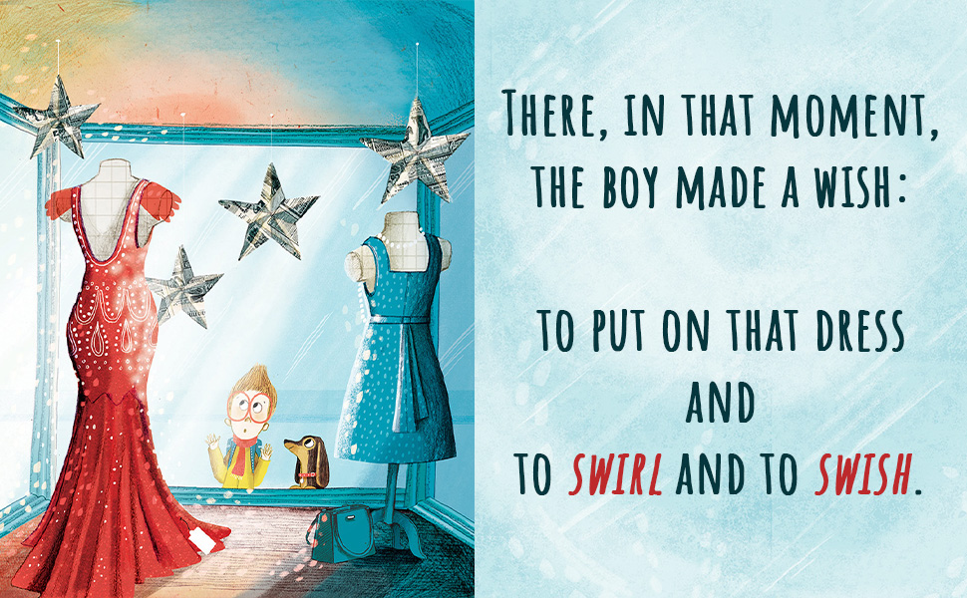


感谢您的阅读！
请将反馈信息发至：版权负责人
Email：Rights@nurnberg.com.cn
安德鲁·纳伯格联合国际有限公司北京代表处
北京市海淀区中关村大街甲59号中国人民大学文化大厦1705室, 邮编：100872
电话：010-82504106, 传真：010-82504200
公司网址：http://www.nurnberg.com.cn
书目下载：http://www.nurnberg.com.cn/booklist_zh/list.aspx
书讯浏览：http://www.nurnberg.com.cn/book/book.aspx
视频推荐：http://www.nurnberg.com.cn/video/video.aspx
豆瓣小站：http://site.douban.com/110577/
新浪微博：安德鲁纳伯格公司的微博_微博 (weibo.com)
微信订阅号：ANABJ2002


