新 书 推 荐

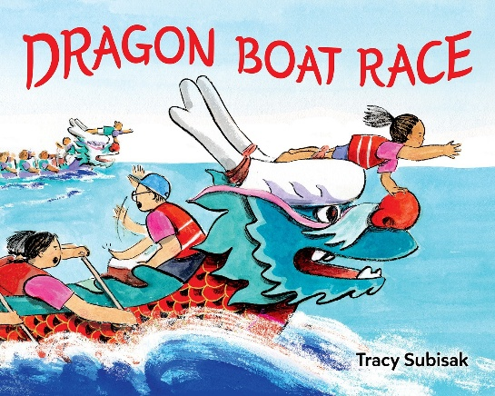
中文书名：《龙舟比赛》
英文书名：DRAGON BOAT RACE
作 者：Tracy Subisak
出 版 社：Little Brown
代理公司：Little Brown/ANA
页 数：40页
出版时间：2027年3月
代理地区：中国大陆、台湾
审读资料：电子稿
类 型：故事绘本

- 获奖绘本作者结合自身代表台湾队多年划龙舟、带队参赛的真实经历创作，海量精美插画还原端午激烈竞渡现场，完整展现传统龙舟赛事全过程，紧凑刺激的竞赛剧情，让孩子沉浸式感受端午盛会，读懂团结拼搏的力量。
- 作者兼具作家与专业插画师双重身份，多部作品广受好评，绘画风格柔和细腻，充满童趣与动感。文字简洁明快，画面细节丰富，龙舟、锣鼓、赛场人群刻画栩栩如生，不管是独立阅读还是亲子共读都十分合适。
- 书中不止讲述竞技故事，文末还增设端午、龙舟相关中文词汇解读板块。以海外儿童绘本为媒介，生动普及中国端午非遗文化，轻松搭建跨文化沟通渠道，让海外小读者直观感受中华传统节日的独特魅力。

内容简介：

Packed with excitement and richly illustrated, imaginative action scenes, Dragon Boat Race takes readers through the experience of participating in this vibrant cultural event and holiday!

The Dragon Boat Festival has begun!

Every team has prepared for months to race their dragon-shaped boats to capture the flag at the finish. If Team Taiwan wants to win, they must work together and give it their all!

The crowd cheers, team captains pound the drums, and paddlers work together to propel their boats forward! But this is a close race . . . Can Team Taiwan pull ahead to victory?

作者简介：

Tracy Subisak is the author and illustrator of Sorry, Snail and the award-winning Jenny Mei Is Sad, as well as the illustrator of several picture books, including The Inactivity Book and Amah Faraway. She has raced dragon boats with Team Taiwan for several years, has captained the team, and has earned fourth place out of nearly seventy teams, in the Pacific Northwest where she lives with her family. You can visit her online at tracysubisak.com and on Instagram @tracysubisak.

内页插图：
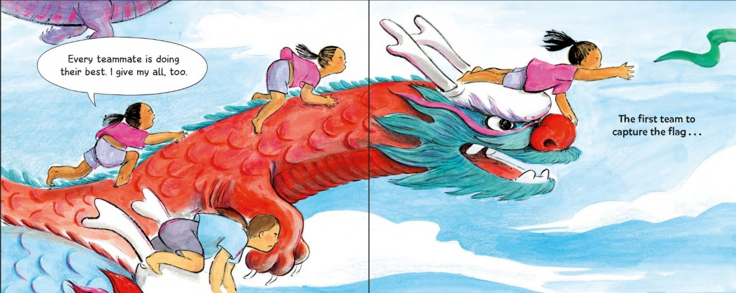

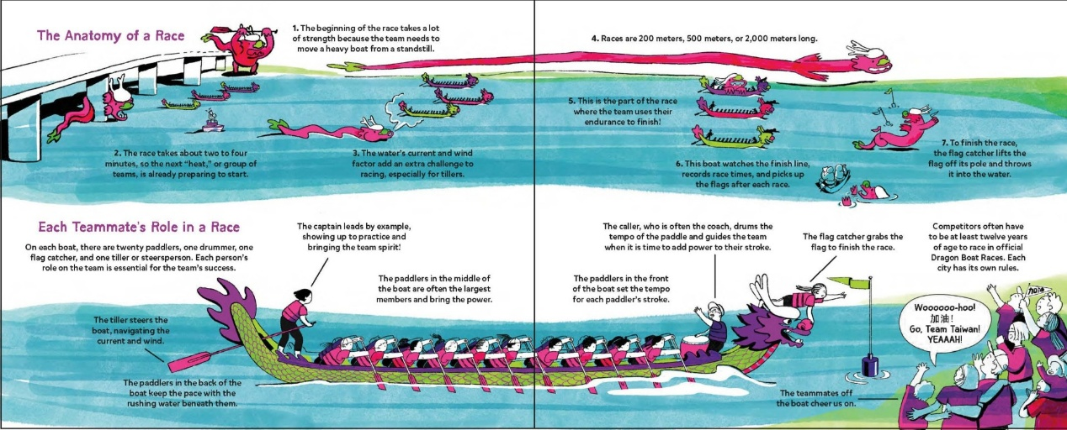

感谢您的阅读！
请将反馈信息发至：版权负责人
Email：Rights@nurnberg.com.cn
安德鲁·纳伯格联合国际有限公司北京代表处
北京市海淀区中关村大街甲59号中国人民大学文化大厦1705室, 邮编：100872
电话：010-82504106, 传真：010-82504200
公司网址：http://www.nurnberg.com.cn
书目下载：http://www.nurnberg.com.cn/booklist_zh/list.aspx
书讯浏览：http://www.nurnberg.com.cn/book/book.aspx
视频推荐：http://www.nurnberg.com.cn/video/video.aspx
豆瓣小站：http://site.douban.com/110577/
新浪微博：安德鲁纳伯格公司的微博_微博 (weibo.com)
微信订阅号：ANABJ2002


