新 书 推 荐
《珍宝姐妹的绝妙传奇》
La Folle Fabule Des Sœurs Trésor

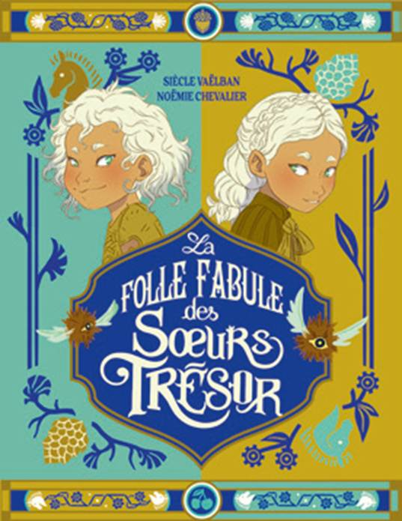
中文书名：《珍宝姐妹的绝妙传奇》
英文书名：The Fabulous Fable of the Trésor Sisters
法文书名：La Folle Fabule Des Sœurs Trésor
作 者：Siècle Vaëlban and Noëmie Chevalier
出 版 社：Casterman Jeunesse
代理公司：Curtis Brown UK/ANA
出版时间：2026年10月
代理地区：中国大陆、台湾
审读资料：电子稿
类 型：故事绘本

本书卖点：

首创双面叙事：一书两读，从正反两面分别进入一对双胞胎的平行世界，体验独一无二。
艺术与品质兼具：插画精美生动，辅以礼品级装帧设计，既是精神食粮，也是收藏珍品。
故事与内涵并存：情节奇幻冒险、诙谐感人，内核更探讨成长平衡与个性包容，寓意深远。

内容简介：

Twin sisters Ishel and Ishtar happily scramble around the Treasure Godmothers' orphanage until the day they win a Marquise and her husband in the parents' lottery. Louise de Millecerises, Monsieur Toque, and the little girls embark on a long journey to their new home. An attack by red-spotted unicorns separates the two sisters, who will grow up in radically different environments.

Like the Treasure sisters themselves, the book features two mirrored stories. This double-sided illustrated picture book can be read from either direction. Read right-side-up, you follow the story from Ishel's perspective. Turn it upside down, and you discover Ishtar's point of view. This dual narration serves themes such as the quest for freedom, the various lessons one needs to find balance, and the benefits of the middle path.

Extravagant, magical, and moving, The Tall Tale of the Treasure Sisters celebrates diversity and encourages its readers to nurture the little (or grand!) bit of madness that resides in each of us.

作者简介：

Siècle Vaëlban is a writer who finds equal inspiration in philosophical inquiry and the boundless realm of imagination. A traveler at heart, she learned from the road that wonder is a path to joy and that our differences are what make us universally human. Her work celebrates creativity, celebrates the power of story, and invites readers to see the world through a uniquely whimsical lens—preferably one shaped like a heart.

Noëmie Chevalier (b. 1988) is a graphic designer and illustrator. After studying visual communication, she embarked on her professional career and now works from her studio in Tours.

内页插图：
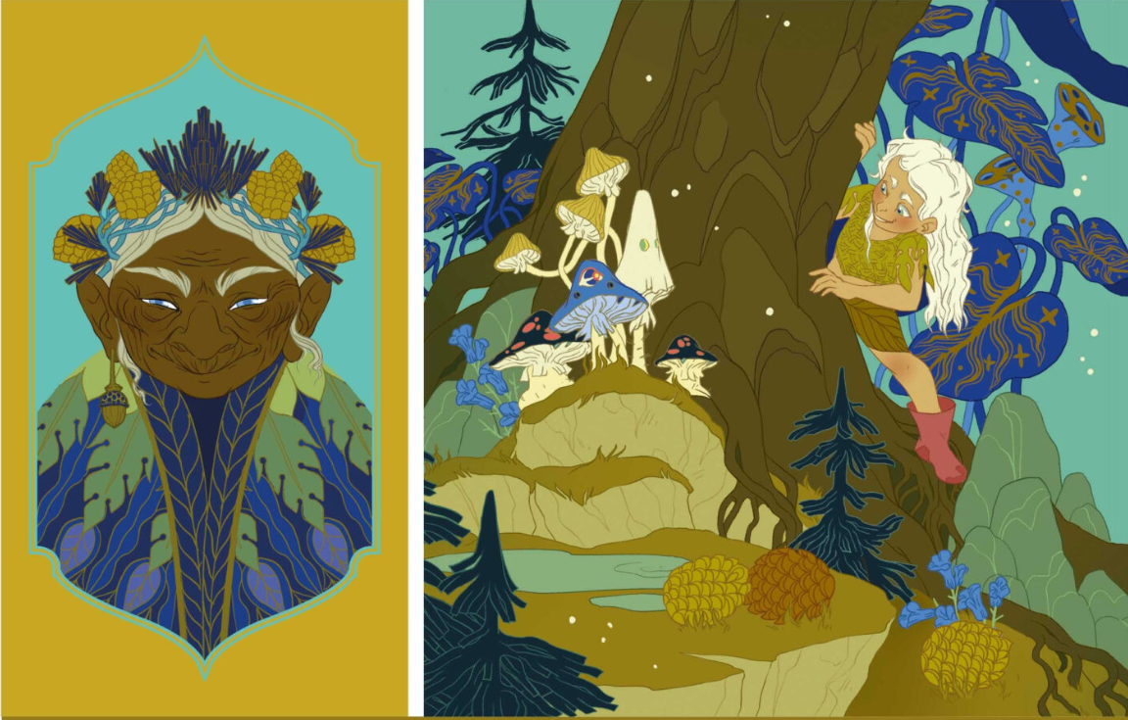

感谢您的阅读！
请将反馈信息发至：版权负责人
Email：Rights@nurnberg.com.cn
安德鲁·纳伯格联合国际有限公司北京代表处
北京市海淀区中关村大街甲59号中国人民大学文化大厦1705室, 邮编：100872
电话：010-82504106, 传真：010-82504200
公司网址：http://www.nurnberg.com.cn
书目下载：http://www.nurnberg.com.cn/booklist_zh/list.aspx
书讯浏览：http://www.nurnberg.com.cn/book/book.aspx
视频推荐：http://www.nurnberg.com.cn/video/video.aspx
豆瓣小站：http://site.douban.com/110577/
新浪微博：安德鲁纳伯格公司的微博_微博 (weibo.com)
微信订阅号：ANABJ2002


