新 书 推 荐

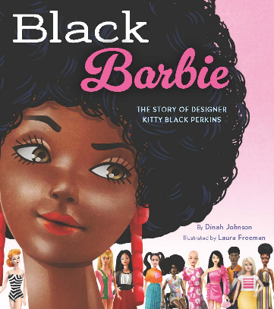
中文书名：《黑人芭比》
英文书名：BLACK BARBIE
作 者：Dinah Johnson and Laura Freeman
出 版 社：Little Brown
代理公司：Little Brown/ANA
页 数：40页
出版时间：2027年1月
代理地区：中国大陆、台湾
审读资料：电子稿
类 型：知识绘本

- 取材真实历史，讲述设计师Kitty Black Perkins如何推动世界首款黑人芭比诞生，一段改写芭比发展史的重要故事。
- 温暖有力的励志叙事，展现女性创意力量，启发孩子敢于表达想法、坚持心中的理想。
- 金牌创作阵容：畅销童书获奖作者Dinah Johnson和科丽塔・斯科特金奖荣誉插画师Laura Freeman联手打造，品质广受图书馆认可。

内容简介：

Celebrate the creator of the world’s first Black Barbie in this inspiring story about Kitty Black Perkins, the visionary toy designer who helped define the course of Barbie’s history.

Ever since she was little, Kitty Black Perkins loved making clothes for dolls. She’d cut the materials using paper, creating outfits and accessories from a rainbow of colors and patterns. So when she saw an ad to work for Mattel designing clothes for Barbie, she jumped at the opportunity. But it never felt right to Kitty that all the dolls had the same skin tone, and she wished there was a Barbie that looked like her and her family and neighbors back home in South Carolina.

This inspiring true story celebrates the life of Kitty Black Perkins, whose creativity and confidence led to the production, manufacturing, and marketing of the first Black Barbie doll. It’s a radiant portrait of the woman who dared to see herself in Barbie, allowing children to do the same.

作者简介：

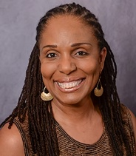
Dinah Johnson is the award-winning author of many books for young readers including Ida B. Wells Marches for the Vote (W24) and H Is for Harlem, illustrated by April Harrison, which received five starred reviews, was named a Boston-Globe Horn Book Honor Book, a Kirkus Best Book of the Year, a School Library Journal Best Book of the Year, and a Horn Book Fanfare title. A professor of English at the University of South Carolina, she lives in Columbia. She invites you to visit her at dinahjohnsonbooks.com.

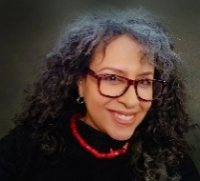
Laura Freeman is the acclaimed illustrator of the New York Times bestseller Hidden Figures: The True Story of Four Black Women and the Space Race, which received a Coretta Scott King Book Award Illustrator Honor and an NAACP Image Award for Outstanding Literary Work for Children. She has illustrated over thirty books for young readers. A native New Yorker residing in Atlanta with her family, she invites you to visit her website: lfreemanart.com.

内页插图：
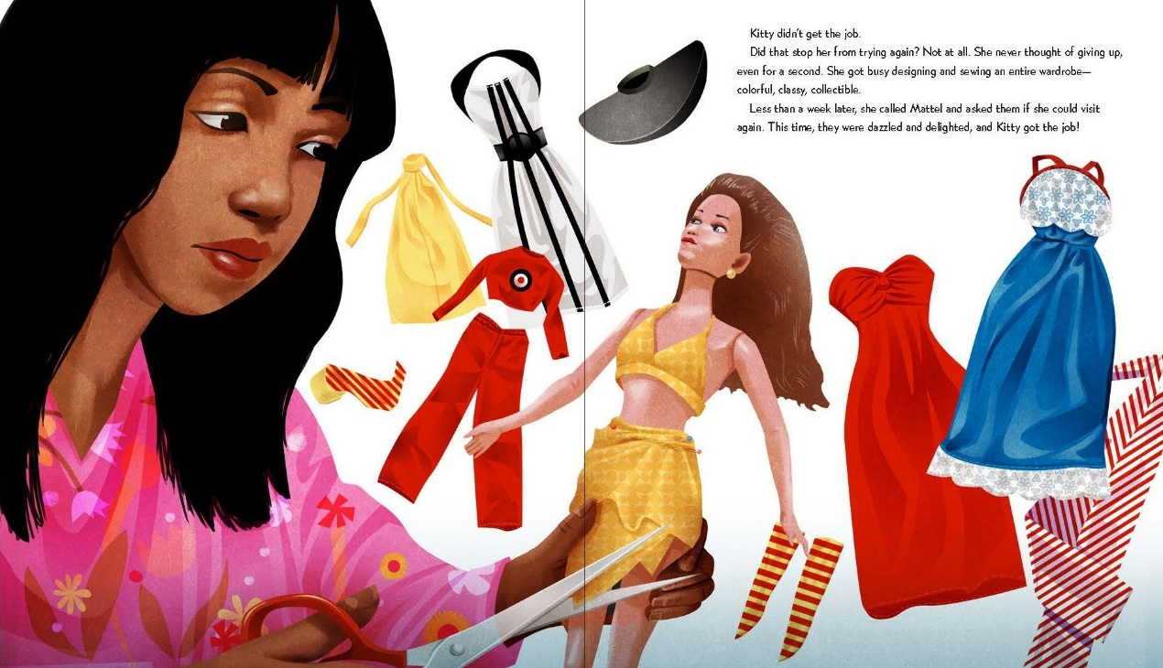
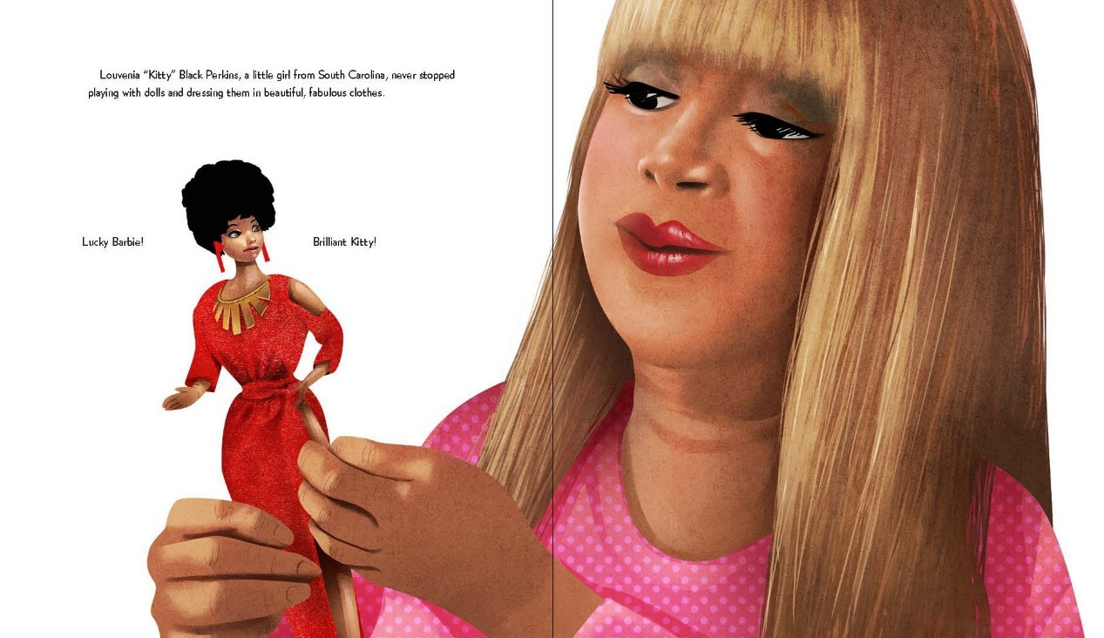
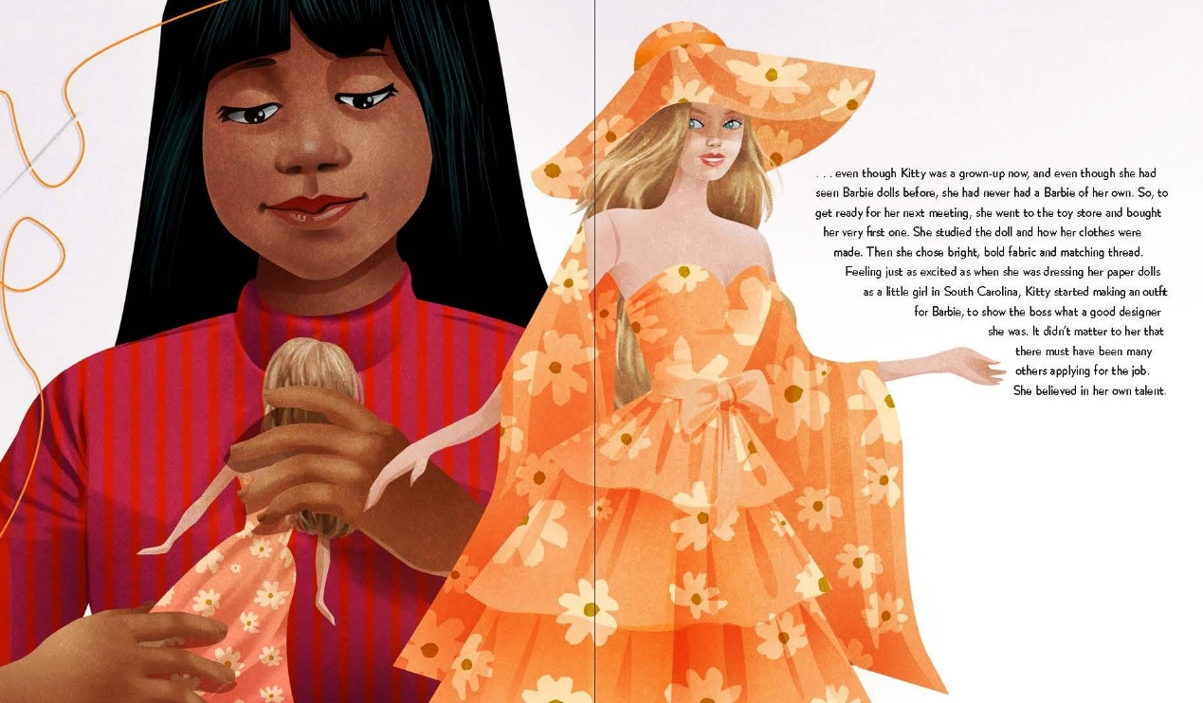
感谢您的阅读！
请将反馈信息发至：版权负责人
Email：Rights@nurnberg.com.cn
安德鲁·纳伯格联合国际有限公司北京代表处
北京市海淀区中关村大街甲59号中国人民大学文化大厦1705室, 邮编：100872
电话：010-82504106, 传真：010-82504200
公司网址：http://www.nurnberg.com.cn
书目下载：http://www.nurnberg.com.cn/booklist_zh/list.aspx
书讯浏览：http://www.nurnberg.com.cn/book/book.aspx
视频推荐：http://www.nurnberg.com.cn/video/video.aspx
豆瓣小站：http://site.douban.com/110577/
新浪微博：安德鲁纳伯格公司的微博_微博 (weibo.com)
微信订阅号：ANABJ2002


