新 书 推 荐

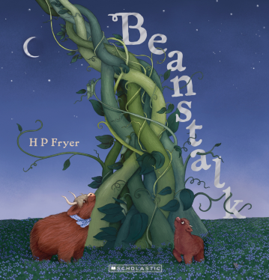
中文书名：《豆茎》
英文书名：BEANSTALK
作 者：H.P. Fryer
出 版 社：Scholastic New Zealand
代理公司：Scholastic /ANA
页 数：32页
出版时间：2026年10月
代理地区：中国大陆、台湾
审读资料：电子稿
类 型：故事绘本

- 本书由新西兰知名插画师、《奥格》（Ogg）作者汉娜・弗莱尔（H.P. Fryer）自写自绘。作者兼具历史与哲学双学位、专业插画本科背景，曾举办个人画展；
- 聚焦隔代亲情传承，引导幼儿感知长辈爱意，学会珍惜陪伴、理解思念情绪；
- 重构家喻户晓的魔豆传说，主角换成苏格兰高地小牛，以聆听奶奶口述的魔法故事为线索，跳出原版冒险冲突，打造温柔治愈的全新叙事。

内容简介：

Bo the Scottish Highland calf adores his Old Nan’s tales of magic beans and towering beanstalks. When Bo discovers a mysterious golden bean, his belief in Old Nan’s magic grows into something magnificent in this tender, intergenerational story that celebrates magic, adventure, family ties and remembering the joy and delight of our loved ones.

作者简介：


H.P. Fryer is a New Zealand-based illustrator and children’s book author residing north of Auckland with her husband Ryan and their two lively young children.

A lifelong history enthusiast and self-proclaimed pizza lover, Fryer holds a Bachelor of Arts with a double major in History and Philosophy from the University of Auckland, alongside a Bachelor of Illustration from Melbourne Polytechnic. Her artistic roots were showcased in formal gallery exhibitions across Melbourne, including the 2017 group graduate show STOKED and her 2018 solo exhibition The Tour De Nesle Affair, both hosted at Off The Kerb Gallery.

Fryer’s creative practice is defined by a core, joyful obsession: she firmly stands by the idea that gorillas are inherently humorous—a belief that permeates nearly all her artwork.

感谢您的阅读！
请将反馈信息发至：版权负责人
Email：Rights@nurnberg.com.cn
安德鲁·纳伯格联合国际有限公司北京代表处
北京市海淀区中关村大街甲59号中国人民大学文化大厦1705室, 邮编：100872
电话：010-82504106, 传真：010-82504200
公司网址：http://www.nurnberg.com.cn
书目下载：http://www.nurnberg.com.cn/booklist_zh/list.aspx
书讯浏览：http://www.nurnberg.com.cn/book/book.aspx
视频推荐：http://www.nurnberg.com.cn/video/video.aspx
豆瓣小站：http://site.douban.com/110577/
新浪微博：安德鲁纳伯格公司的微博_微博 (weibo.com)
微信订阅号：ANABJ2002


