新 书 推 荐

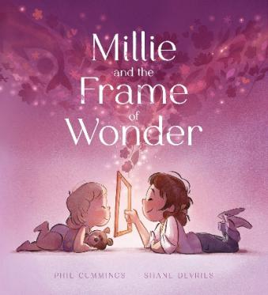
中文书名：《米莉与奇妙之框》
英文书名：MILLIE AND THE FRAME OF WONDER
作 者：Phil Cummings and Shane Devries
出 版 社：Scholastic Australia
代理公司：Scholastic /ANA
页 数：32页
出版时间：2026年8月
代理地区：中国大陆、台湾
审读资料：电子稿
类 型：故事绘本

- 创作者为澳大利亚极具影响力的儿童文学作家Phil Cummings，著作超百部，与插画师Shane Devries合作的作品《BOY》入围澳大利亚儿童图书委员会年度图书奖短名单，被瑞士巴塞尔的国际青少年读物委员会评为“残疾儿童优秀读物”，并于2017年荣获儿童和平文学奖。此外，他的作品《骑吧，里卡多，骑吧》（Ride Ricardo Ride）入选2016年澳大利亚儿童图书委员会荣誉书目，《丹尼·艾伦来过这里》（Danny Allen was here）入围阿德莱德艺术节文学奖短名单，《羽毛》（Feathers）入围总理文学奖短名单，《报纸帽子》（Newspaper Hats）最近在法国荣获了阿尔茨海默病“克罗诺斯奖”。
- 插画师Shane DeVries因绘制《圣诞龙》（Christmasaurus）系列风靡全球，笔下角色深入人心，建立了庞大的国际读者基础。他拥有二十余年童书与动画创作履历，擅长水粉、数字绘画等多元创作形式，画作自带温暖诙谐的气质。
- 以奇妙画框为巧妙引子，引导主角跳出固有视角，学会在普通日常里发掘惊喜与美好。故事传递简单真挚的生活哲思，鼓励孩子用心感受身边无处不在的乐趣与诗意。
- 整体画风柔和梦幻，线条温润不张扬，人物形象灵动可爱。画面没有强烈的视觉冲击，以舒缓的美术基调营造出松弛、治愈的阅读氛围。

内容简介：

When Millie finds an old wooden frame while treasure-hunting with Dad, she starts seeing things in new ways ... An award-winning team returns with this heart-warming story of discovering moments of joy and wonder all around you.

作者简介：


Phil Cummings was born in the small seaside town of Port Broughton in South Australia. His interest in writing began with poetry and writing songs. With the beginning of teacher training, Phil was exposed to a great deal of children’s literature, particularly picture books. Phil decided to sit down and write one! He mistakenly believed it would not be difficult at all! His work was rejected time and time again but, having the writing bug, he kept going. He soon learnt that writing for children was a lot harder than he ever imagined. Seven years after his first attempts, Phil had a book published.

Goodness Gracious!– illustrated by Craig Smith – was published by Omnibus Books in 1989. and in the U.S. in 1990. Since that time Phil has published over a hundred books for children - from pictures books to novels. He has received numerous awards for his books including Children’s Book Council of Australia honors. Ride Ricardo Ride was a CBCA honor book in 2016. ‘Danny Allen was here’ was shortlisted for the Adelaide Festival of Arts Literary Awards and ‘Feathers’ was shortlisted for the Prime Ministers Literary Awards. His book BOY (illustrated by Shane Devries) was shortlisted for the CBCA Book of the Year Awards and won the Children’s Peace Literature Award in 2017.

Phil’s books have been published extensively overseas, with BOY being named an outstanding book for children with disabilities by the International Board of Books for Young People in Basel, Switzerland. His book Newspaper Hats recently won the Chronos Award for Alzheimers in France.


Shane DeVries is an Australian children's book illustrator and animation art director with over two decades of experience across publishing and screen. Born in Adelaide and now based in Perth, Shane's illustration work spans gouache painting, digital art, and mixed media — always with a warmth and wit that connects immediately with young readers.

Shane's most recognised work is the illustration of Tom Fletcher's bestselling Christmasaurus series for Penguin Books, including The Christmasaurus, The Christmasaurus and the Winter Witch, The Christmasaurus and the Naughty List, and A Christmasaurus Carol. His picture book adaptations have introduced the beloved characters to a new generation of early readers. Other published works include The Creakers (also by Tom Fletcher), 100% Wolf, Boy, The Danger Gang, Brain Freeze, Crumbs, 1001 Nights, Peleda, and Figaro Pho.

Shane's illustration style draws on a deep love of character, texture, and storytelling — built from a foundation in architectural illustration and a long career in animation art direction, including work on internationally distributed animated series.

He is represented by Curtis Brown and has worked with publishers including Penguin Books, Scholastic, and Kane Miller. His work is distributed internationally through Amazon and has earned recognition from Goodreads readers worldwide.

Shane also works as a remote contractor on animation and illustrated book projects. For commissions, publishing enquiries, or collaboration, use the contact page.

内页插图：

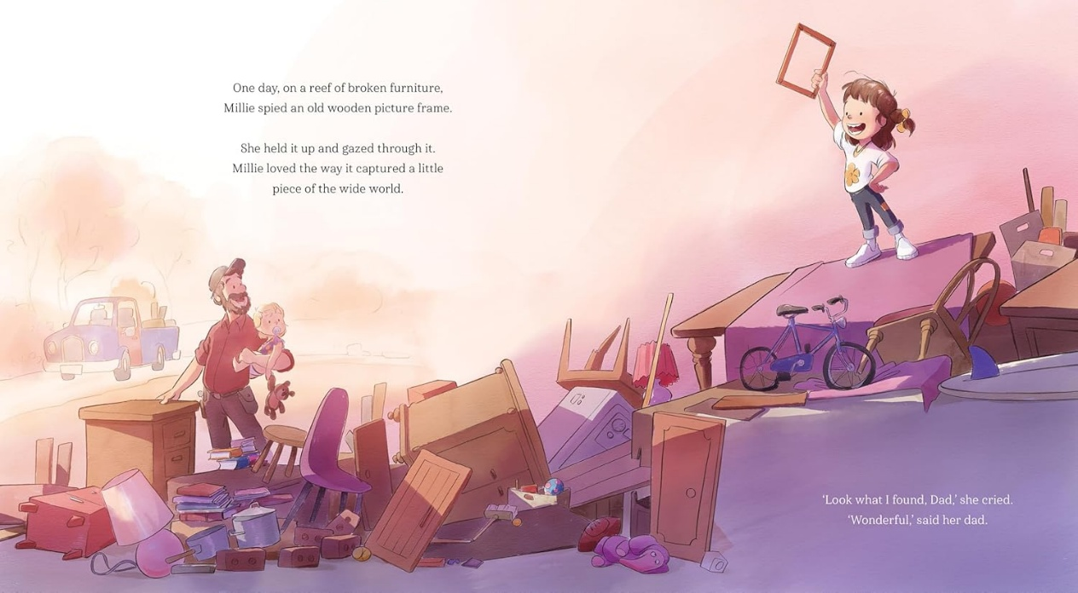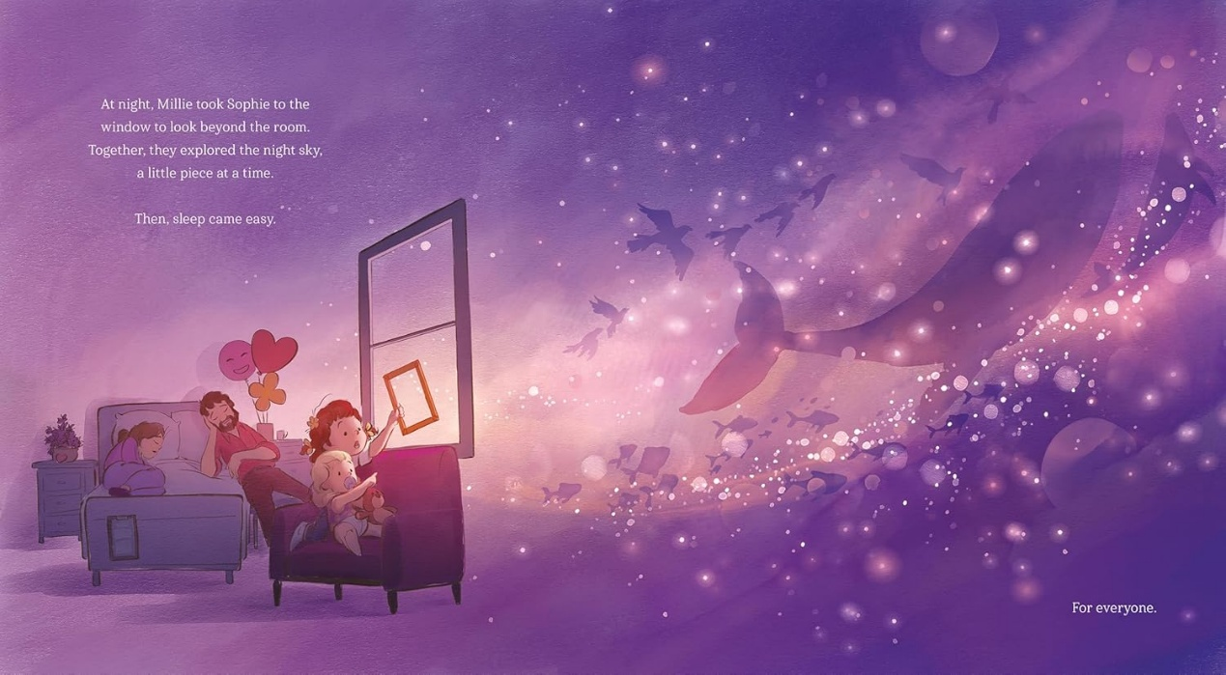

感谢您的阅读！
请将反馈信息发至：版权负责人
Email：Rights@nurnberg.com.cn
安德鲁·纳伯格联合国际有限公司北京代表处
北京市海淀区中关村大街甲59号中国人民大学文化大厦1705室, 邮编：100872
电话：010-82504106, 传真：010-82504200
公司网址：http://www.nurnberg.com.cn
书目下载：http://www.nurnberg.com.cn/booklist_zh/list.aspx
书讯浏览：http://www.nurnberg.com.cn/book/book.aspx
视频推荐：http://www.nurnberg.com.cn/video/video.aspx
豆瓣小站：http://site.douban.com/110577/
新浪微博：安德鲁纳伯格公司的微博_微博 (weibo.com)
微信订阅号：ANABJ2002


