新 书 推 荐

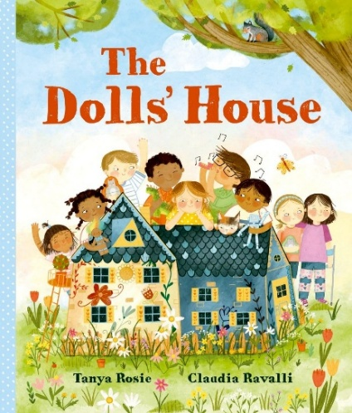
中文书名：《玩偶屋》
英文书名：The Dolls' House
作 者：Tanya Rosie and Claudia Ravalli
出 版 社：OUP
代理公司：OUP/ANA
页 数：32页
出版时间：2024年9月
代理地区：中国大陆、台湾
审读资料：电子稿
类 型：儿童故事绘本
版权已授：以色列、希腊

- 故事塑造性格各异的一群孩子，重点刻画羞怯、难以融入集体的孩子。叙事视角温和客观，让小读者看见人与人之间的性格差异，懂得给予他人空间，理解善意存在多种表达形式。
- 破旧玩偶屋作为全书核心意象，从路边无人问津的旧物，转变为孩子们相聚的乐园。物件的命运变化与孩童的人际交往相互呼应，巧妙用具象事物承载抽象的友谊主题，构思巧妙，让孩子更容易读懂陪伴与善意带来的改变。
- 由SCBWI获奖插画师倾力打造，作品兼具原创性与艺术性。画风大胆新颖却不失柔和亲和力。画师将自然探索、童年嬉戏的生活感悟融入画面，纹理细腻、画面饱满，为整本绘本赋予浓郁的童真氛围感。

内容简介：

One day Mia and her mum are walking home to their new house when they find a dolls' house on the side of the road. It looks sad with its broken shutters and peeling paint, but Mia falls in love and takes it home to fix it up.

The next morning a little boy is looking at the dolls' house on Mia's porch. Soon more and more children arrive, and they spend the long summer days playing together. Just one child does not join in, and nothing Mia does can persuade him to overcome his shyness.

Then, one night, there is a terrible storm and the dolls' house is damaged. Mia learns that
kindness can come from the most unexpected places.

作者简介：


Tanya Rosie studied English Literature in Nottingham, Vancouver and London, before becoming an editor, author and passionate reader of children's books. She currently works as a commissioning editor at Walker Books, and also loves to write poems and picture books of her own.

She has three beautiful publications from Walker: Mum, Me and the Mulberry Tree, and Grandpa Is Here, all illustrated by Chuck Groenink. The latest is The Night of the Hedgehog. Based on the Tanya's own childhood memories, it is as tender and sweet a father-daughter book as you can get and will hopefully inspire a whole new generation of keen hedgehog spotters.

Tanya grew up in Milton Keynes in a household filled with Iranian traditions (from her mum), and a few Scottish ones, too (from her dad). In all her writing, she likes to capture something of the way it was being a child. She now lives in St Albans.


Claudia Ravalli is a professional illustrator. Originally from New York City where she studied art history, she currently resides in Geneva, Switzerland with her family and two Siberian cats. An awardee of the SCBWI Big 5-Oh Portfolio Showcase, she creates daring and original yet accessible artwork that fits the picture book market.

Claudia draws inspiration from her children and her childhood countryside summers. Her early experiences of exploring forests, playing with bugs and swimming in rivers shape the authentic tone of her illustrative works.

All of her illustrations start with hand-drawn creation, then are refined in Photoshop and Procreate with various brushes and textures. Outside of creation, she enjoys cooking, running and walking in nature, which continuously fuels her artistic inspiration.

媒体评价：

'...a beautiful book for encouraging class and the whole school community, with the strong central message that every child is welcome and everyone has something to give and share with others.' ― Books For Topics

"This heartwarming and charming story shows empathy and different ways for children to spend time together." ― Farrah Riaz, author of The Twirly Wiggly Dance

"Charming and sweet." ― The Bookseller

"This joyful story is a wonderful celebration of play, friendship and kindness! Perfect for sharing, the book offers much to enjoy." ― Through the Bookshelf

"Such a sweet story of friendship with enchanting and detailed illustrations!" ― Harriet Muncaster, Author of Isadora Moon

"A relatable, heart-warming story." ― ACHUKA

"With themes of friendship, sharing and empathy, this is a wonderfully heart-warming story to share. If you read it aloud to a class, make sure you have plenty of time for your listeners to explore the details in Claudia Ravalli's illustrations, large and small." ― Jill Bennett, Red Reading Hub

"Who can resist a dolls' house? Mia, the main character of Tanya Rosie's The Dolls' House can't! The dolls' house that she can't resist is made all the more alluring, not just by Claudia Ravalli's beautiful, gentle, classically detailed illustrations... The warmth of this story is palpable." ― Louise Ellis-Barrett, Armadillo

"A charming picture book about friendship, kindness and community, with a magical doll's house at its heart. Beautifully written, with warm, inviting illustrations." ― Sarah Webb, award-winning children's author

内页插图：

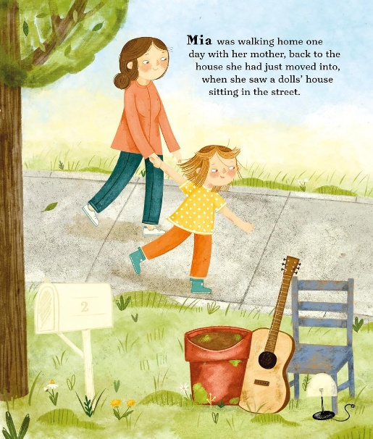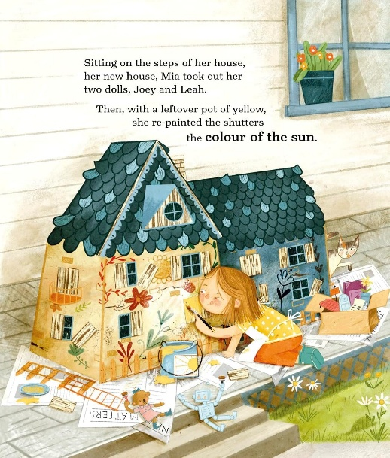
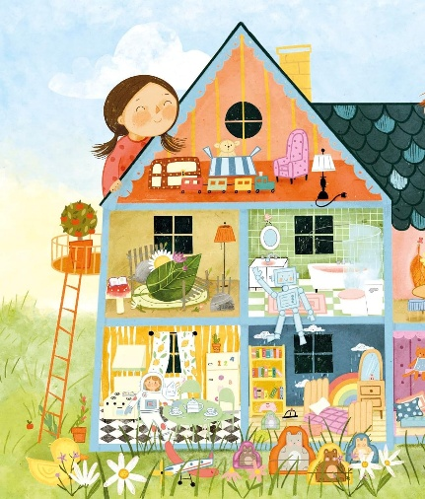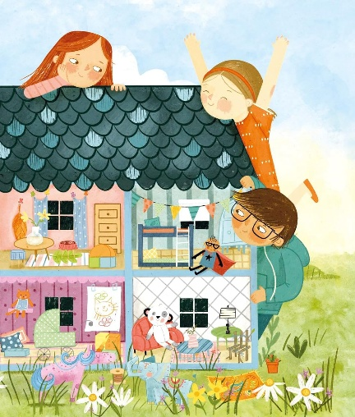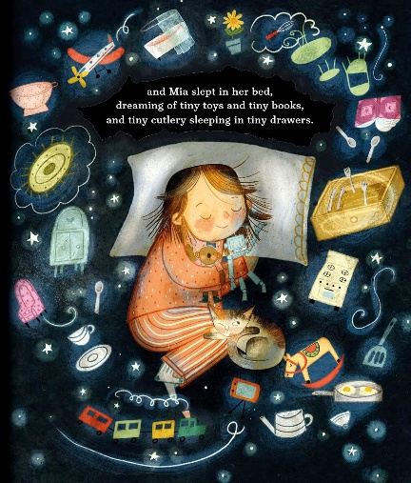

感谢您的阅读！
请将反馈信息发至：版权负责人
Email：Rights@nurnberg.com.cn
安德鲁·纳伯格联合国际有限公司北京代表处
北京市海淀区中关村大街甲59号中国人民大学文化大厦1705室, 邮编：100872
电话：010-82504106, 传真：010-82504200
公司网址：http://www.nurnberg.com.cn
书目下载：http://www.nurnberg.com.cn/booklist_zh/list.aspx
书讯浏览：http://www.nurnberg.com.cn/book/book.aspx
视频推荐：http://www.nurnberg.com.cn/video/video.aspx
豆瓣小站：http://site.douban.com/110577/
新浪微博：安德鲁纳伯格公司的微博_微博 (weibo.com)
微信订阅号：ANABJ2002


