系 列 推 荐
《如何做》两册系列
How To Catch A Rainbow & How To Make A Story
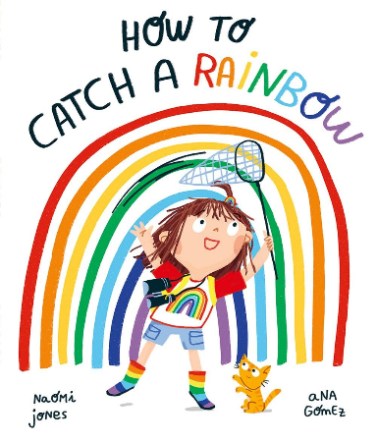
中文书名：《如何捕捉彩虹》
英文书名：How To Catch A Rainbow
作 者：Naomi Jones and Ana Gómez
出 版 社：OUP
代理公司：OUP /ANA
页 数：36页
出版时间：2022年8月
代理地区：中国大陆、台湾
审读资料：电子稿
类 型：儿童故事绘本
版权已授：韩国、荷兰、卢森堡等8种语言及地区

绝佳的思维启蒙读物。故事围绕 “追逐目标 — 遭遇失败 — 转换思路 —解决” 展开，潜移默化培养孩子韧性、创造力与逆向思考能力。
激发儿童的想象力与创造力，鼓励动手实践与问题解决，通过收集彩虹色彩的过程，帮助孩子认识颜色并培养审美能力，温暖的家庭互动场景和多彩插画，增强亲子阅读的情感共鸣。
融合色彩认知与自然观察。芙蕾在花园搜集各色植物的情节引导孩子留意大自然中的缤纷色彩，适合幼儿园阅读活动。

内容简介：

Freya loves rainbows. She loves their bright colours and their curvy shape. More than anything, she wishes she has one of her very own. One that she can keep forever. So she decides to become a Rainbow Hunter!

She searches high and low, but no rainbows are to be found, so she decides to make her own, collecting items in every colour of the rainbow from the garden. But when things don't go quite to plan, Freya has to use her imagination and creativity to come up with a way to make her wish come true.

A vibrant story from the author of the bestselling The Perfect Fit with technicolour illustrations by Ana Gomez.

内页插图：
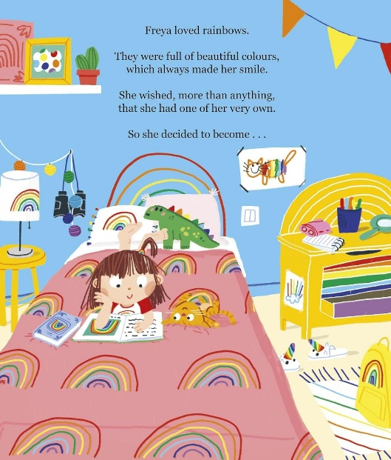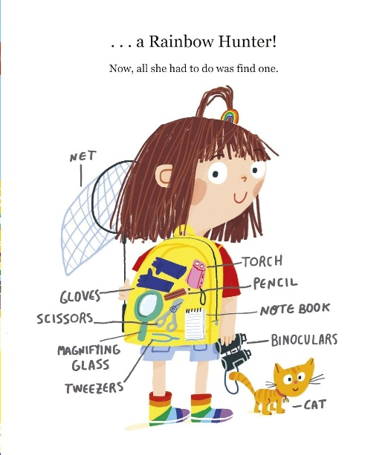
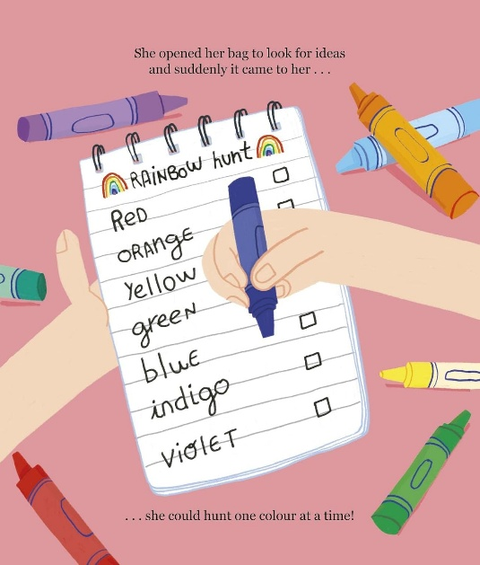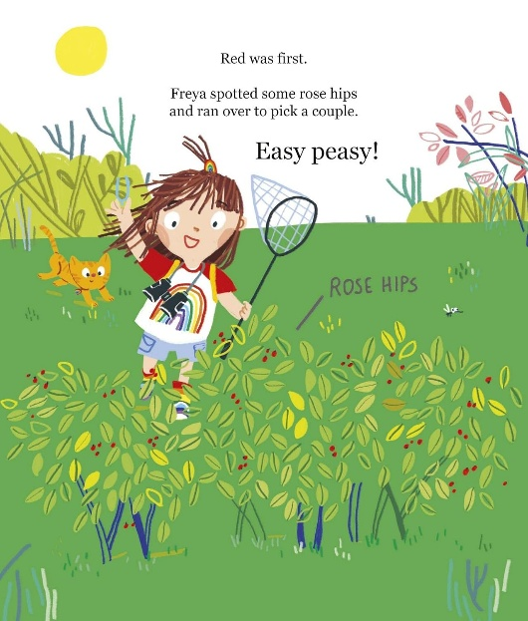
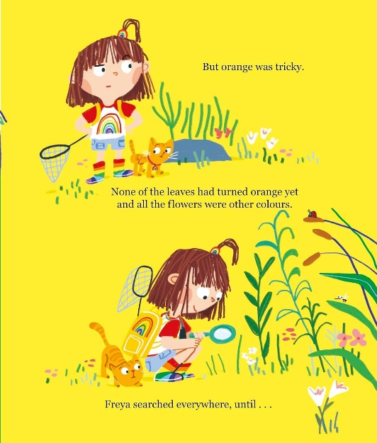

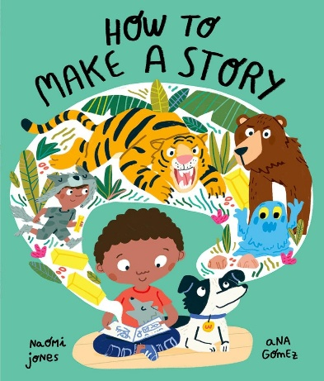
中文书名：《如何编写故事》
英文书名：How To Make A Story
作 者：Naomi Jones and Ana Gomez
出 版 社：OUP
代理公司：OUP /ANA
页 数：36页
出版时间：2023年2月
代理地区：中国大陆、台湾
审读资料：电子稿
类 型：儿童故事绘本
版权已授：韩国、荷兰、卢森堡等8种语言及地区

小男孩麦洛想要创作专属故事，却苦恼不知道如何开头、设计情节、构思结尾。在家人启发下，他从日常生活汲取灵感，即便遭到弟弟妹妹打扰也没有放弃，并最终领悟最重要的道理：故事，就是用来分享的。生动引导孩子发掘生活灵感，敢于大胆表达、自由创作。
灵动缤纷的插画搭配温柔叙事，跳出枯燥的写作教学，用童话方式点燃孩子想象力。鼓励每一位孩子大胆构思、主动讲述，让所有天马行空的想法都拥有表达的机会。

内容简介：

When Milo decides he's going to tell a story, it seems like a great idea. A story of his very own, made up by him! The only problem is that he's not sure how to start ... or what to put in the middle ... or how to end it. With a little help from his family and a lot of real-life inspiration, Milo's story is soon off to a flying start. If only his little brother and sister weren't getting in the way. But then Milo learns the most important lesson of all about stories - that they are made to be shared.

内页插图：
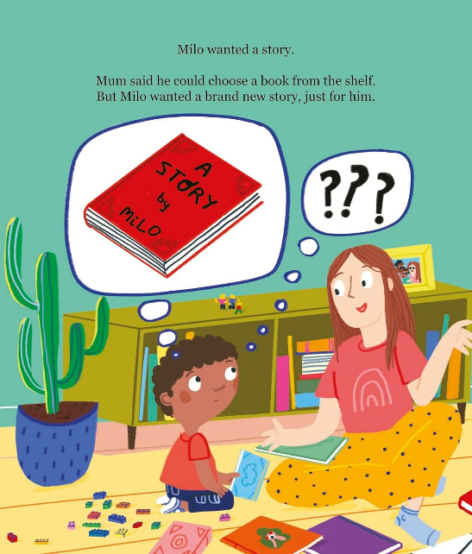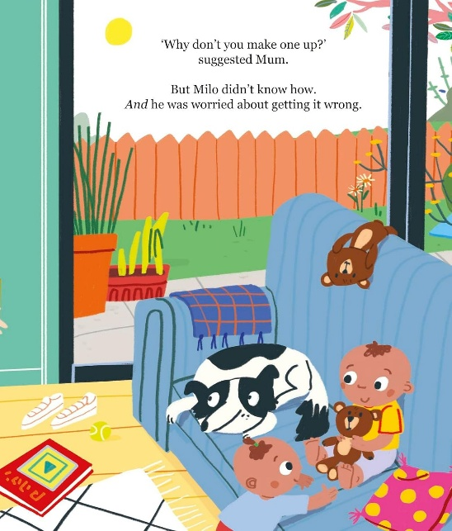
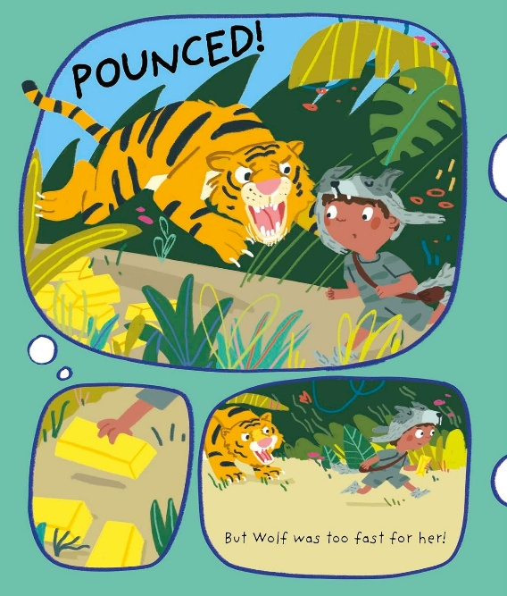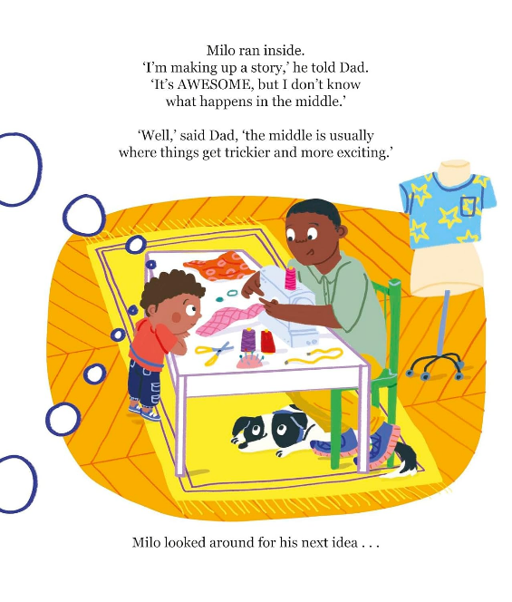
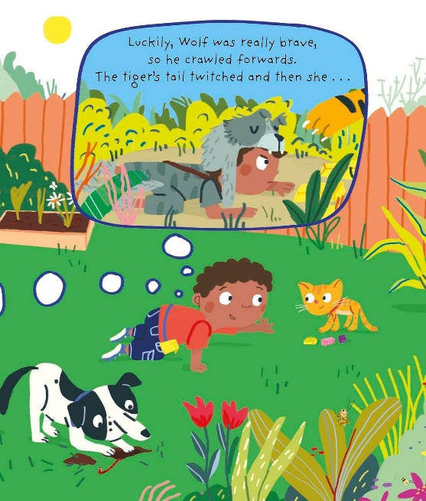

作者简介：

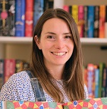
Naomi Jones is an award-winning children’s author. Her books are published by HarperCollins, Penguin Random House, Oxford Children’s Books and Hachette Children’s Group in the UK and have been translated into 22 languages.

In 2025 Naomi was shortlisted for the Sustainable Story Awards and the Ruth Rendell Award for services to literacy. In 2024 her picture book Thunderboots inspired by her diagnosis of dyslexia won the Reader’s Choice Award for Picture Books at the Diversity Awards, the Derby Picture Book Award and was also shortlisted for The Week Junior Awards.

Naomi lives with her family by the sea in Cornwall. She loves wild swimming, playing netball and curling up with a good book.

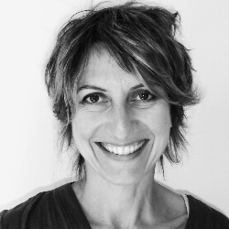
Rebecca Ashdown is an award winning children’s book illustrator, artist and author. Her titles have been shortlisted for Kate Greenaway CILIP Medal, the Portsmouth Book Award, the Sheffield Book Award, the Stockport Children’s Book Award and the Hillingdon Picture Book Award. Her most recent book, Thunderboots, (by Naomi Jones / Oxford University Press, 2024), won the Derby Children’s Picture Book Award and The Readers’ Choice Award in The Diverse Book Awards.

Passionate about teaching art and visual literacy, Rebecca runs regular workshops exploring innovative and inclusive approaches to creativity. She also works with the NHS and ReConnect Gloucestershire as a Creative Health practitioner, developing and delivering online and in person weekly art classes for people with long term health conditions.

Rebecca lives with her family and their lurcher in the Golden Valleys, near Stroud UK.

请将反馈信息发至：版权负责人
Email：Rights@nurnberg.com.cn
安德鲁·纳伯格联合国际有限公司北京代表处
北京市海淀区中关村大街甲59号中国人民大学文化大厦1705室, 邮编：100872
电话：010-82504106, 传真：010-82504200
公司网址：http://www.nurnberg.com.cn
书目下载：http://www.nurnberg.com.cn/booklist_zh/list.aspx
书讯浏览：http://www.nurnberg.com.cn/book/book.aspx
视频推荐：http://www.nurnberg.com.cn/video/video.aspx
豆瓣小站：http://site.douban.com/110577/
新浪微博：安德鲁纳伯格公司的微博_微博 (weibo.com)
微信订阅号：安德鲁纳伯格联合国际北京代表处

