新 书 推 荐

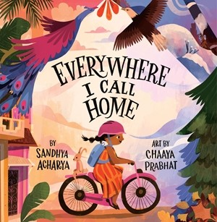
中文书名：《心安之处是吾家》
英文书名：EVERYWHERE I CALL HOME
作 者：Sandhya Acharya and Chaaya Prabhat
出 版 社：LITTLE BROWN
代理公司：LITTLE BROWN/ANA
页 数：40页
出版时间：2027年4月
代理地区：中国大陆、台湾
审读资料：电子稿
类 型：儿童故事绘本

源于移民亲身经历的双重归属主题：本书源于作者作为移民的真实体验，她提出，许多移民都经历过关于“家”的矛盾情感，在多重文化、人群、记忆与梦想之间辗转。本书为跨文化家庭的孩子提供了珍贵的自我认同参照，以并列对照的结构展示两种生活的丰盈，帮助孩子将“双重归属”理解为一种财富而非负担，也让单一文化背景的孩子学会理解身边的多元同伴。

色彩浓烈的视觉盛宴：翻开书页，小读者在加州阳光与南亚季风之间自由穿行——市集的喧嚣、街巷的追逐、节日般的色彩扑面而来。40页的篇幅装下两个国家的感官记忆，足不出户即可完成一次沉浸式的环球文化之旅。

星级口碑作者×国际品牌青睐的插画师： 作者上一部作品获《学校图书馆杂志》星级书评；绘者是被谷歌、奥巴马基金会选中的新锐艺术家。两位南亚裔女性创作者强强联手，让这本书从文字到画面都流淌着真正的文化底气。

内容简介：

This lyrical picture book celebrates multicultural identity and the joys of being from more than one country—perfect for fans of Home in a Lunchbox and Where Are You From?

An Indian American girl explores what “home” means to her as she travels between two worlds: In America, she collects pinecones, eats sweet honey sticks at the farmer’s market, and rides her bike down rolling hills with her friends. In India, she savors jalebis from street hawkers, smells the scent of jasmine in the air, and plays tag in crisscross lanes with her cousins. For her family, "home" is both America and India at the same time, and she doesn't have to choose just one!

With poetic text and vibrant illustrations, this picture book offers an affirming message about being from more than one place and belonging to more than one culture. Home is so much more than just a place on a map: It’s wherever your heart lives!

作者简介：

Sandhya Acharya grew up in Mumbai, India, and now lives in Santa Clara, California. Her picture book Living Bridges: The Hidden World of India's Woven Trees was a Junior Library Guild Selection, and her articles and short stories have been featured in The Washington Post and on NPR (KQED), among other outlets. When she is not writing, you can find her training for marathons, learning a form of Indian classical dance, or hosting a podcast for a non-profit. She invites you to visit her online at sandhyaacharya.com.

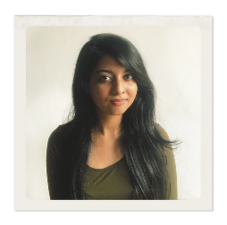
Chaaya Prabhat is an illustrator and lettering artist from Chennai, India, currently based in Goa. She has illustrated many picture books, including Bracelets for Bina’s Brothers by Rajani LaRocca; Animal Tales from India: Ten Stories from the Panchatantra by Nikita Gill; and Anni Dreams of Biryani by Namita Moolani Mehra. When she's not illustrating children's books, she's baking bread, birdwatching, reading, or drawing for fun. She invites you to visit her online at chaayaprabhat.com.

媒体评价：

作者前作《生命之桥》Living Bridges评价：
"By presenting an important example of a caring and concerned community effort based on Indigenous traditions along with vibrant, detailed, and interesting illustrations, this book offers young readers insight into a positive way to sustain the environment, and is highly recommended."——School Library Journal

"A tribute to the Jingkieng Jri, bridges woven from the roots of living trees by the residents of northeastern India's rainy Meghalaya state. … A perceptive visit to a remote wonder that blends natural materials and human skills."——Kirkus Reviews

内页插图：

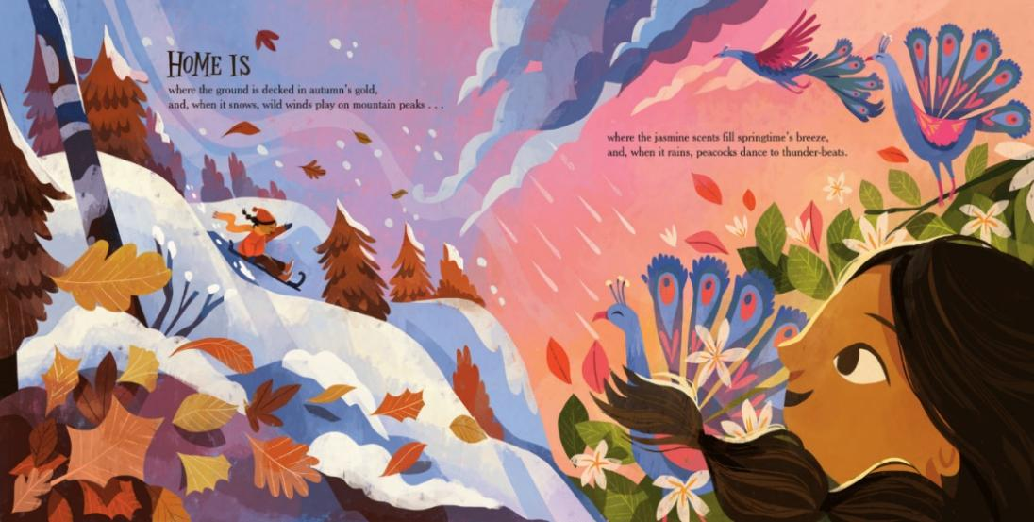
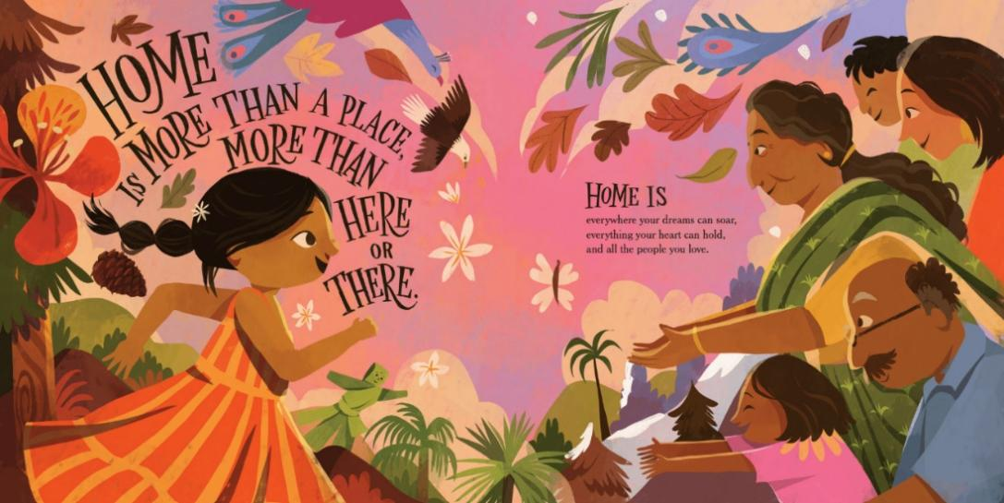

感谢您的阅读！
请将反馈信息发至：版权负责人
Email：Rights@nurnberg.com.cn
安德鲁·纳伯格联合国际有限公司北京代表处
北京市海淀区中关村大街甲59号中国人民大学文化大厦1705室, 邮编：100872
电话：010-82504106, 传真：010-82504200
公司网址：http://www.nurnberg.com.cn
书目下载：http://www.nurnberg.com.cn/booklist_zh/list.aspx
书讯浏览：http://www.nurnberg.com.cn/book/book.aspx
视频推荐：http://www.nurnberg.com.cn/video/video.aspx
豆瓣小站：http://site.douban.com/110577/
新浪微博：安德鲁纳伯格公司的微博_微博 (weibo.com)
微信订阅号：ANABJ2002


