新 书 推 荐

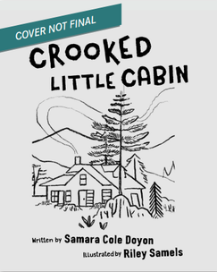
中文书名：《歪斜的小木屋》
英文书名：Crooked Little Cabin
作 者：Samara Cole Doyon and Riley Samuels
出 版 社：Tilbury House
代理公司：Biagi/ANA
页 数：40页
出版时间：2027年4月
代理地区：中国大陆、台湾
审读资料：电子稿
类 型：故事绘本

小读者们将加入这群朋友和家人的行列，他们来到湖边高大的松林中、山脚下那座歪斜的小木屋，准备在此度过夏天。随之开始了一个丰饶的季节，充满了欢乐的游戏、阳光普照的午睡、冒险、艺术和讲故事——那是田园诗般的夏日昼夜所带来的欢乐怀旧。

内容简介：

Dive into an idyllic summer on a lake in the woods with a gaggle of family and friends, from the author of Magnificent Homespun Brown.

A dynamic gaggle of kids—friends and extended family—arrive for the summer at the crooked little cabin within the tall pine woods by the lake, at the foot of the mountains. And with that begins a lush season of joyful play, sun-soaked naps, adventure, art, and storytelling. With equal parts nostalgia and ambition, this story evokes the idyllic summer days that readers of all ages long for.

作者简介：

Samara Cole Doyon is a poet, educator, and award-winning children’s book author living on unceded Wabanaki/Abenaki territory. She is a neurodivergent mother of neurodivergent children, continually learning more from her offspring than they could ever learn from her. She earned both a Lupine Award and an International Literacy Association Award for her debut picture book, Magnificent Homespun Brown, and her second children’s book, Magic Like That, received a starred review from Kirkus and made the Bookstagang Best Picture Books of 2021 list. Samara works at Maine Writers and Publishers Alliance and resides with her husband, two children, and rescue pup in central Maine.

Riley Samuels is an illustrator in both the children's book and greeting card industries.

内页插图：

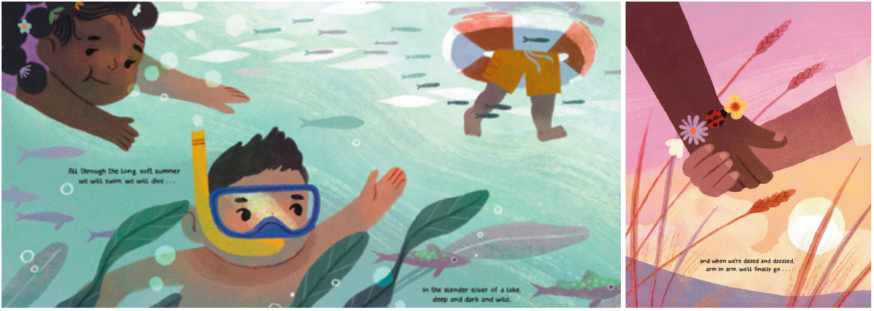

请将反馈信息发至：版权负责人
Email：Rights@nurnberg.com.cn
安德鲁·纳伯格联合国际有限公司北京代表处
北京市海淀区中关村大街甲59号中国人民大学文化大厦1705室, 邮编：100872
电话：010-82504106, 传真：010-82504200
公司网址：http://www.nurnberg.com.cn
书目下载：http://www.nurnberg.com.cn/booklist_zh/list.aspx
书讯浏览：http://www.nurnberg.com.cn/book/book.aspx
视频推荐：http://www.nurnberg.com.cn/video/video.aspx
豆瓣小站：http://site.douban.com/110577/
新浪微博：安德鲁纳伯格公司的微博_微博 (weibo.com)
微信订阅号：安德鲁纳伯格联合国际北京代表处

