新 书 推 荐
《互动人体大百科》
The Interactive Human Body
中文书名：《互动人体大百科》
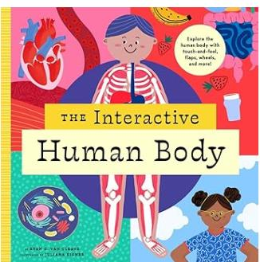
英文书名：The Interactive Human Body
作 者：Ryan G. Van Cleave
插 画 师：Juliana Eigner
出 版 社：Bushel & Peck
代理公司：Biagi
页 数：16页
出版时间：2025年11月
代理地区：中国大陆、台湾
审读资料：电子稿
类 型：知识绘本

人体奥秘 × 动手探索 趣味科普互动！
“动手触摸探索人体，趣味玩转生物科普”
欧美爆款互动探索系列新作
集趣味机关、触感设计、硬核科普于一体
化被动阅读为动手实操，让孩子在玩乐中读懂人体构造

本书卖点：

·获奖系列重磅新作，品质口碑双优：隶属于大奖级「互动探索家」经典系列，主打沉浸式实操科普，系列内容成熟、市场认可度高，是欧美热销常青树科普产品线。

·全页丰富机关设计，互动性拉满：跨页大量配置翻翻页、旋转齿轮、操控拉杆、触感纹理等多元机关，可摸、可转、可掀、可操作，充分满足低龄儿童动手探索天性。

·硬核科学通俗解读，适配儿童认知：专业作者撰写通俗科普文本，拆解消化、循环、细胞、DNA 等人体系统知识，语言简单易懂，规避晦涩术语，轻松启蒙生物常识。

·沉浸式感官体验，记忆效果更强：搭配器官、肠道专属触感材质，近距离观察细胞结构、螺旋 DNA，直观具象化抽象生理知识，助力长效记忆，适配亲子早教与课堂教学。

内容简介：

The Interactive Human Body invites children to touch, spin, lift, and discover what's happening inside them- turning the human body into an unforgettable hands-on adventure. This premium novelty nonfiction title blends real science with irresistible interactivity, making learning feel like play.

What It Is
. A bold, beautifully illustrated interactive book that brings human anatomy to life Packed with flaps, wheels, levers, and tactile elements on nearly every spread
. A standout STEM title in the award-winning Interactive Explorer series

Who It's For
. Curious kids ages 5-9 who love to explore with their hands .
.Parents and educators looking for learning that actually sticks
.Gift buyers, schools, museums, and science-loving families worldwide

What Makes It Pop
. Follow food as it travels through the digestive system
. Feel the textures of organs and intestines
. Split open cells, spin spiraling DNA, and explore body systems up close
. Clear, child-friendly science text by Ryan G. Van Cleave
. Dynamic, colorful illustrations by Juliana Eigner
. Durable, high-quality interactive design built for repeat reads

The Interactive Human Body is an evergreen children's science property with built-in engagement and perfect for publishers seeking fun, facts, and fascination in one unforgettable package.

作者简介：

Ryan G. Van Cleave is the author of dozens of books for both children and adults. He earned a PhD in American literature with an emphasis in poetry and has taught writing at numerous colleges and universities. As the Picture Book Doctor, Ryan helps celebrities create stories for kids.

插画师简介：

Juliana Eigner was born in São Paulo and currently lives in Ubatuba, a small coastal town in Brazil. Since graduating with a degree in design Juliana has experimented with many different types of art, including jewelry, ceramics, porcelain, collage, and painting.

内页插图：

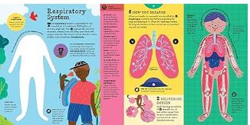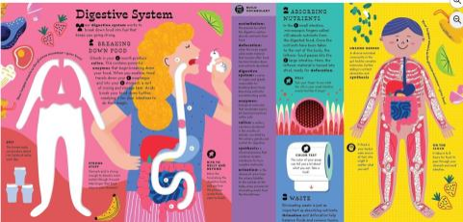

请将反馈信息发至：版权负责人
Email：Rights@nurnberg.com.cn
安德鲁·纳伯格联合国际有限公司北京代表处
北京市海淀区中关村大街甲59号中国人民大学文化大厦1705室, 邮编：100872
电话：010-82504106, 传真：010-82504200
公司网址：http://www.nurnberg.com.cn
书目下载：http://www.nurnberg.com.cn/booklist_zh/list.aspx
书讯浏览：http://www.nurnberg.com.cn/book/book.aspx
视频推荐：http://www.nurnberg.com.cn/video/video.aspx
豆瓣小站：http://site.douban.com/110577/
新浪微博：安德鲁纳伯格公司的微博_微博 (weibo.com)
微信订阅号：安德鲁纳伯格联合国际北京代表处

