新 书 推 荐

中文书名：《爸爸的胡子不见了》
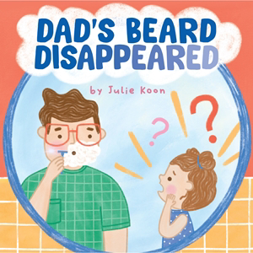
英文书名：Dad’s Beard Disappeared
作 者：Julie Koon
出 版 社：Abrams
代理公司：Abrams/ANA
页 数：32页
出版时间：2027年4月
代理地区：中国大陆、台湾
审读资料：电子稿
类 型：故事绘本

- 一本图画书：当爸爸剃掉了胡子，女儿该怎么办？！这本迷人、有共鸣的图画书聚焦一位父亲为了让沮丧的女儿安心，愿意走多远……
- 父亲节：配有有趣的押韵朗读文本和暖心艺术，这是一份普世的、必备的礼物，适合送给爸爸们，任何时节都合适，尤其是父亲节。
- 有共鸣的主题：正如无数TikTok视频和搞笑家庭录像所展示的，父母外表的任何变化对幼儿来说都是地震级的！目前还没有关于这个确切主题的书出版，这使其成为填补市场空白的完美机会。
- 令人捧腹：简单但完全有共鸣，各地的爸爸和小读者们一定会开心地阅读关于替代消失胡子的各种搞笑方法！
- 崛起中的作家：Julie Koon是互动板板书《呼吸彩虹》(Breathe a Rainbow)(Abrams，2026年春季)的作者兼插画家，该书探索身心连接和平静的技巧。我们希望继续在书单上见到她——她对幼儿的声音和表达有着深刻的理解。

内容简介：

When June woke up, her dad looked weird.
In fact, his beard had disappeared!
She sat in shock, perplexed, appalled.
Where there was hair, his chin was BALD.

Follow a toddler and her dad as they try to achieve the unachievable:quickly growing back his missing beard! From pillow fluff to spaghetti to cotton candy, Dad'll do anything to get his beard back ... and to put a smile back on his daughter's face. On one level, Julie Koon's adorable,kid-friendly art and rollicking rhyming text combine to make a perfect picture book pick for dads considering a shift in facial hair fashion. Buton a deeper level, this book provides a road map for any caregiver gently guiding a child toward acceptance of the big and small changes life brings.

作者简介：


Julie Koon is a children's book author and illustrator who loves making sweet and silly books for kids. As a preschool teacher, she works with amazing dads everyday, bearded and beardless. Koon's books include Breathe a Rainbow, City Farm, and The Struggle Bus.She is passionate about creating books that explore emotions and help children navigate their big, wide world.Koon lives in Massachusetts with her husband and three kids.

内页插图：

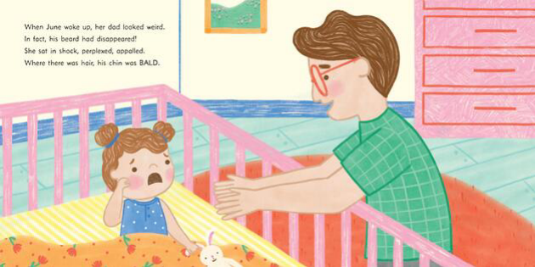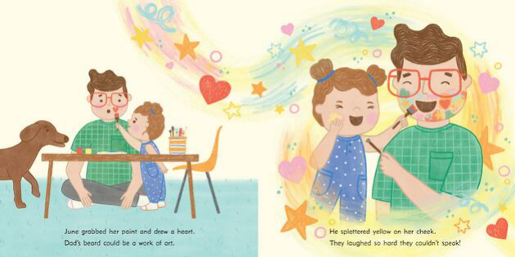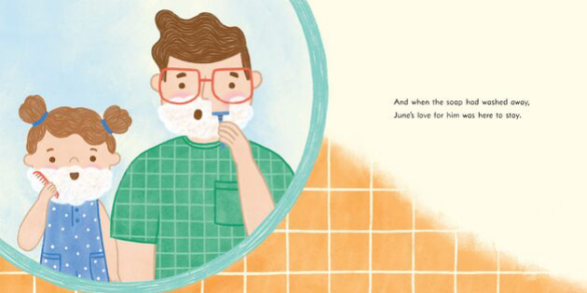

请将反馈信息发至：版权负责人
Email：Rights@nurnberg.com.cn
安德鲁·纳伯格联合国际有限公司北京代表处
北京市海淀区中关村大街甲59号中国人民大学文化大厦1705室, 邮编：100872
电话：010-82504106, 传真：010-82504200
公司网址：http://www.nurnberg.com.cn
书目下载：http://www.nurnberg.com.cn/booklist_zh/list.aspx
书讯浏览：http://www.nurnberg.com.cn/book/book.aspx
视频推荐：http://www.nurnberg.com.cn/video/video.aspx
豆瓣小站：http://site.douban.com/110577/
新浪微博：安德鲁纳伯格公司的微博_微博 (weibo.com)
微信订阅号：安德鲁纳伯格联合国际北京代表处

