新 书 推 荐

中文书名：《慵懒的一天》
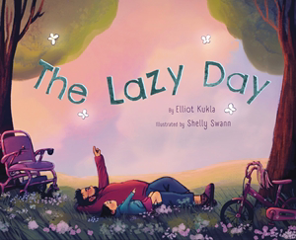
英文书名：The Lazy Day
作 者：Elliot Kukla and Shelly Swann
出 版 社：Abrams
代理公司：Abrams/ANA
页 数：40页
出版时间：2027年5月
代理地区：中国大陆、台湾
审读资料：电子稿
类 型：故事绘本

- 在这本由作家、活动家Elliot Kukla创作的温暖人心的图画书中，一个小女孩和她的父亲一起度过了一个慵懒的日子，鼓励读者慢下来，与所爱之人一起欣赏周围的世界。
- 媒体作家：Elliot Kukla的散文曾刊登在《纽约时报》、《时代》杂志、Teen Vogue等媒体上。他在《纽约时报》上疯传的专栏文章《我能教给孩子的最有价值的事是如何变懒》(The Most Valuable Thing I Can Teach My Kid Is How to Be Lazy)是这本图画书故事的灵感来源。
- 残障代表： 这本图画书聚焦多个残障角色，并捕捉了他所在残障群体中的多样性。爸爸——一位可行走的轮椅使用者——灵感来自Kukla自己的经历。这场对休息的颂歌根植于对残障文化智慧的感恩。
- 正念讯息： 这个可爱的故事鼓励读者慢下来，关注周围的自然世界。在一个重视生产力和速度的文化中，一个慵懒的日子可能正是所需要的。
- 永恒主题： Abrams在正念类书籍上有着良好的记录，我们认为这本书将与《慢下来》(Slow Down)和《我》(I Am)系列等书名相得益彰。此外，爸爸和黛西的情感联系使其成为父亲节或收藏代际家庭故事的绝佳选择。

内容简介：

When Papa suggests they spend a lazy day together, Daisy isn't so sure. She'd rather play dress-up or bake a cake or go exploring or do anything besides sit still! But Papa is determined to show his daughter all the joys of a lazy day, so the two grab their wheels-a bike for Daisy,and a wheelchair for Papa-and head to the park. Daisy wants to race around, but Papa encourages her to sit with him and see what she can notice about the world around her.

Daisy soon begins to see the beauty and mystery of nature. She feels tiny butterfly feet, hears wind in the leaves, and experiences the miracle of sunshine on her face. It turns out a lazy day was just what she needed.

This sweet and gentle story encourages kids and their caregivers to make space to slow down, be present, and find beauty in their world.

作者简介：


Elliot Kukla is a rabbi, writer, and activist. His work has been featured in The New York Times, NPR, National Geographic, and more. In 2006, Kukla became the first openly transgender rabbi to be ordained in a mainstream denomination of Judaism. He spent over a decade offering spiritual care to the dying at Bay Area Jewish Healing Center. This training as a rabbi and his time providing spiritual care to the dying at Bay Area Jewish Healing Center has deeply informed both his activism and his understanding of what is needed to heal us in the modern world.


Shelly Swann is an author/illustrator based in Portland, Oregon. Outside of her home studio,she mainly spends her days meandering the city or surrounding forests, always finding magic in the mundane.

内页插图：


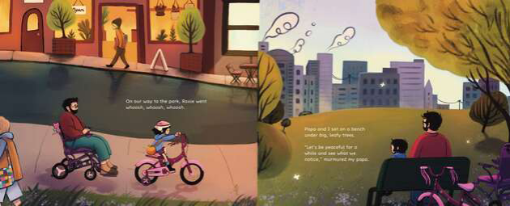
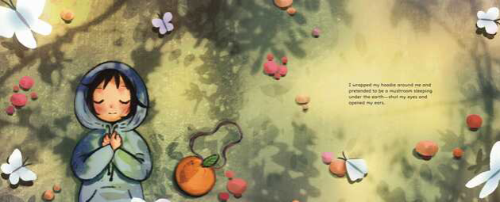

请将反馈信息发至：版权负责人
Email：Rights@nurnberg.com.cn
安德鲁·纳伯格联合国际有限公司北京代表处
北京市海淀区中关村大街甲59号中国人民大学文化大厦1705室, 邮编：100872
电话：010-82504106, 传真：010-82504200
公司网址：http://www.nurnberg.com.cn
书目下载：http://www.nurnberg.com.cn/booklist_zh/list.aspx
书讯浏览：http://www.nurnberg.com.cn/book/book.aspx
视频推荐：http://www.nurnberg.com.cn/video/video.aspx
豆瓣小站：http://site.douban.com/110577/
新浪微博：安德鲁纳伯格公司的微博_微博 (weibo.com)
微信订阅号：安德鲁纳伯格联合国际北京代表处

