新 书 推 荐

中文书名：《如何吃一首诗》
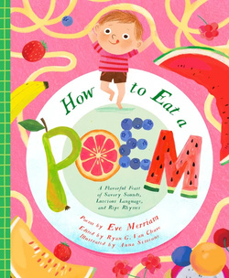
英文书名：How to Eat a Poem
作 者：Eve Merriam, Ryan Van Cleave and Anna Simeone
出 版 社：Bushel & Peck
代理公司：Biagi/ANA
页 数：40页
出版时间：2026年11月
代理地区：中国大陆、台湾
审读资料：电子稿
类 型：知识绘本

- 作者伊芙·梅里安是一位美国诗人、剧作家和备受赞誉的儿童作家，曾获得耶鲁青年诗人奖(Yale Younger Poets Prize)和NCTE儿童诗歌卓越奖(NCTE Award for Excellence in Children's Poetry)。
- 一本欢乐的、适合朗读的合集，邀请孩子们一头扎进语言纯粹乐趣中。这是一场文字扭曲、翻滚、飞溅和歌唱的俏皮盛宴。
- 谜语、数数诗和充满声音的诗句将平凡时刻变成生动的冒险。非常适合分享笑声、课堂探索，以及培养年轻读者对节奏的感知力。

内容简介：

A joyful collection of Eve Merriam’s beloved poetry packed with sound, rhythm, and wordplay.

Poetry is meant to be savored, and this playful collection invites young readers to jump right in.

In How to Eat a Poem, Eve Merriam delivers a lively feast of language where words twist, tumble, splash, and sing. Riddles, counting poems, and sound driven verses bring everyday moments to life, from spaghetti that winds and winds to rain that goes drip drop and machines that swish swash.

Perfect for reading aloud, shared laughter, and classroom discovery, these poems build a child’s ear for language while celebrating the sheer fun of words. A fresh, irresistible invitation to taste poetry one delicious bite at a time.

作者简介：

伊芙·梅里安(Eve Merriam，1916-1992)是一位美国诗人、剧作家和备受赞誉的儿童作家。她曾获得耶鲁青年诗人奖(Yale Younger Poets Prize)和NCTE儿童诗歌卓越奖(NCTE Award for Excellence in Children's Poetry)，她倡导文字游戏、节奏和社会评论，为年轻读者和成人广泛出版作品。

瑞安·范·克利夫(Ryan van Cleave)已创作了二十多本书，包括《解锁》(Unlocked)(Walker Books)和《抉择与生存：泰坦尼克号》(Decide and Survive: The Titanic)(Bushel & Peck)。

Anna Simeone is a children’s illustrator based in Sopot, Poland. After studying Literature in Gdansk and spending ten years in Italy, she returned to her seaside hometown, where she now lives with her husband, daughter, and their dog, Leo. She has illustrated children’s books for publishers in Poland, Italy, France, and the UK, capturing joyful, heartfelt moments of everyday life. Her vibrant colour palettes are inspired by the world around her―seasonal vegetables and flowers, secondhand porcelain, and even the soft fur of her dog.

内页插图：

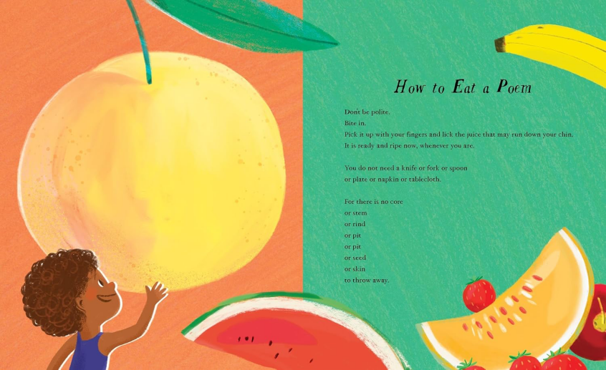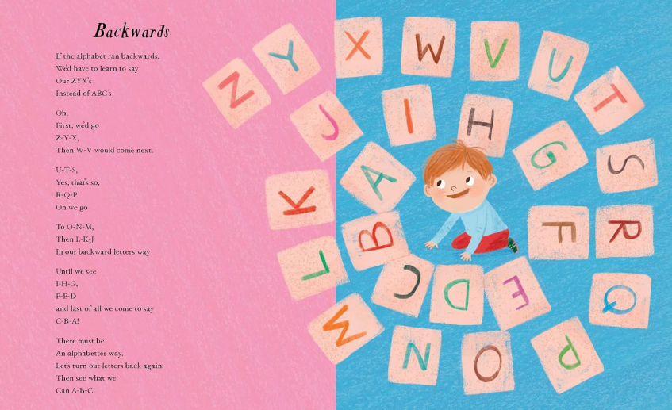

请将反馈信息发至：版权负责人
Email：Rights@nurnberg.com.cn
安德鲁·纳伯格联合国际有限公司北京代表处
北京市海淀区中关村大街甲59号中国人民大学文化大厦1705室, 邮编：100872
电话：010-82504106, 传真：010-82504200
公司网址：http://www.nurnberg.com.cn
书目下载：http://www.nurnberg.com.cn/booklist_zh/list.aspx
书讯浏览：http://www.nurnberg.com.cn/book/book.aspx
视频推荐：http://www.nurnberg.com.cn/video/video.aspx
豆瓣小站：http://site.douban.com/110577/
新浪微博：安德鲁纳伯格公司的微博_微博 (weibo.com)
微信订阅号：安德鲁纳伯格联合国际北京代表处

