新 书 推 荐

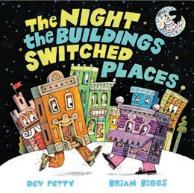
中文书名：《建筑们交换位置的那一夜》
英文书名：The Night the Buildings Switched Places
作 者：Devorah Petty and Brian Biggs
出 版 社：Little Brown
代理公司：Little Brown/ANA
页 数：40页
出版时间：2027年6月
代理地区：中国大陆、台湾
审读资料：电子稿
类 型：故事绘本

一天夜里，镇上所有的建筑都活了过来。这是一个关于古怪混乱的搞笑故事，由《纽约时报》畅销书画家绘制插画，献给《晚安，晚安，建筑工地》(Goodnight, Goodnight, Construction Site)的粉丝。

内容简介：

All the buildings in town come to life one night in this silly story of wacky mix-ups illustrated by a New York Times bestselling artist, for fans of Goodnight, Goodnight, Construction Site.

Late one night, the bored buildings in town have a sneaky idea: to switch places! But what happens when the townspeople wake up to find the dentist office has swapped with the candy store? Or the ice cream shop has parked itself on the school playground? From award-winning author Dev Petty and New York Times bestselling illustrator Brian Biggs comes this uniquely funny tale that takes a silly prank to a whole new level of mixed-up fun.

作者简介：

Dev Petty was once a visual effects artist who worked on films like The Matrix, but these days she writes funny picture books for kids and their people, such as Claymates, Claydate: A Playdate with the Claymates, and I Don’t Want to Be a Frog. She lives in her hometown of Berkeley, California, with her husband, daughters, dogs, cats, and a snake named Boots. She invites you to visit her online at devpetty.com or @devpetty.

Brian Biggs has created or collaborated on more than 75 books for kids, including the New York Times bestselling Frank Einstein series by Jon Scieszka, A Whale’s Tale and the Otter’s Side of the Story by Kate Messner, and the Tinyville Town series. Brian also works as an animator and designer, and he teaches at Tyler School of Art. He lives with his family in Philadelphia, Pennsylvania, and invites you to visit him online at BrianBiggs.com.

内页插图：

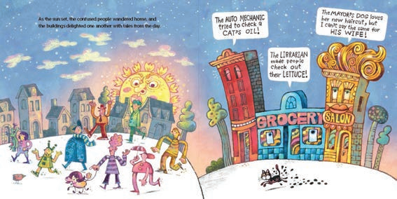

请将反馈信息发至：版权负责人
Email：Rights@nurnberg.com.cn
安德鲁·纳伯格联合国际有限公司北京代表处
北京市海淀区中关村大街甲59号中国人民大学文化大厦1705室, 邮编：100872
电话：010-82504106, 传真：010-82504200
公司网址：http://www.nurnberg.com.cn
书目下载：http://www.nurnberg.com.cn/booklist_zh/list.aspx
书讯浏览：http://www.nurnberg.com.cn/book/book.aspx
视频推荐：http://www.nurnberg.com.cn/video/video.aspx
豆瓣小站：http://site.douban.com/110577/
新浪微博：安德鲁纳伯格公司的微博_微博 (weibo.com)
微信订阅号：安德鲁纳伯格联合国际北京代表处

