新 书 推 荐

中文书名：《功夫》
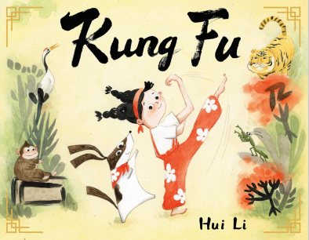
英文书名：Kung Fu
作 者：Hui Li
出 版 社：Little Brown
代理公司：Little Brown/ANA
页 数：40页
出版时间：2027年4月
代理地区：中国大陆、台湾
审读资料：电子稿
类 型：故事绘本

- 作者前作获ALA Notable
- 在这个关于古老武术——功夫的互动故事中，学习如何像猴子一样灵巧顽皮，像老虎一样强壮有力。
- 这个充满想象力的故事是李慧获奖处女作《卷轴》(Scroll)的绝佳伴侣篇。它向孩子们介绍了汉字和武术，并颂扬了功夫与自然世界之间的联系。

内容简介：

Learn how to be as playful as a monkey and as strong as a tiger in this interactive story about the ancient martial art of Kung Fu.

When Lulu and her dog Dumpling watch Grandma practice Kung Fu, they are eager to join in. Grandma teaches them that this ancient martial art explores our relationship with nature. Before long, Lulu and Dumpling are transported to a forested world where they can practice Kung Fu alongside the animals. They can be as nimble as a mantis, as graceful as a white crane, and as strong as a tiger.

This imaginative story is an excellent companion to Hui Li’s award-winning debut Scroll. It introduces children to Chinese characters as well as martial arts, and celebrates the connection between Kung Fu and the natural world.

作者简介：

Hui Li is the creator of Scroll which was an ALA Notable book among other honors. She has also written and illustrated books for children in her native China. Hui loves sharing traditional aspects of her culture to children through her inspired books. She lives in New Jersey with her husband and two young sons where she delights in practicing Kung Fu and crafting imaginative stories. She brings her creativity to everything she makes whether the medium is paper, wood, or clay.

内页插图：

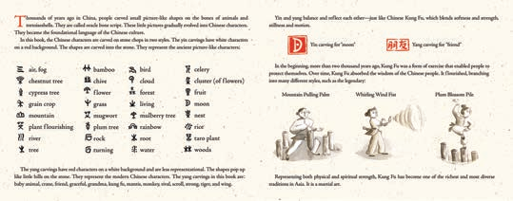
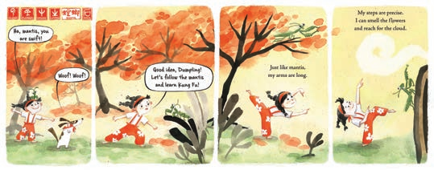

请将反馈信息发至：版权负责人
Email：Rights@nurnberg.com.cn
安德鲁·纳伯格联合国际有限公司北京代表处
北京市海淀区中关村大街甲59号中国人民大学文化大厦1705室, 邮编：100872
电话：010-82504106, 传真：010-82504200
公司网址：http://www.nurnberg.com.cn
书目下载：http://www.nurnberg.com.cn/booklist_zh/list.aspx
书讯浏览：http://www.nurnberg.com.cn/book/book.aspx
视频推荐：http://www.nurnberg.com.cn/video/video.aspx
豆瓣小站：http://site.douban.com/110577/
新浪微博：安德鲁纳伯格公司的微博_微博 (weibo.com)
微信订阅号：安德鲁纳伯格联合国际北京代表处

