新 书 推 荐

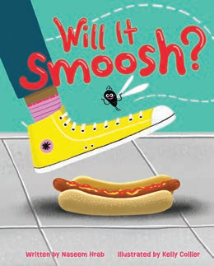
中文书名：《它会被压扁吗？》
英文书名：Will It Smoosh?
作 者：Naseem Hrab and Kelly Collier
出 版 社：Little Brown
代理公司：Little Brown/ANA
页 数：40页
出版时间：2027年6月
代理地区：中国大陆、台湾
审读资料：电子稿
类 型：故事绘本

关于苍蝇和一大堆被压扁的食物

内容简介：

For a fly, there’s nothing better than a smooshed apple, a squished juice box, or a smorshed hot dog. And hearing what sounds these foods make is half the fun! Find out which ones will SMOOSH in this silly story about bananas, pizza, and more getting trampled by unsuspecting people—then slurped, munched, and crunched by three very hungry flies.

作者简介：

Naseem Hrab is the award-winning author of How to Party Like a Snail, Weekend Dad, The Sour Cherry Tree, and other books for young readers. She works in children’s publishing and invites you to visit her online at naseemhrab.com.

Kelly Collier is the creator of the Steve the Horse series and other books for young readers, as well as the illustrator of Sloth and Squirrel in a Pickle and How to Party Like a Snail. She invites you to visit her on Instagram @iusedtobeanartist.

内页插图：

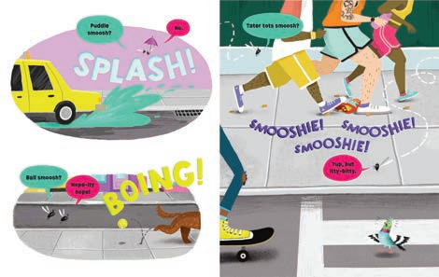

请将反馈信息发至：版权负责人
Email：Rights@nurnberg.com.cn
安德鲁·纳伯格联合国际有限公司北京代表处
北京市海淀区中关村大街甲59号中国人民大学文化大厦1705室, 邮编：100872
电话：010-82504106, 传真：010-82504200
公司网址：http://www.nurnberg.com.cn
书目下载：http://www.nurnberg.com.cn/booklist_zh/list.aspx
书讯浏览：http://www.nurnberg.com.cn/book/book.aspx
视频推荐：http://www.nurnberg.com.cn/video/video.aspx
豆瓣小站：http://site.douban.com/110577/
新浪微博：安德鲁纳伯格公司的微博_微博 (weibo.com)
微信订阅号：安德鲁纳伯格联合国际北京代表处

